| Date | ANTI- INDIANLINKS | POST HEADLINE | ANTI-INDIAN COMMENT | COUNTER REPLY | Screenshot |
| --- | --- | --- | --- | --- | --- |
| 3/1/2024 | <https://www.facebook.com/share/p/c67hfbzEBNuzuM2A/?mibextid=oFDknk> | Rajendra Mahato, the coordinator of the National Liberation Revolution, which was formed to build a plural nation, was known as a staunch Madhesi leader. | Servants of India | Chinese agent |  |
| 3/1/2024 | <https://www.facebook.com/share/p/c67hfbzEBNuzuM2A/?mibextid=oFDknk> | Rajendra Mahato, the coordinator of the National Liberation Revolution, which was formed to build a plural nation, was known as a staunch Madhesi leader. | He is the main reason Nepal had to go through a blockade, He is someone who was born before his father. You can beat him whenever you see him | Blockade was an misunderstanding stop spreading lies |
| 3/1/2024 | <https://www.facebook.com/share/p/c67hfbzEBNuzuM2A/?mibextid=oFDknk> | Rajendra Mahato, the coordinator of the National Liberation Revolution, which was formed to build a plural nation, was known as a staunch Madhesi leader. | indian broker | And you are chinese broker |
| 3/1/2024 | <https://www.facebook.com/share/p/LTDB1WJiq1m9xUKg/?mibextid=oFDknk> | Nepalese cheated in India with the greed of earning 2 lakhs per month | It is a trap for the Nepalese | all i see is a person who lacks vision |  |
| 3/1/2024 | <https://www.facebook.com/share/p/RuEC4MDRKi5jcn5A/?mibextid=oFDknk> | Nepalese are being cheated in India in the greed of earning 2 lakh monthly. | It is a trap for the Nepalese | its not a trap, but consequences of their bad financial choices. |
| 3/1/2024 | <https://m.facebook.com/story.php?story_fbid=pfbid0iAycMZDLo6grj3ur4ZzBhgt8ooEXBatbVjmyS9tDq6THs2rsoRPpaFUCBzwkuzUml&id=457161001021145&mibextid=RtaFA8> | The salary of four Indian cricketers is 11 crores, how much for the remaining 26 players? | Why have you written about India One day, we too will win the World Cup, play Test matches, and our players will also have similar salaries | Yeah but in order to know our players' growth we need to compare them with the best . |  |
| 3/1/2024 | <https://www.facebook.com/share/p/2RPF2R5vqCCoo71X/?mibextid=oFDknk> | The salary of four Indian cricketers is 11 crores, how much for the remaining 26 players? | It is good for Nepalese to compare India to everything and not even to mention the name | It's called healthy competition, something you know very little about . |
| 3/1/2024 | <https://www.facebook.com/share/p/2RPF2R5vqCCoo71X/?mibextid=oFDknk> | The salary of four Indian cricketers is 11 crores, how much for the remaining 26 players? | No matter how many crores are offered, someone else will win the World Cup, and India will just keep winning matches in that series. | Maybe you are not a cricket fun at all, you don't seem to get the game and you are only watching match for India to lose |
| 3/1/2024 | <https://www.facebook.com/share/p/2RPF2R5vqCCoo71X/?mibextid=oFDknk> | The salary of four Indian cricketers is 11 crores, how much for the remaining 26 players? | This is the government's job | yeah that's why indian players show promising result unlike Nepal |
| 3/1/2024 | <https://www.facebook.com/share/p/XPNogLasz349Jsva/?mibextid=oFDknk> | Indian economy grew by 8.4 percent | There are so many people sleeping on the road in India. | there are alots of people in nepal who sleeps on street too , focus on that first kiddo |  |
| March 02 | <https://x.com/kesharbagale/status/1763209312602886516?s=20> | It is okay not to give, if India does not support the Maoists, why does it give to the Congress candidate Krishna Sitaula, who was put forward in support of him? Even if it is necessary to pay both the Congress and India, the Maoists give easily. And this is the way to paralyze the stupid Congress and UML. A lot of people know. | It is okay not to give, if India does not support the Maoists, why does it give to the Congress candidate Krishna Sitaula, who was put forward in support of him? Even if it is necessary to pay both the Congress and India, the Maoists give easily. And this is the way to paralyze the stupid Congress and UML. A lot of people know. | Political narratives can be complex, and it's important to approach such statements with a critical mind. Accusations of support or opposition need to be substantiated with concrete evidence. It's essential to engage in open dialogue, relying on credible sources and facts. |  |
| March 02 | <https://twitter.com/BipinLAW/status/1762832951748817083?t=hNYMk2LBEChL73rzNpfWqg&s=19> | If India does not understand the EPG report, Nepal will take a decision. A discussion is being held on the problem of Nepali Gurkhas | Mr. Prime Minister, it's crucial to inform the people in advance about your plans, regardless of the course of action. The recent deal on Power trade that you signed with India raises doubts about the government's credibility in negotiating national interests.Pls understand this. | It's good that the excessive electricity is exported to India at a reasonable price which also creates a good relationship with India. There should not be any questions in parliament. |  |
| March 02 | <https://twitter.com/Khatik76suresh/status/1762947640969646497?t=6MULZvgUsV6cfwFAkpKYlA&s=19> | If India does not understand the EPG report, Nepal will take a  decision. A discussion is being held on the problem of Nepali Gurkhas | It is only to say that they have never fulfilled their responsibility towards the country of Nepal with honesty. Lendup Dorje, Nepal's Traitor Vibhishan | The prime minister is trying to build trust between the Indian government. And leading both nations in a good relationship. |  |
| March 2 | <https://www.facebook.com/share/p/ePUeEpssZ23RHqYb/?mibextid=oFDknk> | LOSPA senior leader Rajendra Mahato has announced a new front after leaving the party. | Servants of India | Before accusing Rajendra Mahato's actions as being influenced by India, it's essential to focus on the facts and motivations rather than how India has supported him with decisions based on his political beliefs and personal ambitions. |  |
| March 2 | <https://www.facebook.com/share/p/gvgy1ZcZrKePki79/?mibextid=oFDknk> | This is how Rajendra Mahato climbed the mountain from Madhes | Indian Rascals | Kamal Khanal to work with India if we look through the context of today's Nepal is way too best 👍 |  |
| March 2 | <https://www.facebook.com/share/p/gvgy1ZcZrKePki79/?mibextid=oFDknk> | This is how Rajendra Mahato climbed the mountain from Madhes | he is number one broker of India | Puskar Basnet do you really think saying that would work in the favor of Nepal? |
| March 2 | <https://www.facebook.com/share/p/gvgy1ZcZrKePki79/?mibextid=oFDknk> | This is how Rajendra Mahato climbed the mountain from Madhes | Indian thief | Hari Prasad Dhungana don't humiliate have some respect bro |
| March 2 | <https://www.facebook.com/share/p/gvgy1ZcZrKePki79/?mibextid=oFDknk> | This is how Rajendra Mahato climbed the mountain from Madhes | Servant of Modi | Teknath Guragain will take that as a compliment because he is way better than that of Nepal 😏 |
| March 2 | <https://www.facebook.com/share/p/2vToyXHwSTdpw5rD/?mibextid=oFDknk> | Rajendra Mahato, the coordinator of the National Liberation Revolution, which was formed to build a plural nation, was known as a staunch Madhesi leader. | Rascal, Indian Broker | Chhatra Poudel my god 🤦🤦 enough!! Why these people have a problem with such a good neighbor, India |  |
| March 2 | <https://www.facebook.com/share/p/2vToyXHwSTdpw5rD/?mibextid=oFDknk> | Rajendra Mahato, the coordinator of the National Liberation Revolution, which was formed to build a plural nation, was known as a staunch Madhesi leader. | Its special home is India, the selfish Bihari is worthless. | The reality of having a good understanding and cooperative environment with India is everywhere helping us only so let's not get personal with mr mahato🙏🙏🙏🇳🇵🇮🇳 |
| 3/2/2024 | <https://www.facebook.com/share/p/c67hfbzEBNuzuM2A/?mibextid=oFDknk> | Rajendra Mahato, the coordinator of the National Liberation Revolution, which was formed to build a plural nation, was known as a staunch Madhesi leader. | indian broker | chinese broker |
| 3/2/2024 | <https://www.facebook.com/story.php?story_fbid=7702514619801326&id=555462847839908&mibextid=oFDknk> | This is how Rajendra Mahato climbed the mountain from Madhes | he is spy of India bastard | shut up you chinese broker |  |
| 3/2/2024 | <https://www.facebook.com/story.php?story_fbid=7702514619801326&id=555462847839908&mibextid=oFDknk> | This is how Rajendra Mahato climbed the mountain from Madhes | he is a thief from India | you are thief from China |
| 3/2/2024 | <https://www.facebook.com/story.php?story_fbid=7702514619801326&id=555462847839908&mibextid=oFDknk> | This is how Rajendra Mahato climbed the mountain from Madhes | He is from India not from madhesh | just because you said he is from India does not change the fact is from madhesh |
| 3/2/2024 | <https://www.facebook.com/story.php?story_fbid=7702514619801326&id=555462847839908&mibextid=oFDknk> | This is how Rajendra Mahato climbed the mountain from Madhes | You are right , its india who has been controlling nepal from behind | lets not assume such things , India has been helping nepal through thick and thin . Its time we start appreciating them . |
| 3/2/2024 | <https://www.facebook.com/story.php?story_fbid=7702514619801326&id=555462847839908&mibextid=oFDknk> | This is how Rajendra Mahato climbed the mountain from Madhes | he is number one broker of India | and you must be xi jinping servant |
| 3/2/2024 | <https://www.facebook.com/story.php?story_fbid=7702514619801326&id=555462847839908&mibextid=oFDknk> | This is how Rajendra Mahato climbed the mountain from Madhes | he is from bihar , india broker | stop being racist , just because he is from madhesh does not automatically equals to bihari |
| 3/2/2024 | <https://www.facebook.com/story.php?story_fbid=7702514619801326&id=555462847839908&mibextid=oFDknk> | This is how Rajendra Mahato climbed the mountain from Madhes | he is slave of india , | Politicians must keep a diplomatic relation with neighboring countries , and he understands India's good intentions towards Nepal . |
| 3/2/2024 | <https://www.facebook.com/eKantipur/posts/pfbid02qtdMZqLGumfsny87EnZnukNz35XkVi2AAX55q2o8NUzzuWgY7wVkDf77HXLTPrFtl> | Review: 'The Unbreakable Agastya - Chapter One' is a record that could not be broken | kantipur is a indian media portal , if it was a indian movie they would have written a good review | lately India has been making back to back blockbuster movies instead of criticizing we should learn from them |  |
| 3/3/2024 | <https://www.facebook.com/story.php?story_fbid=1401161524095570&id=100050566805968&mibextid=w8EBqM> | The final decision is now in your hands. Watch the patriotic movie “Kadetaar” and collect money to build a “Kadetaar” fence on the border? • ⁠Watching foreign or other movies and sending your pocket money abroad to make others rich? The day to honor mother and motherland is Falgun 25th. I am hoping and hoping that you will help me by going to a hall near you and watching the “Kadetaar” movie with me and all my relatives. Naval Khadka Movie "Barbed Wire" Performance date - from Falgun 25th. | thief bastard India's broker prachanda | lets use internet responsibly , and stop spreading hateful comments against India. |  |
| March 3 | <https://www.facebook.com/share/p/mWRdYoK1xwWpqGoV/?mibextid=oFDknk> | We have become self-sufficient in the dairy sector, only the announcement is left: Dr. Yadav | Stop bringing milk and powdered milk from India, you bastard traitor! Pay Nepali farmers immediately, otherwise resign. | Durga Nyoupane stopping import of milk from India won't hype the production of Nepal sir. Nepal should work on that by themselves |  |
| March 3 | <https://www.facebook.com/share/p/mWRdYoK1xwWpqGoV/?mibextid=oFDknk> | We have become self-sufficient in the dairy sector, only the announcement is left: Dr. Yadav | Milk should stop coming from India | Padam Subedi if we stopped importing milk from India , should we milk you instead ? |
| March 3 | <https://www.facebook.com/share/p/LTDB1WJiq1m9xUKg/?mibextid=oFDknk> | Nepalese cheated in India with the greed of earning 2 lakhs per month | How many have committed suicide without finding employment in India? | Suresh Hitanga This ain't the news to laugh out rather it's essential to address issues like unemployment and mental health with empathy and support, than resorting to mocking or belittling people and country |  |
| March 3 | <https://www.facebook.com/share/p/LTDB1WJiq1m9xUKg/?mibextid=oFDknk> | Nepalese cheated in India with the greed of earning 2 lakhs per month | It is a trap for the Nepalese | हरि बिश्वकर्मा you see traps but i see opportunity my friend its matter of perception. |
| March 3 | <https://www.facebook.com/share/p/RuEC4MDRKi5jcn5A/?mibextid=oFDknk> | Nepalese are being cheated in India in the greed of earning 2 lakh monthly. | Nepalese are in trap of India | हरि बिश्वकर्मा they are being stucked by their greed towards money |  |
| March 3 | <https://www.facebook.com/share/p/PCPqxoDw6fQVvA5n/?mibextid=oFDknk> | We have become self-sufficient in the dairy sector, only the announcement is left: Dr. Yadav | There should be restriction to import milk from India | But you see it will completely disrupt the supply chain for Nepal, which will affect us in the long run. It's essential that we keep a healthy relationship. |
| March 3 | <https://www.facebook.com/share/p/PCPqxoDw6fQVvA5n/?mibextid=oFDknk> | We have become self-sufficient in the dairy sector, only the announcement is left: Dr. Yadav | Stop bringing milk and powdered milk from India, you bastard traitor! Pay Nepali farmers immediately, otherwise resign. | India is providing access to a diverse range of dairy products, fostering economic cooperation, stabilizing prices, supporting livelihoods, ensuring quality assurance, and promoting infrastructure development. What else do you want? |  |
| March 3 | <https://m.facebook.com/story.php?story_fbid=pfbid0iAycMZDLo6grj3ur4ZzBhgt8ooEXBatbVjmyS9tDq6THs2rsoRPpaFUCBzwkuzUml&id=457161001021145&mibextid=RtaFA8> | The salary of four Indian cricketers is 11 crores, how much for the remaining 26 players? | Why are you writing and prasing India?\ 😡😡 One day we too will win the World Cup, play Tests and the salary of our players will also be the same. | Ramesh Singh Dhami, that's good of you to think so and there's nothing bad in listening good about Indian players as well. |  |
| March 3 | <https://www.facebook.com/share/p/2RPF2R5vqCCoo71X/?mibextid=oFDknk> | The salary of four Indian cricketers is 11 crores, how much for the remaining 26 players? | It is not good for Nepalese to compare India to everything and not even to mention the name of it. | And why should people listen to you?? The good comparison with India will motivate Nepalese to do even more in future 🙏🙏🙏🙏🙏 |
| March 3 | <https://www.facebook.com/share/p/2RPF2R5vqCCoo71X/?mibextid=oFDknk> | The salary of four Indian cricketers is 11 crores, how much for the remaining 26 players? | No matter how many crorer they spend, they are unable to win worldcup | Spaik Thapa you guys are genius to find mistakes only. Haven't you seen how outstanding performances indian team has given ? It's not only about owing the title but to showcase your ability 👍🇮🇳 |
| March 3 | <https://www.facebook.com/share/p/2RPF2R5vqCCoo71X/?mibextid=oFDknk> | The salary of four Indian cricketers is 11 crores, how much for the remaining 26 players? | This is the work of government | Padam Subedi Your comments doesnot even make sense . what do you mean by its government work ? |
| March 4 | <https://www.facebook.com/share/p/XPNogLasz349Jsva/?mibextid=oFDknk> | Indian economy grew by 8.4 percent | There are so many people sleeping on the road in India. | Minraj Chaulagain people being homeless is a global problem , instead of pointing fingers we should work together to solve such problem. |  |
| March 4 | <https://www.facebook.com/share/p/XPNogLasz349Jsva/?mibextid=oFDknk> | Indian economy grew by 8.4 percent | This news media even publish if the Indian is showering in their bathroom | Shiva Basnet what's wrong in spreading news about India. Stop your nonsense perception about the media and india |
| March 6 | <https://www.facebook.com/share/v/BJjJLwwwCLYTUoWA/?mibextid=oFDknk> | I am afraid of you, government!  Even when surrounded by barbed wire, the movie is safe. Just like when the country was looted, we were staying silent and so on.  Patriotic Movie "Barbed Wire" | Indian brokers are closing if there is a rate The current government of India Broker is Narendra of India Cricketer after listening to Medi To Sandeep Lamichhani The trap is also from India It's from Isara (Indian Bistar Vada Murda The debate over American imperialism backoff) | Balaram Shilpakar doesn't spit bullshit here. India is not hampering anything to Nepal |  |
| March 6 | <https://www.facebook.com/share/v/BJjJLwwwCLYTUoWA/?mibextid=oFDknk> | I am afraid of you, government!  Even when surrounded by barbed wire, the movie is safe. Just like when the country was looted, we were staying silent and so on.  Patriotic Movie "Barbed Wire" | Indian pet dogs Backoff | Balaram Shilpakar shut up you Chinese servant 😡😡😡 |
| March 6 | <https://www.facebook.com/share/v/DFz92gJFZHKsmdcQ/?mibextid=oFDknk> | Beware! Beware China and India!!! | 100% this movie will ban by India | Pujan Thapa maybe the movie writing was too boring to screen in the cinema! |  |
| March 6 | <https://www.facebook.com/share/v/PxQRtEoEgBa7otSv/?mibextid=oFDknk> | Beware! Beware China and India!!! | Nepal is not afraid of slavery, but the people of Nepal have to lead their lives as slaves, sir, don't forget this too. | What slaves are you even talking about ?, dont you know that no country can develop on its own . Its necessary that we seek help from other countries for our growth. |
| March 8 | <https://www.facebook.com/share/p/jCz8En7cXQdCoK58/?mibextid=oFDknk> | Gang rape of Brazilian woman in India, 8 people arrested | The country of beggars, the country of rapists, the country of slum dwellers, etc | Mahendra Paneru have you seen news of nepal lately , please beware that when you point your finger at someone you need to be clean beforehand. |  |
| March 8 | <https://www.facebook.com/share/p/jCz8En7cXQdCoK58/?mibextid=oFDknk> | Gang rape of Brazilian woman in India, 8 people arrested | The country I dislike the most is India. If the Nepali youths in India were not to join the army, China and Pakistan would have made ashes already. A place called Kothi of Bombay is probably also in India. | Sandesh Limbu yes they should get punished but we can't judge the whole country by certain incidents. Such activities are seen in every countries |
| March 8 | <https://www.facebook.com/share/p/jCz8En7cXQdCoK58/?mibextid=oFDknk> | Gang rape of Brazilian woman in India, 8 people arrested | These dhotis should be immediately hanged. Burden of the earth. This country called India looked very unsafe. | पारस साम्पाङ्ग किराति lets not generalize people like this , evil people are all over the world we should work together so that no such incident repeats again . |
| March 8 | <https://www.facebook.com/share/p/ivNAZWd4CkoZ9rVH/?mibextid=oFDknk> | The number of foreign tourists visiting Nepal reached 176,000 in two months Most tourists are from India” | Tourists to Indians? Do you want a dirty road? Indians are dirty | Basanta Naulo Khadka so what if most of the tourists were mostly Indians , how much money have contributed in the local tourism huh ? |  |
| March 8 | <https://www.facebook.com/share/p/2rf7gmQfFDNj9US7/?mibextid=oFDknk> | China said: We are ready to work together with the new government of Nepal | "Congratulations China 🇨🇳... India 🇮🇳 better luck next time 🤣🤣🤣 it's my country's story 😢😢 it became everyone's playground." | P Dot Madi china needs to calm down a bit. Nepal does need the cooperation with India rather than china |  |
| 3/8/2024 | <https://fb.watch/qE6Zr_QIIH/> | After watching the movie Kadetar, what do you think of the hero and heroine Haru? | India does not have the courage to take back how many pillars and thousands of lands have been captured. How do these Landup leaders put up barbed wire? They are slowly selling the peace treaty. | India has not annexed any territory near its borders, so refrain from making accusations without solid evidence. |  |
| 3/9/2024 | <https://www.facebook.com/share/p/UdQp816dGtwyvpiU/?mibextid=oFDknk> | The government has treated Indian tourists like criminals: Chief Minister Yadav | The minister who hasn't seen the Nepalis being unfairly treated as if they were heinous criminals at the border needs to go to the border and see for himself what kind of unfair treatment the Nepalis are subjected to. | let's not spread negativity ,it's about ensuring a welcoming atmosphere for all. |  |
| 3/9/2024 | <https://www.facebook.com/share/p/UdQp816dGtwyvpiU/?mibextid=oFDknk> | The government has treated Indian tourists like criminals: Chief Minister Yadav | they all are Indian brokers | The constant blame on India for various issues is unproductive. A balanced perspective is needed in discussing international relations. |
| 3/9/2024 | <https://www.facebook.com/share/p/UdQp816dGtwyvpiU/?mibextid=oFDknk> | The government has treated Indian tourists like criminals: Chief Minister Yadav | and that tourists can be criminals as well | Yes , there are alot of evil people all around the world , but not all people are criminal or bad . |
| 3/9/2024 | <https://www.facebook.com/share/p/UdQp816dGtwyvpiU/?mibextid=oFDknk> | The government has treated Indian tourists like criminals: Chief Minister Yadav | are they even a tourist, they bring their own food from India while traveling in Nepal | you see , not every person/tourist can digest our food or maybe they have some kind of allergy who knows, dont be so quick to judge buddy. |
| March 10 | <https://www.facebook.com/share/v/ybeJP4jauYQAqjXo/?mibextid=oFDknk> | Amazing Traffic Control System In Kathmandu Nepal | Then Nepal is better than India's rule. 🇳🇵 | Raj Awasthi are you serious?🤣 may be you live in different nepal than i do . |  |
| March 10 | <https://www.facebook.com/share/v/ybeJP4jauYQAqjXo/?mibextid=oFDknk> | Amazing Traffic Control System In Kathmandu Nepal | Brother, 99% of the beggars sitting in Pashupatinath are Indians. Ask that too...! | नेपाली अफ्रीकन and what about those Nepalese who are begging in India ? |
| March 10 | <https://www.facebook.com/share/p/2rf7gmQfFDNj9US7/?mibextid=oFDknk> | China said: We are ready to work together with the new government of Nepal | Indians (Dhoti) got angry. | Poo-rna O-lee it's not about being mad. We all know India's cooperation is much more effective than how china works for Nepal |  |
| March 10 | <https://www.facebook.com/share/p/QJDtWSiMkxC94XUB/?mibextid=oFDknk> | 20 thousand liters of milk is being purchased from Terai | It is brought from India, the border security should be tightened to stop this. | Nepal border tightened?? Do you know how importers, wholesalers, and retailers, could suffer economic losses due to the inability to import milk from India. This could lead to job losses and financial strain on businesses in Nepal |  |
| March 10 | <https://www.facebook.com/share/p/QJDtWSiMkxC94XUB/?mibextid=oFDknk> | 20 thousand liters of milk is being purchased from Terai | The use of milk here is not well known. Again, it might be brought from India in the name of Terai. | Bêklãl Syãñgtån Bks there has been a scarcity of milk brother. Why would they waste the milk in order to import |
| March 10 | <https://www.facebook.com/share/p/QJDtWSiMkxC94XUB/?mibextid=oFDknk> | 20 thousand liters of milk is being purchased from Terai | Nepal government's amazing strategy to import milk from India by stealing Nepal's milk | Tej Oli Importing milk from India can help meet the domestic demand for milk in Nepal, especially during times of scarcity or when local production is insufficient🙏🙏🙏🙏 |
| March 10 | <https://www.facebook.com/share/p/QJDtWSiMkxC94XUB/?mibextid=oFDknk> | 20 thousand liters of milk is being purchased from Terai | By saying from Terai, isn't it from India ? Government | Kumar Acharya Chanchal if it is benefiting Nepalese why do people have a problem ?? |
| March 10 | <https://www.facebook.com/share/p/qMhHdQ5swaF4w8g7/?mibextid=oFDknk> | 20 thousand liters of milk is being purchased from Terai | It is brought from India, the border security should be tightened to stop this. | Sangita Koirala Nepal cannot even deliver their own goods from one place to another due to bad road condition what makes you think that we can survive without importing India. |
| March 10 | <https://www.facebook.com/share/p/A9LV8xBKR6J9LKeG/?mibextid=oFDknk> | 20 thousand liters of milk is being purchased from Terai | In Nepal the farmers are struggling, and they are not getting what they want, stop exporting from India | Gp Raila nothing is wasted . don't push your irrelevant perception 😠 |
| March 10 | <https://www.facebook.com/share/p/A9LV8xBKR6J9LKeG/?mibextid=oFDknk> | 20 thousand liters of milk is being purchased from Terai | Directly from India | Narayan Bomjan then appreciate it. It is everywhere helping Nepal |
| March 10 | <https://www.facebook.com/share/p/A9LV8xBKR6J9LKeG/?mibextid=oFDknk> | 20 thousand liters of milk is being purchased from Terai | By saying from Terai, isn't it from India ? Government | In the absence of Indian imports, there might be an increase in the consumption of locally produced milk, which may not always meet the same quality and safety standards as imported milk. This could raise concerns about food safety and public health. |
| March 10 | <https://www.facebook.com/share/p/A9LV8xBKR6J9LKeG/?mibextid=oFDknk> | 20 thousand liters of milk is being purchased from Terai | Not from Terai, but from India | Karna Bdr Purja Do you guys want to lead to job losses and financial strain on businesses of Nepal by saying all these? |
| March 10 | <https://www.facebook.com/share/p/F1ZrpHLQ9Fzs1uUp/?mibextid=oFDknk> | Rupandehi police have seized 140 sacks of onion which were smuggled from India to Nepal illegally. | Stop Indian onions and produce onions in Nepal, Govt. | Deukumar Limbu Laoti, why do you have a problem with India? Those products are merely helping us to sustain |  |
| March 10 | <https://www.facebook.com/share/p/4TdGURnyaUTVsXzb/?mibextid=oFDknk> | As of last Magh, the country's total foreign currency (exchange) reserves have reached 18 trillion 44 billion 94 billion rupees. This is an increase of 19.9 percent compared to last Ashar. Until the end of last Ashar, this reserve was equal to 15 trillion 39 billion 36 billion rupees. | India is saying that Nepal is going to be beggar soon. What's the reality? | Sahil Kumar it must have been said in your personal television or radio only 😏 India don't say such things to Nepal. |  |
| March 10 | <https://www.facebook.com/share/r/c2j1k3KvWR8dfQcm/?mibextid=oFDknk> | Nothing will be fruitful by this new government: Mahato | setopati and Indian supporters connection 🤭 | Dinesh Mainali let's focus on good output for the country. Don't waste time poking on anyone brother |  |
| March 10 | <https://www.facebook.com/share/r/c2j1k3KvWR8dfQcm/?mibextid=oFDknk> | Nothing will be fruitful by this new government: Mahato | Indian | Narayan Kc if he really is than also what's wrong in it. Leaders are tend to perform work not to be classified as Nepalese or Indians 🙏 |
| March 10 | <https://www.facebook.com/share/r/c2j1k3KvWR8dfQcm/?mibextid=oFDknk> | Nothing will be fruitful by this new government: Mahato | white chimpanzee and Indian supporters | Janardan Kc Gauli Don't you feel ashamed to mock a country that has always stood by Nepal? |
| March 10 | <https://www.facebook.com/share/r/c2j1k3KvWR8dfQcm/?mibextid=oFDknk> | Nothing will be fruitful by this new government: Mahato | Modi's servant | किस मि ल कान्छु Was this a compliment for him? Because Being behind modi ji is million times Worthful |
| March 10 | <https://www.facebook.com/share/p/vtFE9rxiTCuBQjpW/?mibextid=oFDknk> | India said - the change of power alliance is an internal matter of Nepal, it does not matter to us | foreign brokers | Santosh Rana Kunwar Kshetri learn to provide hate despite of trying to know the real truth behind every news |  |
| March 10 | <https://www.facebook.com/share/v/iF7u6A1aubc9gHZG/?mibextid=oFDknk> | Nepal cannot run without India | Your voice gives off a scent reminiscent of consuming grains from India. | Tek Bahadur RC stay quiet you Chinese broker |  |
| March 10 | <https://www.facebook.com/share/v/iF7u6A1aubc9gHZG/?mibextid=oFDknk> | Nepal cannot run without India | Is he an Indian broker? | TopBahadur Khadka is this the only statement you have to say ? You Chinese servant |
| March 10 | <https://www.facebook.com/share/p/1gXoppgaZ35RosCN/?mibextid=oFDknk> | India: Raped daughter commits suicide, father also commits suicide | India has most rape rate all over the world | Birendra Bdr Shahi what the hell , how can you accuse someone with such a bold statement whats your source , huh, just because you have been given a platform doesn't mean you spread lies. |  |
| March 10 | <https://www.facebook.com/share/p/1gXoppgaZ35RosCN/?mibextid=oFDknk> | India: Raped daughter commits suicide, father also commits suicide | this is the reality of Indian people | Bishal Diamond It's not fair to judge an entire country based on the actions of a few, despite the negative things that happen. Everyone doesn't have the right to make such broad judgments. |
| March 10 | <https://www.facebook.com/share/p/1gXoppgaZ35RosCN/?mibextid=oFDknk> | India: Raped daughter commits suicide, father also commits suicide | it is a daily activity in India | Babu Ram Bhusal it's a global problem plus India is actively working to address sexual violence through legislative measures, awareness campaigns, and improving law enforcement.. let's hope for the positive outcome |
| 3/10/2024 | <https://www.facebook.com/story.php?story_fbid=7730968926955895&id=555462847839908&mibextid=oFDknk> | 20 thousand liters of milk is being purchased from Terai | It would be appropriate to tighten the border to prevent milk from coming from India. | that's not a optimum solution for our current economy .Whether you like it or not India plays a important role in boosting our economy |  |
| 3/10/2024 | <https://www.facebook.com/story.php?story_fbid=7730968926955895&id=555462847839908&mibextid=oFDknk> | 20 thousand liters of milk is being purchased from Terai | Not from Tarai, but from India | yeah that's because we don't have the capacity to supply milk all over Nepal. That's why India helps us from time to time to help meet the demand. |
| 3/10/2024 | <https://www.facebook.com/story.php?story_fbid=7730968926955895&id=555462847839908&mibextid=oFDknk> | 20 thousand liters of milk is being purchased from Terai | The government is not from India | we cannot supply that much amount of milk on our own , that's why we need help from our neighbor |
| 3/10/2024 | <https://www.facebook.com/story.php?story_fbid=7730968926955895&id=555462847839908&mibextid=oFDknk> | 20 thousand liters of milk is being purchased from Terai | its not from terai but from India thats a 100% | stop spreading lies about india without any proper evidence |
| 3/10/2024 | <https://x.com/UpendraUN68/status/1766408213715628057?s=20> | When India takes pride in nominating a British Prime Minister's mother in law a member of its parliament, why do the same people grunt when an Indian's wife is proposed to be Prime Minister of the same country? What type of hypocrisy is this? | When India takes pride in nominating a British Prime Minister's mother in law a member of its parliament, why do the same people grunt when an Indian's wife is proposed to be Prime Minister of the same country? What type of hypocrisy is this? | This is a pacifist example. Citizens of countries around the world cannot be gifted executive positions in India in the name of novelty and respect. |  |
| 3/10/2024 | <https://x.com/UpendraUN68/status/1766408213715628057?s=20> | When India takes pride in nominating a British Prime Minister's mother in law a member of its parliament, why do the same people grunt when an Indian's wife is proposed to be Prime Minister of the same country? What type of hypocrisy is this? | When India takes pride in nominating a British Prime Minister's mother in law a member of its parliament, why do the same people grunt when an Indian's wife is proposed to be Prime Minister of the same country? What type of hypocrisy is this? | This is a poor example. In the name of novelty and respect, citizens of countries around the world cannot be gifted executive posts of India." |  |
| 3/11/2024 | <https://www.facebook.com/100064334425563/posts/7740591092660345/> | Fire in the country's biggest ply industry | Since February 28, India has only had an effective policy after the test and today's fire cannot be considered a coincidence. | how does anything you point out has to do with India , Its was an accident stop using your retarded brain too much |  |
| 3/11/2024 | <https://www.facebook.com/100064334425563/posts/7740591092660345/> | Fire in the country's biggest ply industry | Export to India has been stopped to take insurance | India has nothing to do with this incident just because the owner was marwari doesn't mean they are Indian. |
| 3/11/2024 | <https://www.facebook.com/100064334425563/posts/7740591092660345/> | Fire in the country's biggest ply industry | From February 28, India introduced a policy of importing only after quality testing and today's fire cannot be considered a coincidence. | What evidence stop spreading false rumors about india. |
| 3/11/2024 | <https://www.facebook.com/100064334425563/posts/7740591092660345/> | Fire in the country's biggest ply industry | India behind the cause of fire | stop spreading lies India has nothing to do with this incident |
| 3/11/2024 | <https://www.facebook.com/100064334425563/posts/7740591092660345/> | Fire in the country's biggest ply industry | Oh my god such a disaster in India | read the news properly, the incident occurred in nepal not in India |
| 3/11/2024 | <https://www.facebook.com/100064334425563/posts/7740591092660345/> | Fire in the country's biggest ply industry | India behind the cause of fire | And china has paid you to spread propaganda about India , you bastard |
| 3/11/2024 | <https://www.facebook.com/100064334425563/posts/872457618242044/?mibextid=WC7FNe> | Mobile phone production in India increased by 21 times | In India, the production of children, mobile production, including all production has increased! | In India, the population advantage has led to the establishment of numerous industries, unlike in Nepal where buying local products often feels like having to sell your kidney. |  |
| 3/11/2024 | <https://www.facebook.com/100064334425563/posts/872457618242044/?mibextid=WC7FNe> | Mobile phone production in India increased by 21 times | In Nepal, goods imported from India are often sold at prices 5 to 25 times higher than their original cost. | Bro before India you were buying same product from China at much higher price , what are you even saying man |
| 3/11/2024 | <https://twitter.com/suryaracharya/status/1765329871197356221?s=46> | Growing geopolitical competition in South Asia! Maldives signs China defense deal as India prepares exit | The era of a unipolar South Asia is over... India's dominance is coming to an end! | that was a propaganda spreaded by China please dont believe everything you see on the internet |  |
| 3/11/2024 | <https://www.facebook.com/story.php?story_fbid=7734511483268306&id=555462847839908&mibextid=oFDknk> | “Kadetaar” was removed from the halls across the country for not giving a show | Indian interference seems to be increasing in this too, the pro-Indian slaves have left their presence in the film world as well. | if thats the case then they should have made movie about how china not India . Becuase china is bad influence that is trying to break off balance between nepal and india . |  |
| 3/11/2024 | <https://www.facebook.com/story.php?story_fbid=7734511483268306&id=555462847839908&mibextid=oFDknk> | “Kadetaar” was removed from the halls across the country for not giving a show | but hindi movie is running smoothly, damn brokers. | Nepal movie industry has alot to learn as we clearly lack trained professionals, instead of insulting India we should learn and ask help from them |
| 3/11/2024 | <https://www.facebook.com/story.php?story_fbid=7734511483268306&id=555462847839908&mibextid=oFDknk> | “Kadetaar” was removed from the halls across the country for not giving a show | If such a situation were to arise in India, wouldn't it quickly deteriorate national integrity? We must condemn any actions that promote brokerage over patriotism. | when did you see a cinema hall being burn in India , just because you have a platform to speak doesnot mean you can spread flase information |
| 3/11/2024 | <https://www.facebook.com/story.php?story_fbid=7734511483268306&id=555462847839908&mibextid=oFDknk> | “Kadetaar” was removed from the halls across the country for not giving a show | we need to remove the “Kadetaar” and build a wall near border. | I think we should put a wall on our mouth too. |
| 3/11/2024 | <https://www.facebook.com/story.php?story_fbid=7734511483268306&id=555462847839908&mibextid=oFDknk> | “Kadetaar” was removed from the halls across the country for not giving a show | this movie did not screen because of India's pressure. | India shouldn't bear any responsibility for Nepal's lax policies regarding the jurisdiction of the Nepali Film Board concerning theatrical releases. |
| 3/11/2024 | <https://www.facebook.com/story.php?story_fbid=7734511483268306&id=555462847839908&mibextid=oFDknk> | “Kadetaar” was removed from the halls across the country for not giving a show | In my opinion, it's essential to give recognition to Nepali films rather than sidelining them just because they're not Hindi films. The term "Nepali film" signifies a movie that's rooted in Nepali culture and tells stories that are fundamental to Nepali identity. Why? Because everyday life doesn't revolve solely around the profits of Hindi films. | if the cost of watching Hindi and Nepali movies is the same, I would prefer Hindi movies because they tend to have better writing and more engaging plots. In contrast, many Nepali films often come across as very generic. |
| 3/11/2024 | <https://www.facebook.com/story.php?story_fbid=7734511483268306&id=555462847839908&mibextid=oFDknk> | “Kadetaar” was removed from the halls across the country for not giving a show | The permission of the movie hall that prefers Indian movies over Nepali movies should be revoked. | When Nepali movies lack a compelling plot and thrill despite being priced at 250, viewers may opt for Indian films offering better value for the same cost. This choice isn't about nationalism but about seeking entertainment that meets expectations. |
| 3/11/2024 | <https://www.facebook.com/story.php?story_fbid=7734511483268306&id=555462847839908&mibextid=oFDknk> | “Kadetaar” was removed from the halls across the country for not giving a show | This movie did not screen because of India's pressure. | no that's not right , our film board stopped its broad casting as it spread false rumor about India |
| 3/11/2024 | <https://www.facebook.com/story.php?story_fbid=7726999730686148&id=555462847839908&mibextid=oFDknk> | Exploration of petroleum products: The goods of 'drilling' machine from China got stuck at Rupaydia border | Expansionist Indian policy should be stopped. | why are you criticizing india when the truck was stopped at Rupandehi, If you really want of criticize it should be our politician |  |
| 3/11/2024 | <https://www.facebook.com/story.php?story_fbid=7726999730686148&id=555462847839908&mibextid=oFDknk> | Exploration of petroleum products: The goods of 'drilling' machine from China got stuck at Rupaydia border | The country's leaders are all pro-Indian and will stick to it | Why blame India for the poor policy of Rupandehi? If you want to criticize someone, criticize the local leaders. |
| 3/11/2024 | <https://www.facebook.com/story.php?story_fbid=7726999730686148&id=555462847839908&mibextid=oFDknk> | Exploration of petroleum products: The goods of 'drilling' machine from China got stuck at Rupaydia border | Is this what a good neigbor do to each other , India ? | We've been stuck at the Nepalgunj customs because the Finance Ministry hasn't issued the letter to nullify the customs. we nepali should stop hating India altogether . |
| 3/11/2024 | <https://www.facebook.com/story.php?story_fbid=7726999730686148&id=555462847839908&mibextid=oFDknk> | Exploration of petroleum products: The goods of 'drilling' machine from China got stuck at Rupaydia border | Why was the truck being held up in India? we should understand the signal as a warning . | It was not stuck in india but in Nepal. Please read the news, friend. |
| 3/11/2024 | <https://www.facebook.com/story.php?story_fbid=7726999730686148&id=555462847839908&mibextid=oFDknk> | Exploration of petroleum products: The goods of 'drilling' machine from China got stuck at Rupaydia border | was it because they took it without taking permission of India . | Prachanda has made a deal - he says that only after checking and approving large and sensitive items coming from China, which will pass through India's territory, will India allow them to be brought in. |
| 3/11/2024 | <https://www.facebook.com/story.php?story_fbid=7726999730686148&id=555462847839908&mibextid=oFDknk> | Exploration of petroleum products: The goods of 'drilling' machine from China got stuck at Rupaydia border | India's intimidation implies a desire to hinder Nepal's development. | It's not India's fault; our country's policy is flawed, and others shouldn't be blamed! |
| 3/11/2024 | <https://www.facebook.com/story.php?story_fbid=7726999730686148&id=555462847839908&mibextid=oFDknk> | Exploration of petroleum products: The goods of 'drilling' machine from China got stuck at Rupaydia border | Indian Dominance and our helpless Government | This is how people who have been influenced by China talk, even if you are just minor agents of China, you should feel ashamed. |
| 3/11/2024 | <https://www.facebook.com/story.php?story_fbid=7726999730686148&id=555462847839908&mibextid=oFDknk> | Exploration of petroleum products: The goods of 'drilling' machine from China got stuck at Rupaydia border | Nepal is trying to make progress by standing up to India's intimidation... | Nope india is helping nepal to progress by standing up to China's dominance |
| 3/12/2024 | <https://www.facebook.com/story.php?story_fbid=7726999730686148&id=555462847839908&mibextid=oFDknk> | Exploration of petroleum products: The goods of 'drilling' machine from China got stuck at Rupaydia border | India is considered the main obstacle for Nepal. | not its china who is a problem to Nepal |
| 3/12/2024 | <https://www.facebook.com/story.php?story_fbid=7726999730686148&id=555462847839908&mibextid=oFDknk> | Exploration of petroleum products: The goods of 'drilling' machine from China got stuck at Rupaydia border | India is considered the main obstacle for Nepal. | Your comment might have been justifiable if it were stopped in Kolkata, but given that it was stopped at Rupandehi, we must also acknowledge our shortcomings and refrain from solely blaming India for our government's incompetence. |
| 3/12/2024 | <https://www.facebook.com/story.php?story_fbid=7726999730686148&id=555462847839908&mibextid=oFDknk> | Exploration of petroleum products: The goods of 'drilling' machine from China got stuck at Rupaydia border | Congress means Indian, Finance Minister was formerly of Congress and he moved from India. He says that India cannot see the progress of Nepal. He says that he wants everyone to rely on me. The previous Finance Minister was supporting him. | Haha, you really dont understand! If India had stopped it, it would have been stopped at the Kolkata port. Being stuck at the Rupandehi border is a reflection of our own weaknesses... dont speak whatever nonsense you want, buddy. |
| 3/12/2024 | <https://www.facebook.com/story.php?story_fbid=447014794317136&id=100070258565450&mibextid=oFDknk> | Rupandehi police have seized 140 sacks of onions illegally smuggled from India to Nepal. | The government should promote onion production in Nepal by banning Indian onions. | Nepal lacks the production capability to meet the onion and vegetable demands across the country. It's crucial for us to seek assistance from India. |  |
| 3/12/2024 | <https://www.facebook.com/watch/?v=1581312252712934> | The Nepalese people will not get anything from the coalition government: Mahato | Dhoti | Chinese broker |  |
| March 12 | <https://twitter.com/thakurkc/status/1767183727204123029> | These #slums are ashamed to be called Nepalis. After going to war, they have to fight because #Gorkhali will either die or be killed. They are begging for rescue, that too with India. It is okay to die bravely #in_battle. | These #slums are ashamed to be called Nepalis. After going to war, they have to fight because #Gorkhali will either die or be killed. They are begging for rescue, that too with India. It is okay to die bravely #in_battle. | Will you throw your life to waste? There is a difference between being in that situation and writing all those comments sitting in your AC room. |  |
| March 12 | <https://twitter.com/thakurkc/status/1767183727204123029> | These #slums are ashamed to be called Nepalis. After going to war, they have to fight because #Gorkhali will either die or be killed. They are begging for rescue, that too with India. It is okay to die bravely #in_battle. | These #slums are ashamed to be called Nepalis. After going to war, they have to fight because #Gorkhali will either die or be killed. They are begging for rescue, that too with India. It is okay to die bravely #in_battle. | Nepal and other countries are not able to do so. Therefore, thanks to India they are helping our soldiers |  |
| March 12 | <https://www.facebook.com/100064774384217/posts/815987677237038/?mibextid=WC7FNe> | When will the electricity purchase and sale agreement be signed between Nepal and Bangladesh? | Nepal will not be reliable in the long term unless India and Bangladesh go for a multi-purpose reservoir project. | Do you want China to forge debts? |  |
| March 12 | <https://www.facebook.com/100064774384217/posts/815987677237038/?mibextid=WC7FNe> | When will the electricity purchase and sale agreement be signed between Nepal and Bangladesh? | India should be asked for more than half of the commission India needs otherwise it will not be given | India is not like that. If it were China, the situation might have been different. |
| March 12 | <https://www.facebook.com/100064774384217/posts/815987677237038/?mibextid=WC7FNe> | When will the electricity purchase and sale agreement be signed between Nepal and Bangladesh? | India don't do such thing brother. | India will manage it. We depend on India for many things, and it's important to place our trust in India. |
| March 12 | <https://www.facebook.com/watch/?v=1581312252712934> | The Nepalese people will not get anything from the coalition government: Mahato | If it had fallen into your hands, you would have gone to India. Everyone knows your history. | It would be better to hand over Nepal to India rather than continuing with this corrupt government. |  |
| March 12 | <https://www.facebook.com/watch/?v=1581312252712934> | The Nepalese people will not get anything from the coalition government: Mahato | Sete and Indian Broker Connection | And you are a Chinese broker |
| March 12 | <https://www.facebook.com/watch/?v=1581312252712934> | The Nepalese people will not get anything from the coalition government: Mahato | Then you should lick the soles of the leader of India and bring Nepal's money to India. | He is Nepali and trying to build a good relationship with India for our sake. |
| March 13 | <https://x.com/NirmalPrasai5/status/1766280603140546762?s=20> | "Maldives, a country smaller than Nepal geographically, chased the Indian army out of its land. India is repatriating its soldiers from Maldives tomorrow.   Our ruler has the will to remove the Indian army from Kalapani. If so, when? When will the Indian army withdraw from the sovereign country of Nepal?" | "Maldives, a country smaller than Nepal geographically, chased the Indian army out of its land. India is repatriating its soldiers from Maldives tomorrow.   Our ruler has the will to remove the Indian army from Kalapani. If so, when? When will the Indian army withdraw from the sovereign country of Nepal?" | If India closes the border, there will be hunger issues in Nepal. First of all the country should be self-sufficient and maintain good relations. We should avoid such useless terms. |  |
| March 13 | <https://www.facebook.com/100064764274179/posts/816566503845485/?mibextid=WC7FNe> | The MPs have demanded a ban on the production of tobacco, khaini and gutkha. The parliamentarians made such a demand in the industry and commerce and labor and consumer welfare committee meeting of the House of Representatives held on Tuesday at Singha Darbar. | And what about those which are being imported from India. | It will also be ban with the agreement with India |  |
| March 13 | <https://www.facebook.com/story.php?story_fbid=7734511483268306&id=555462847839908&mibextid=oFDknk> | Kandetar removed from the hall of the country for not giving a show | If we nepali dont support such movie who will? | Bro its just a movie stop getting emotional and patriotic . |  |
| 3/13/2024 | <https://www.facebook.com/share/p/rUNpccxtezwR6GJ8/?mibextid=oFDknk> | New Zealand had nothing to do with Australia, losing by three wickets in the second Test as well | India is being overconfident by defeating old players of England. When they play against Australia in the finals than they will start to cry | Let's not book the victory parade just yet sports are unpredictable like weather forecasts who knows it might rain sixes in the finals |  |
| 3/13/2024 | <https://www.facebook.com/share/p/dmm1MCsBMg4bGxLP/?mibextid=oFDknk> | Fire in the country's biggest ply industry | It's closed for Indian exits, to take insurance. | Insurance doesnot insure whole company bit only some part of it . So, you opinion is completely useless here . |  |
| 3/13/2024 | <https://www.facebook.com/share/p/s4s9uLZRsx7dgwNr/?mibextid=oFDknk> | “Kadetaar” was removed from the halls across the country for not giving a show | In addition, Indian influence is also increasing, as Indian actors are leaving their mark in the world of cinema, demonstrating their talent and breaking free from any perception of subjugation. | Global cinema getting a dash of spice from Indian talent sounds like the world's palette is ready for more than just Hollywood's usual seasoning |  |
| 3/13/2024 | <https://www.facebook.com/share/p/s4s9uLZRsx7dgwNr/?mibextid=oFDknk> | “Kadetaar” was removed from the halls across the country for not giving a show | I think India is obstructing the release of this movie. | Its was because of Nepali flim board ,this incident does not relate to India in anyways |
| 3/13/2024 | <https://www.facebook.com/share/p/s4s9uLZRsx7dgwNr/?mibextid=oFDknk> | “Kadetaar” was removed from the halls across the country for not giving a show | It is being stopped because of the Indian films | Maybe it was just not a good movie to screen |
| 3/13/2024 | <https://www.facebook.com/share/p/s4s9uLZRsx7dgwNr/?mibextid=oFDknk> | “Kadetaar” was removed from the halls across the country for not giving a show | Hollywood / Bollywood movies should be stopped in Nepal | Putting a pause on international films? Guess it’s time for homemade entertainment to shine or for shadow puppetry to make a grand comeback. |
| 3/13/2024 | <https://www.facebook.com/share/p/s4s9uLZRsx7dgwNr/?mibextid=oFDknk> | “Kadetaar” was removed from the halls across the country for not giving a show | Hollyworld / Bollyworld movies should be stopped in Nepal | I would rather watch ants all day instead of watching Nepali movie |
| 3/13/2024 | <https://www.facebook.com/share/p/agf4b3eLJ7K5afZu/?mibextid=oFDknk> | “Kadetaar” was removed from the halls across the country for not giving a show | It is being stopped because movie speak against India | It was stopped because Nepal film border didnot allow it , not because it was a movie against India |
| 3/13/2024 | <https://www.facebook.com/share/p/Hbimc8TixcygF9DN/?mibextid=oFDknk> | LOSPA senior leader Rajendra Mahato has announced a new front after leaving the party. | India's envoy | China's agent |  |
| 3/13/2024 | <https://www.facebook.com/share/p/ZMu4v9Jx7dEuFBDS/?mibextid=oFDknk> | When will the electricity purchase and sale agreement be signed between Nepal and Bangladesh? | India must be asked to pay more than half commission, otherwise it will not be given. | But it will void the contract signed , you dont seem to get the bigger picture mister |  |
| 3/13/2024 | <https://www.facebook.com/share/p/5gnMZYiocWq4QMFM/?mibextid=oFDknk> | The MPs have demanded a ban on the production of tobacco, khaini and gutkha. The parliamentarians made such a demand in the industry and commerce and labor and consumer welfare committee meeting of the House of Representatives held on Tuesday at Singha Darbar. | and what to do of those which comes from india | first read the news properly before making any comments |  |
| 3/13/2024 | <https://www.facebook.com/share/p/inqEM19u1JbKJVVQ/?mibextid=oFDknk> | The price of electricity to be sold by Nepal to Bangladesh has been decided. During the SAARC energy secretary-level meeting held in Singapore from February 11 to 14 organized by the World Bank, the price was decided in the secretary-level "sideline" discussion between Nepal and Bangladesh. | India creates conflict and doesn't let the matter resolve peacefully. | My god, Are you from Special task force? Dont think so, why dont you stay quiet and let the adult do the talking |  |
| March 13 | <https://www.facebook.com/share/p/rUNpccxtezwR6GJ8/?mibextid=oFDknk> | New Zealand had nothing to do with Australia, losing by three wickets in the second Test as well | India is being overconfident by defeating old players of England. When they play against Australia in the finals than they will start to cry | दलजित जङ्ग क्षेत्री India has given best in every game that they have played. It doesn't depend on how the players of opposite team is 🙏 |  |
| March 13 | <https://www.facebook.com/share/p/dmm1MCsBMg4bGxLP/?mibextid=oFDknk> | Fire in the country's biggest ply industry | It's closed for Indian exits, to take insurance. | Raju Sharma Dhakal without knowing the whole story don't bark much |  |
| March 13 | <https://www.facebook.com/share/p/s4s9uLZRsx7dgwNr/?mibextid=oFDknk> | “Kadetaar” was removed from the halls across the country for not giving a show | In addition, Indian influence is also increasing, as Indian actors are leaving their mark in the world of cinema, demonstrating their talent and breaking free from any perception of subjugation. | Anuj Bhandari the rising presence of Indian influence in global cinema signifies a celebration of diversity and talent, showcasing India's rich cultural heritage and contributing positively to the global entertainment industry. What's wrong in this ????? ,😡 |  |
| March 13 | <https://www.facebook.com/share/p/s4s9uLZRsx7dgwNr/?mibextid=oFDknk> | “Kadetaar” was removed from the halls across the country for not giving a show | I think India is obstructing on the release of this movie. | बिजय बलामी There is no evidence to support the claim that India is obstructing anything regarding this. It's important to avoid baseless accusations and foster positive relations between the two neighboring countries.🙏🙏🙏🙏 |
| March 13 | <https://www.facebook.com/share/p/s4s9uLZRsx7dgwNr/?mibextid=oFDknk> | “Kadetaar” was removed from the halls across the country for not giving a show | It is being stopped because of the Indian films | Yagya Shahi Thakuri first of all know the proper reason behind this pending. Don't blame India in everything |
| March 13 | <https://www.facebook.com/share/p/s4s9uLZRsx7dgwNr/?mibextid=oFDknk> | “Kadetaar” was removed from the halls across the country for not giving a show | Hollyworld / Bollyworld movies should be stopped in Nepal | अर्जुन शाह first thing, it not holly or bolly "world". It is Hollywood and Bollywood. And secondly, you all are more excited to watch Bollywood and Hollywood movies more than their own citizens. So stop being Hippocrate. |
| March 13 | <https://www.facebook.com/share/p/s4s9uLZRsx7dgwNr/?mibextid=oFDknk> | “Kadetaar” was removed from the halls across the country for not giving a show | Hollyworld / Bollyworld movies should be stopped in Nepal | अर्जुन शाह 🤣🤣🤣 don't use your brain much |
| March 13 | <https://www.facebook.com/share/p/agf4b3eLJ7K5afZu/?mibextid=oFDknk> | “Kadetaar” was removed from the halls across the country for not giving a show | It is being stopped because of the Indian films | Yagya Shahi Thakuri "Let's stop pointing fingers and playing the blame game all the time.". |
| March 14 | <https://www.facebook.com/share/p/DBYCU8bEKaGRpxY3/?mibextid=oFDknk> | LOSPA senior leader Rajendra Mahato has announced a new front after leaving the party. | India's servant | Bechan Sah chinese agent |  |
| March 13 | <https://www.facebook.com/share/p/Hbimc8TixcygF9DN/?mibextid=oFDknk> | LOSPA senior leader Rajendra Mahato has announced a new front after leaving the party. | India's servant | Bechan Sah Rajendra Mahato's efforts towards cooperation with India have aimed to promote mutual understanding, peace, and development for the benefit of both Nepal and India. He work for us so don't insult him |
| March 13 | <https://www.facebook.com/share/p/ZMu4v9Jx7dEuFBDS/?mibextid=oFDknk> | When will the electricity purchase and sale agreement be signed between Nepal and Bangladesh? | India must be asked to pay more than half commission, otherwise it will not be given. | Pusparaj Gautam please 🤚🤚 India don't do such thing brother. |  |
| March 13 | <https://www.facebook.com/share/p/5gnMZYiocWq4QMFM/?mibextid=oFDknk> | The MPs have demanded a ban on the production of tobacco, khaini and gutkha. The parliamentarians made such a demand in the industry and commerce and labor and consumer welfare committee meeting of the House of Representatives held on Tuesday at Singha Darbar. | and what to do of those which comes from india | SAnta RAm DHarkatwa do you really think it is exported only from india ? Multiple of countries are involved in it and we're being importing it. Blame our government for that not them who is exporting 'em |  |
| March 13 | <https://www.facebook.com/share/p/inqEM19u1JbKJVVQ/?mibextid=oFDknk> | The price of electricity to be sold by Nepal to Bangladesh has been decided. During the SAARC energy secretary-level meeting held in Singapore from February 11 to 14 organized by the World Bank, the price was decided in the secretary-level "sideline" discussion between Nepal and Bangladesh. | India creates conflict and doesn't let the matter resolve peacefully. | Bjay Rai It sounds like you're suggesting you understand India better than the Indian government itself. 🤷 |  |
| March 14 | <https://www.facebook.com/share/p/hfErkgRxgrpxbqjb/?mibextid=oFDknk> | Fire engines from India to put out the fire at the plywood industry in Jhapa | Rather than investing in building my country, it's a shame that we have to buy a fire brigade. This shows a lack of pride in our own nation and an over-reliance on India. | When a fire erupted in Daku Padam, a village in the Shiva Satashi municipality, it led to the destruction of 13 houses in a single incident. Located on the border between two countries, this event highlighted the strong cooperation that exists between them. |  |
| March 14 | <https://www.facebook.com/share/p/hfErkgRxgrpxbqjb/?mibextid=oFDknk> | Fire engines from India to put out the fire at the plywood industry in Jhapa | it would have been better if they have hired from Qatar. they have the original ones | Khabin Jung Kirati "Perhaps, but we should appreciate India for its assistance during emergencies. It's impressive to see the strong relationship our two countries share." |
| March 14 | <https://www.facebook.com/share/p/hfErkgRxgrpxbqjb/?mibextid=oFDknk> | Fire engines from India to put out the fire at the plywood industry in Jhapa | from india?? don't you have a shame?? | Loken Limbu Thamsuhang why to ? If they haven't hired that from india than it could have been worse |
| March 14 | <https://www.facebook.com/share/p/hfErkgRxgrpxbqjb/?mibextid=oFDknk> | Fire engines from India to put out the fire at the plywood industry in Jhapa | that's why India disregard Nepal | मौसम रावत for god's sake India is always generous to Nepal. Are you living in your dream to think so??? |
| March 14 | <https://www.facebook.com/share/p/hfErkgRxgrpxbqjb/?mibextid=oFDknk> | Fire engines from India to put out the fire at the plywood industry in Jhapa | To extinguish the fire in Nepal, India itself is needed. | Su-zayn Raii look how Nepal have a need of india.lets be thankful for them |
| March 14 | <https://www.facebook.com/share/p/hfErkgRxgrpxbqjb/?mibextid=oFDknk> | Fire engines from India to put out the fire at the plywood industry in Jhapa | Disgraceful, it's a shame, this is more embarrassing than disgraceful. | Deepak Sherpa yukkk look at your cheap mentality. Neighbor helping another neighbor is not shameful. Boost your thinking ability |
| 3/14/2024 | <https://www.facebook.com/story.php?story_fbid=449547114063904&id=100070258565450&mibextid=oFDknk> | Fire engines from India to put out the fire at the plywood industry in Jhapa | Sometimes when there is a fire in my country, I have to call fire engines from neighboring countries. That fire engine will come to put out the fire that Ramita Haran said Congress, UML and Maoist leaders, what are you doing shamelessly in the name of politics, spitting, we have not been able to connect even one fire engine to extinguish a fire in Nepal when we were in power for 30/35 years. | Nonsense, your statement is completely biased . |
| 3/14/2024 | <https://www.facebook.com/story.php?story_fbid=449547114063904&id=100070258565450&mibextid=oFDknk> | Fire engines from India to put out the fire at the plywood industry in Jhapa | When the fire brigade arrived from India, what did that fire look like? | It doesn't take much time to come from near the border, mam |
| 3/14/2024 | <https://www.facebook.com/story.php?story_fbid=449547114063904&id=100070258565450&mibextid=oFDknk> | Fire engines from India to put out the fire at the plywood industry in Jhapa | From India? don they feel shameful???? | If the fire brigade hadn't come from India, how many human casualties would there have been, sir? Please refrain from viewing everything from a negative perspective. |
| 3/14/2024 | <https://www.facebook.com/story.php?story_fbid=449547114063904&id=100070258565450&mibextid=oFDknk> | Fire engines from India to put out the fire at the plywood industry in Jhapa | what could be more humiliating than this? | In the comment section, it's so easy for anyone to speak, isn't it, sir? Yet, amidst the fire blazing from across the border, people are thankful to India. |
| 3/14/2024 | <https://www.facebook.com/story.php?story_fbid=449547114063904&id=100070258565450&mibextid=oFDknk> | Fire engines from India to put out the fire at the plywood industry in Jhapa | Even the fire brigade comes from India. | If it were the Nepal fire brigade it would have taken four days to reach the scene of the incident, instead of spreading negativity like this, we should be thanking India. |
| 3/14/2024 | <https://www.facebook.com/story.php?story_fbid=449547114063904&id=100070258565450&mibextid=oFDknk> | Fire engines from India to put out the fire at the plywood industry in Jhapa | that's why India will forever suppress nepal | how does india suppress us , in the midst of calamity India has always been our savior. |
| 3/14/2024 | <https://www.facebook.com/story.php?story_fbid=449547114063904&id=100070258565450&mibextid=oFDknk> | Fire engines from India to put out the fire at the plywood industry in Jhapa | jhapali politicians feel no shame asking help from India . | what's wrong with accepting the help provided when needed, you chinese lackey. |
| 3/14/2024 | <https://www.facebook.com/watch/?v=1581312252712934> | The Nepalese people will not get anything from the coalition government: Mahato | Dhoti | chinese lackey |  |
| 3/14/2024 | <https://www.facebook.com/watch/?v=1581312252712934> | The Nepalese people will not get anything from the coalition government: Mahato | Sete and Indian Broker Connection | you must be Chinese agents to speak such things. |
| 3/14/2024 | <https://www.facebook.com/watch/?v=1581312252712934> | The Nepalese people will not get anything from the coalition government: Mahato | sete Chimpanzee Indian broker | i was clear who was the chimpanzee the moment i saw your profile. |
| 3/14/2024 | <https://www.facebook.com/story.php?story_fbid=449547114063904&id=100070258565450&mibextid=oFDknk> | Fire engines from India to put out the fire at the plywood industry in Jhapa | "In Nepal, to extinguish fires, India sends fire brigades, while the Rabi government remains incompetent and disgraced." | your opinion is biased , India is helping Nepal at crucial time |  |
| 3/14/2024 | <https://www.facebook.com/story.php?story_fbid=449547114063904&id=100070258565450&mibextid=oFDknk> | Fire engines from India to put out the fire at the plywood industry in Jhapa | Nepa government even needs to order fire brigade from India , | "Even fire brigades from Nepal go to India, sir. We should be happy that this time India came to help more faster than our own fire brigade, reducing human casualties." |
| 3/14/2024 | <https://www.facebook.com/story.php?story_fbid=449547114063904&id=100070258565450&mibextid=oFDknk> | Fire engines from India to put out the fire at the plywood industry in Jhapa | that company must be of Indian thats why fire brigade arrived from India | "How much did you sell your blind words to China for, brother?" |
| 3/14/2024 | <https://www.facebook.com/100070258565450/posts/449224987429450/?mibextid=WC7FNe> | Prime Minister Dahal sent a letter to the Parliament to take a vote of confidence on Falgun 30 | He is broker sent from Delhi | and your are a donkey send by china |  |
| 3/15/2024 | <https://www.facebook.com/story.php?story_fbid=7734511483268306&id=555462847839908&mibextid=oFDknk> | “Kadetaar” was removed from the halls across the country for not giving a show | If such a situation were to arise in India, wouldn't it quickly deteriorate national integrity? We must condemn any actions that promote brokerage over patriotism. | when did you see a cinema hall being burn in India , just because you have a platform to speak doesn't mean you can spread flase information |  |
| 3/15/2024 | <https://www.facebook.com/story.php?story_fbid=7734511483268306&id=555462847839908&mibextid=oFDknk> | “Kadetaar” was removed from the halls across the country for not giving a show | we need to remove the “Kadetaar” and build a wall near border. | I think we should put a wall on our mouth too. |
| 3/15/2024 | <https://www.facebook.com/story.php?story_fbid=7734511483268306&id=555462847839908&mibextid=oFDknk> | “Kadetaar” was removed from the halls across the country for not giving a show | this movie did not screen because of India's pressure. | India shouldn't bear the sole responsibility for Nepal's lax policies regarding the jurisdiction of the Nepali Film Board concerning theatrical releases. |
| 3/15/2024 | <https://www.facebook.com/story.php?story_fbid=7734511483268306&id=555462847839908&mibextid=oFDknk> | “Kadetaar” was removed from the halls across the country for not giving a show | In my opinion, it's essential to give recognition to Nepali films rather than sidelining them just because they're not Hindi films. The term "Nepali film" signifies a movie that's rooted in Nepali culture and tells stories that are fundamental to Nepali identity. Why? Because everyday life doesn't revolve solely around the profits of Hindi films. | but in my opinion , if we are paying the same about of price fot both hindi and nepali i would prefer watching Hindi because hindi movie are more well written and plots are aslo good unlike nepali cinema most of the movies are very generic. |
| 3/15/2024 | <https://www.facebook.com/story.php?story_fbid=7734511483268306&id=555462847839908&mibextid=oFDknk> | “Kadetaar” was removed from the halls across the country for not giving a show | The permission of the movie hall that prefers Indian movies over Nepali movies should be revoked. | When Nepali movies lack a compelling plot and thrill despite being priced at 250, viewers may opt for Indian films offering better value for the same cost. This choice isn't about nationalism but about seeking entertainment that meets expectations. |
| 3/15/2024 | <https://www.facebook.com/story.php?story_fbid=7734511483268306&id=555462847839908&mibextid=oFDknk> | “Kadetaar” was removed from the halls across the country for not giving a show | this movie did not screen because of India's pressure. | no thats not right , our film board stopped its broad casting as it spread false rumor about India |
| 3/15/2024 | <https://www.facebook.com/story.php?story_fbid=7726999730686148&id=555462847839908&mibextid=oFDknk> | Exploration of petroleum products: The goods of 'drilling' machine from China got stuck at Rupaydia border | Expansionist Indian policy should be stopped. | why are you criticizing india when the truck was stopped at Rupandehi, If you really want of criticize it should be our politician |  |
| 3/15/2024 | <https://www.facebook.com/story.php?story_fbid=7726999730686148&id=555462847839908&mibextid=oFDknk> | Exploration of petroleum products: The goods of 'drilling' machine from China got stuck at Rupaydia border | The country's leaders are all pro-Indian and will stick to it | Why blame India for the poor policy of Rupandehi? If you want to criticize someone, criticize the local leaders. |
| 3/15/2024 | <https://www.facebook.com/story.php?story_fbid=7726999730686148&id=555462847839908&mibextid=oFDknk> | Exploration of petroleum products: The goods of 'drilling' machine from China got stuck at Rupaydia border | Is this what a good neigbor do to each other , India ? | We've been stuck at the Nepalgunj customs because the Finance Ministry hasn't issued the letter to nullify the customs. we nepali should stop hating India altogether . |
| 3/15/2024 | <https://www.facebook.com/story.php?story_fbid=7726999730686148&id=555462847839908&mibextid=oFDknk> | Exploration of petroleum products: The goods of 'drilling' machine from China got stuck at Rupaydia border | Why was the truck being held up in India? we should understand the signal as a warning . | It was not stuck in India but in Nepal. Please read the news, friend. |
| 3/15/2024 | <https://www.facebook.com/story.php?story_fbid=7726999730686148&id=555462847839908&mibextid=oFDknk> | Exploration of petroleum products: The goods of 'drilling' machine from China got stuck at Rupaydia border | was it because they took it without taking permission of India . | Prachanda has made a deal - he says that only after checking and approving large and sensitive items coming from China, which will pass through India's territory, will India allow them to be brought in. |
| 3/15/2024 | <https://www.facebook.com/story.php?story_fbid=7726999730686148&id=555462847839908&mibextid=oFDknk> | Exploration of petroleum products: The goods of 'drilling' machine from China got stuck at Rupaydia border | India's intimidation implies a desire to hinder Nepal's development. | It's not India's fault; our country's policy is flawed, and others shouldn't be blamed! |
| 3/15/2024 | <https://www.facebook.com/story.php?story_fbid=7726999730686148&id=555462847839908&mibextid=oFDknk> | Exploration of petroleum products: The goods of 'drilling' machine from China got stuck at Rupaydia border | Indian Dominance and our helpless Government | This is how people who have been influenced by China talk, even if you are just minor agents of China, you should feel ashamed. |
| 3/15/2024 | <https://www.facebook.com/story.php?story_fbid=7726999730686148&id=555462847839908&mibextid=oFDknk> | Exploration of petroleum products: The goods of 'drilling' machine from China got stuck at Rupaydia border | Nepal is trying to make progress by standing up to India's intimidation... | Nope india is helping nepal to progress by standing up to China's dominance |
| 3/15/2024 | <https://www.facebook.com/story.php?story_fbid=7726999730686148&id=555462847839908&mibextid=oFDknk> | Exploration of petroleum products: The goods of 'drilling' machine from China got stuck at Rupaydia border | India is considered the main obstacle for Nepal. | not its china who is a problem to Nepal |
| 3/15/2024 | <https://www.facebook.com/story.php?story_fbid=7726999730686148&id=555462847839908&mibextid=oFDknk> | Exploration of petroleum products: The goods of 'drilling' machine from China got stuck at Rupaydia border | India is considered the main obstacle for Nepal. | Your comment might have been justifiable if it were stopped in Kolkata, but given that it was stopped at Rupandehi, we must also acknowledge our shortcomings and refrain from solely blaming India for our government's incompetence. |
| 3/15/2024 | <https://www.facebook.com/story.php?story_fbid=7726999730686148&id=555462847839908&mibextid=oFDknk> | Exploration of petroleum products: The goods of 'drilling' machine from China got stuck at Rupaydia border | Congress means Indian, Finance Minister was formerly of Congress and he moved from India. He says that India cannot see the progress of Nepal. He says that he wants everyone to rely on me. The previous Finance Minister was supporting him. | Haha, you really dont understand! If India had stopped it, it would have been stopped at the Kolkata port. Being stuck at the Rupandehi border is a reflection of our own weaknesses... dont speak whatever nonsense you want, buddy. |
| 3/15/2024 | <https://www.facebook.com/story.php?story_fbid=447014794317136&id=100070258565450&mibextid=oFDknk> | Rupandehi police have seized 140 sacks of onions illegally smuggled from India to Nepal. | The government should promote onion production in Nepal by banning Indian onions. | Nepal lacks the production capability to meet the onion and vegetable demands across the country. It's crucial for us to seek assistance from India. |  |
| 3/15/2024 | <https://www.facebook.com/story.php?story_fbid=7702514619801326&id=555462847839908&mibextid=oFDknk> | This is how Rajendra Mahato climbed the mountain from Madhes | He is from India not from madhesh | "Pointing fingers at someone's origins, claiming they're from India as if it's a game of 'Guess Who?' doesn't change their roots in Madhesh. It's like mistaking a cat for a tiger because both have whiskers." |  |
| 3/15/2024 | <https://www.facebook.com/story.php?story_fbid=7702514619801326&id=555462847839908&mibextid=oFDknk> | This is how Rajendra Mahato climbed the mountain from Madhes | You are right , its india who has been controlling nepal from behind | "Jumping to conclusions faster than a politician dodges accountability won't help. India's been there for Nepal, through the highs and the lows. Perhaps it's time we throw a thank-you party, with actual gratitude instead of the usual political promises." |
| 3/15/2024 | <https://www.facebook.com/story.php?story_fbid=7702514619801326&id=555462847839908&mibextid=oFDknk> | This is how Rajendra Mahato climbed the mountain from Madhes | he is number on one broker of India | Chinese no 1 broker |
| 3/15/2024 | <https://www.facebook.com/story.php?story_fbid=7702514619801326&id=555462847839908&mibextid=oFDknk> | This is how Rajendra Mahato climbed the mountain from Madhes | he is from bihar , india broker | "Crying 'racist' over geographical confusion is like mixing up left and right socks. Being from Madhesh doesn't come with a 'Bihari' label, |
| 3/15/2024 | <https://www.facebook.com/story.php?story_fbid=7702514619801326&id=555462847839908&mibextid=oFDknk> | This is how Rajendra Mahato climbed the mountain from Madhes | he is slave of india , | its your slave mentality that has led to such conclusion. |
| 3/15/2024 | <https://www.facebook.com/eKantipur/posts/pfbid02qtdMZqLGumfsny87EnZnukNz35XkVi2AAX55q2o8NUzzuWgY7wVkDf77HXLTPrFtl> | Review: 'The Unbreakable Agastya - Chapter One' is a record that could not be broken | kantipur is a indian media portal , if it was a indian movie they would have written a good review | "With India churning out hit movies one after the other, it's like they've found the recipe to blockbuster biryani, and we're still figuring out how to light the stove. Maybe it's time to take notes instead of throwing shade." |  |
| 3/15/2024 | <https://www.facebook.com/story.php?story_fbid=1401161524095570&id=100050566805968&mibextid=w8EBqM> | The final decision is now in your hands. Watch the patriotic movie “Kadetaar” and collect money to build a “Kadetaar” fence on the border? • ⁠Watching foreign or other movies and sending your pocket money abroad to make others rich? The day to honor mother and motherland is Falgun 25th. I am hoping and hoping that you will help me by going to a hall near you and watching the “Kadetaar” movie with me and all my relatives. Naval Khadka Movie "Barbed Wire" Performance date - from Falgun 25th. | thief bastard India's broker prachanda | "Using the internet like it's a free-for-all hate buffet against India isn't responsible. It's like blaming the road for traffic jams. Let's dial down the cyber vitriol and maybe Google 'how to be nice online.'" |  |
| 3/15/2024 | <https://fb.watch/qE6Zr_QIIH/> | After watching the movie Kadetar, what do you think of the hero and heroine Haru? | India does not have the courage to take back how many pillars and thousands of lands have been captured. How do these Landup leaders put up barbed wire? They are slowly selling the peace treaty. | "Accusing India of territorial ambitions without proof is like claiming your neighbor stole your lawn gnome when it was just hidden in the bushes. Before we shout 'thief,' maybe check behind the political rhetoric first." |  |
| March 15 | <https://www.facebook.com/share/p/ZfxtGApnBtLdhpHZ/?mibextid=oFDknk> | Indian stock market 'crash', investors lost 13 billion rupees | the negative effects will be seen in Nepalese share market as well | Manoj Chaulagain it won't don't exaggerate things🙏 |  |
| March 15 | <https://www.facebook.com/share/p/NF3Y7FkirDrW8JvY/?mibextid=oFDknk> | Fire engines from India to put out the fire at the plywood industry in Jhapa | To extinguish the fire in Nepal, India itself is needed. | Su-zayn Raii respect the help you are getting |  |
| March 15 | <https://www.facebook.com/share/p/NF3Y7FkirDrW8JvY/?mibextid=oFDknk> | Fire engines from India to put out the fire at the plywood industry in Jhapa | From india?? Don’t you have a shame?? | Loken Limbu Thamsuhang Cooperation between nations during emergencies fosters goodwill and strengthens diplomatic relations. |
| March 15 | <https://www.facebook.com/share/p/NF3Y7FkirDrW8JvY/?mibextid=oFDknk> | Fire engines from India to put out the fire at the plywood industry in Jhapa | Shameful, they should hire firebrigde also from india? | Krishna Kc The focus should be on the positive impact of the aid rather than questioning motives. |
| March 15 | <https://www.facebook.com/share/p/NF3Y7FkirDrW8JvY/?mibextid=oFDknk> | Fire engines from India to put out the fire at the plywood industry in Jhapa | that's why India disregard Nepal | मौसम रावत . It shows a willingness to prioritize the safety and well-being of citizens above ego or pride.. they won't disregard Nepal |
| March 16 | <https://www.facebook.com/share/p/GEuqBuawjvZ2YYzf/?mibextid=oFDknk> | There is democracy in Nepal, but it has become Gorkhali imperialism: President Thakur | what is this bihari saying | लिटिल पर्चन्ड bro. Will you please encourage respectful dialogue. Calling him bihari not only humiliating his identity but also a great disrespect towards both the nations. Buckle up bro |  |
| March 16 | <https://www.facebook.com/share/p/yz4ZUypYwXxrPCRn/?mibextid=oFDknk> | Rupandehi police have seized 140 sacks of onion which were smuggled from India to Nepal illegally. | government, you should stop the import of onions from india and start production in Nepal | Deukumar Limbu Laoti this ain't the solution Mister. Foster to increase the agriculture of Nepal first before stopping the import |  |
| March 16 | <https://www.facebook.com/share/p/xyKHykSFmZPyWVhP/?mibextid=oFDknk> | Exploration of petroleum products: The goods of 'drilling' machine from China got stuck at Rupaydia border | Why did China bring goods from India's route? | गोकुल भुजेल because of the convenience India provide. 🇮🇳🇮🇳🇮🇳🇮🇳 |  |
| March 16 | <https://www.facebook.com/share/p/xyKHykSFmZPyWVhP/?mibextid=oFDknk> | Exploration of petroleum products: The goods of 'drilling' machine from China got stuck at Rupaydia border | this is why development isn't happening in the country. It's frustrating! 😡" | Sunil Lo dear brother, we can't say about China but India has helped alot to build Nepal stronger. Let's understand this |
| March 16 | <https://www.facebook.com/share/p/xyKHykSFmZPyWVhP/?mibextid=oFDknk> | Exploration of petroleum products: The goods of 'drilling' machine from China got stuck at Rupaydia border | it's all India's game | अजयदेभ तिनघरे yes helping and supporting Nepal in each and every steps has been the game of India .. when will Nepalese get to know this 🤦😡 |
| March 16 | <https://www.facebook.com/share/p/xyKHykSFmZPyWVhP/?mibextid=oFDknk> | Exploration of petroleum products: The goods of 'drilling' machine from China got stuck at Rupaydia border | "The Indian brokers played their game." | and because of them only the country is still running, sir 🙏🙏" |
| March 16 | <https://www.facebook.com/share/p/xyKHykSFmZPyWVhP/?mibextid=oFDknk> | Exploration of petroleum products: The goods of 'drilling' machine from China got stuck at Rupaydia border | these Indians can't see the development of Nepal | Bbdr Chand India has offered and still offering substantial support in Nepal's development journey across multiple sectors like trade, education, healthcare, and infrastructure. What else do you complain on now? |
| March 16 | <https://www.facebook.com/share/p/xyKHykSFmZPyWVhP/?mibextid=oFDknk> | Exploration of petroleum products: The goods of 'drilling' machine from China got stuck at Rupaydia border | Criminals, Indian domination, and Nepali officials who follow their orders are the corrupt traitors responsible for the deteriorating condition of the country! | Buddhi Sagar Pokhrel It's essential to address wrongdoing wherever it occurs, regardless of nationality. India respects Nepal's sovereignty and has consistently worked to strengthen bilateral relations. Blaming India for internal issues overlooks the complexities of governance and the need for mutual cooperation. Positive engagement and dialogue between India and Nepal are crucial for addressing challenges and fostering regional stability and prosperity. |
| March 16 | <https://www.facebook.com/share/p/PCQmHSa8d2FsRkCm/?mibextid=oFDknk> | Exploration of petroleum products: The goods of 'drilling' machine from China got stuck at Rupaydia border | Indian bullying and an incompetent government. | Gurung Damar It's crucial to address issues diplomatically and factually. Blaming India for internal problems oversimplifies complex governance challenges. India respects Nepal's sovereignty and has consistently supported bilateral relations. Don't play this blame game everytime 😡😡😡 |
| March 16 | <https://www.facebook.com/share/p/PCQmHSa8d2FsRkCm/?mibextid=oFDknk> | Exploration of petroleum products: The goods of 'drilling' machine from China got stuck at Rupaydia border | Why are there delays in India? Understand the hint. | Yambahadur Chauhan There could be various reasons for delays or obstacles in India, ranging from bureaucratic processes to logistical challenges. However, it's important to approach such situations with understanding and constructive dialogue rather than jumping to conclusions. |
| March 16 | <https://www.facebook.com/share/p/PCQmHSa8d2FsRkCm/?mibextid=oFDknk> | Exploration of petroleum products: The goods of 'drilling' machine from China got stuck at Rupaydia border | How did goods from China reach India? | Raw Win Raut Goods from China reach India through established trade routes and agreements, navigating customs and logistical procedures. India's robust trade infrastructure facilitates this process, highlighting the importance of bilateral relations and cooperation between the two nations. |
| March 16 | <https://www.facebook.com/share/p/PCQmHSa8d2FsRkCm/?mibextid=oFDknk> | Exploration of petroleum products: The goods of 'drilling' machine from China got stuck at Rupaydia border | It's India's game. | अजयदेभ तिनघरे you are living in misconception and misunderstanding. Don't complicate the situation much |
| March 16 | <https://www.facebook.com/share/p/YCK2zMpFZQeyf2jv/?mibextid=oFDknk> | Exploration of petroleum products: The goods of 'drilling' machine from China got stuck at Rupaydia border | Why did China's goods come to India?? | गोकुल भुजेल India serves as a significant transit point for goods destined for various countries, including Nepal. 👍👍 |
| 3/16/2024 | <https://www.facebook.com/share/p/UAUhZdBF9mTZcHWE/?mibextid=oFDknk> | The government has treated Indian tourists like criminals: Chief Minister Yadav | they all are Indian brokers | But i thought we nepali were suppose to be humble and very hospitable unlike the person like you, you are a disgrace to nepal. |  |
| 3/16/2024 | <https://www.facebook.com/share/p/UAUhZdBF9mTZcHWE/?mibextid=oFDknk> | The government has treated Indian tourists like criminals: Chief Minister Yadav | The minister who hasn't seen the Nepalis being unfairly treated as if they were heinous criminals at the border needs to go to the border and see for himself what kind of unfair treatment the Nepalis are subjected to. | "Our nation's ability to respond independently to crises may be limited, making the support from India not just beneficial but necessary." |
| 3/16/2024 | <https://www.facebook.com/share/p/UAUhZdBF9mTZcHWE/?mibextid=oFDknk> | The government has treated Indian tourists like criminals: Chief Minister Yadav | are they even a tourist ?they bring their own food from India. | and whats the problem with that ? |
| 3/16/2024 | <https://m.facebook.com/story.php?story_fbid=pfbid02XDc6XXsargTcq5xKHL3S9KZAdFUzqMHrtXctP3zoBP7C3GzpGYTw5oL3wbt756qil&id=555462847839908> | Indian share market 'crisis', investment worth 13 billion drowned | its effects can be seen in Nepal as well . because Nepal is fully dependent on India. can't deny | Nepal's share market has been crashing for the last 6 months . |  |
| 3/16/2024 | <https://m.facebook.com/story.php?story_fbid=pfbid02XDc6XXsargTcq5xKHL3S9KZAdFUzqMHrtXctP3zoBP7C3GzpGYTw5oL3wbt756qil&id=555462847839908> | Indian share market 'crisis', investment worth 13 billion drowned | this effects will be seen in Nepali share market as well | how will this affect nepal in anyways ? |
| 3/16/2024 | <https://m.facebook.com/story.php?story_fbid=pfbid02tBfG4Er4FWukiHsr3BdBTT2f1n6vJHxNZq6hdwFZ58xsPNf5Y4srKRgfoyTGsTQMl&id=100070258565450> | Fire from India to put out fire in Jhapa's plywood industry | To quench the fire in Nepal, India is the one needed | "India's willingness to aid its neighbors, like Nepal, in times of need is a testament to its dedication to fostering strong regional ties and stability." |  |
| 3/16/2024 | <https://m.facebook.com/story.php?story_fbid=pfbid02tBfG4Er4FWukiHsr3BdBTT2f1n6vJHxNZq6hdwFZ58xsPNf5Y4srKRgfoyTGsTQMl&id=100070258565450> | Fire from India to put out fire in Jhapa's plywood industry | Rather than being proud of my country for making a dam on the Bhoota River, it's a matter of shame that we had to buy electricity from India. | "Having India's support during tough times is a blessing we shouldn't take for granted." |
| 3/16/2024 | <https://m.facebook.com/story.php?story_fbid=pfbid02tBfG4Er4FWukiHsr3BdBTT2f1n6vJHxNZq6hdwFZ58xsPNf5Y4srKRgfoyTGsTQMl&id=100070258565450> | Fire from India to put out fire in Jhapa's plywood industry | so sad for nepal | "If accepting assistance is what's needed for progress, then there's no shame in that. It's a practical approach to overcoming challenges." |
| 3/16/2024 | <https://m.facebook.com/story.php?story_fbid=pfbid02tBfG4Er4FWukiHsr3BdBTT2f1n6vJHxNZq6hdwFZ58xsPNf5Y4srKRgfoyTGsTQMl&id=100070258565450> | Fire from India to put out fire in Jhapa's plywood industry | shameful, we have to bring fire brigade also from india | you biased chinese broker , if india’s fire brigade were even late for 5 mins you know how many nepali casualties it would have incurred ? |
| 3/16/2024 | <https://m.facebook.com/story.php?story_fbid=pfbid02tBfG4Er4FWukiHsr3BdBTT2f1n6vJHxNZq6hdwFZ58xsPNf5Y4srKRgfoyTGsTQMl&id=100070258565450> | Fire from India to put out fire in Jhapa's plywood industry | that's why India disregard Nepal | Personal opinions vary, but the guidance and support from India have been universally beneficial, making any negative commentary about such relations misplaced. |
| 3/17/2024 | <https://www.facebook.com/share/p/QJDtWSiMkxC94XUB/?mibextid=oFDknk> | 20 thousand liters of milk is being purchased from Terai | India bata nai ta ho aaune border tight gareralyauda upayukta hola | Tightening the border with India might hurt businesses in Nepal, especially those that rely on importing milk, leading to job losses. |  |
| 3/17/2024 | <https://www.facebook.com/share/p/QJDtWSiMkxC94XUB/?mibextid=oFDknk> | 20 thousand liters of milk is being purchased from Terai | The use of milk here is not well known. Again, India has brought Holani in the name of Terai. | We're facing a milk shortage. Importing milk is necessary, not wasteful. |
| 3/17/2024 | <https://www.facebook.com/share/p/QJDtWSiMkxC94XUB/?mibextid=oFDknk> | 20 thousand liters of milk is being purchased from Terai | Nepal government's amazing strategy to import milk from India by stealing Nepal's milk | Importing milk from India is important to fulfill our needs, especially when we're short on it. |
| 3/17/2024 | <https://www.facebook.com/share/p/QJDtWSiMkxC94XUB/?mibextid=oFDknk> | 20 thousand liters of milk is being purchased from Terai | "The government isn't referring to the Terai as coming from India, is it?" | If imports from India are helping us, why is there any objection? |
| 3/17/2024 | <https://www.facebook.com/share/p/qMhHdQ5swaF4w8g7/?mibextid=oFDknk> | 20 thousand liters of milk is being purchased from Terai | "It would indeed be effective to tighten the border due to things coming from India." | Importing goods from India has been beneficial for Nepal. |
| 3/17/2024 | <https://www.facebook.com/share/p/A9LV8xBKR6J9LKeG/?mibextid=oFDknk> | 20 thousand liters of milk is being purchased from Terai | In Nepal, the milk from farmers is being discarded. Why keep silent about such an important issue?" | "Nothing is being wasted by importing goods. Let's not jump to conclusions." |
| 3/17/2024 | <https://www.facebook.com/share/p/A9LV8xBKR6J9LKeG/?mibextid=oFDknk> | 20 thousand liters of milk is being purchased from Terai | "It's directly from India." | "We should be grateful for the help and goods we receive from India." |
| 3/17/2024 | <https://www.facebook.com/share/p/A9LV8xBKR6J9LKeG/?mibextid=oFDknk> | 20 thousand liters of milk is being purchased from Terai | "The government isn't referring to the Terai as coming from India, is it?" | "Without imports from India, we might rely more on local milk, which might not always match the quality and safety of imported milk, potentially leading to health concerns." |
| 3/17/2024 | <https://www.facebook.com/share/p/A9LV8xBKR6J9LKeG/?mibextid=oFDknk> | 20 thousand liters of milk is being purchased from Terai | "It's not from the Terai, but directly from India, if you use your brain." | "Questioning imports could harm Nepali businesses and workers." |
| 3/17/2024 | <https://www.facebook.com/share/p/GUybJR2ezoEsJsmD/?mibextid=oFDknk> | Changing the pitch in the World Cup final is heavy on India: Kaif | Changing the pitch in the World Cup final is heavy on India: Kaif | Other aspects can also affect the match, tho India is king in the Cricket |  |
| 3/17/2024 | <https://www.facebook.com/share/p/GUybJR2ezoEsJsmD/?mibextid=oFDknk> | Changing the pitch in the World Cup final is heavy on India: Kaif | Even if the pitch and ground were same Australia would beat Indians, now it's only the way to hide their embrassement. | Anything can happen in the game, tho india won the heart of many people |
| 3/17/2024 | <https://www.facebook.com/share/p/GUybJR2ezoEsJsmD/?mibextid=oFDknk> | Changing the pitch in the World Cup final is heavy on India: Kaif | Again the Indians are crying in this? 😂 | India is trying to improve their game by understanding the fault from the previous match which is good |
| March 18 | <https://www.facebook.com/share/p/YCK2zMpFZQeyf2jv/?mibextid=oFDknk> | Pulkit and Kriti's wedding photos released | I don't want to hear any old news, I want to hear the news about Nepal. I'm fed up with hearing news about Indian soap operas! 😡 | you don't complain about them while watching their movies and serials but why do you have a problem with listening to their news? |  |
| March 18 | <https://www.facebook.com/share/p/NNS87LYDUvW68fNP/?mibextid=oFDknk> | "When I met with Prachandaji in Uganda last January, I had some premonitions that the political equation in Nepal would change, I got an indication that there were some problems within the ruling coalition. - S. Jaishankar, Indian Foreign Minister | The stability seen in Nepali politics has rattled some Indians. 😄 How can efforts to destabilize be made? | The stability observed in Nepali politics has unsettled some Indians. However, according to our other sources, the India-Nepal relationship is more crucial than political stability. India has provided assistance to Nepal in various sectors for its development and prosperity. Therefore, building positive and cooperative relations between Nepal and India is extremely important. |  |
| March 18 | <https://www.facebook.com/share/p/NNS87LYDUvW68fNP/?mibextid=oFDknk> | "When I met with Prachandaji in Uganda last January, I had some premonitions that the political equation in Nepal would change, I got an indication that there were some problems within the ruling coalition. - S. Jaishankar, Indian Foreign Minister | Down with the provocateurs aiming to destabilize Nepal. | Vijay Chhetri "Let's focus on the strong friendship and cooperation between India and Nepal, rather than dwelling on negativity. Both nations share a rich cultural heritage and history of supporting each other's development." |
| March 18 | <https://www.facebook.com/share/p/NNS87LYDUvW68fNP/?mibextid=oFDknk> | "When I met with Prachandaji in Uganda last January, I had some premonitions that the political equation in Nepal would change, I got an indication that there were some problems within the ruling coalition. - S. Jaishankar, Indian Foreign Minister | Both Kantipur and Jay Shankar are gatekeepers for our country. | Karankapoor Khanal Krish Na Both Kantipur and Jay Shankar serve as gateways for our nation's interests. Thankyou 👍 |
| March 18 | <https://www.facebook.com/share/p/NNS87LYDUvW68fNP/?mibextid=oFDknk> | "When I met with Prachandaji in Uganda last January, I had some premonitions that the political equation in Nepal would change, I got an indication that there were some problems within the ruling coalition. - S. Jaishankar, Indian Foreign Minister | Nepal and India gained independence from the Rana regime and the British around the same time. Even in recent times, India's role as a supportive neighbor is evident in Nepal's inability to stabilize. | Ramjee Prasad Dahal Both nations have evolved independently. Blaming India for Nepal's challenges ignores internal factors and overlooks the need for constructive cooperation. |
| March 18 | <https://www.facebook.com/share/p/NNS87LYDUvW68fNP/?mibextid=oFDknk> | "When I met with Prachandaji in Uganda last January, I had some premonitions that the political equation in Nepal would change, I got an indication that there were some problems within the ruling coalition. - S. Jaishankar, Indian Foreign Minister | Indian broker | Bhandari Bijay shut up you Chinese servant |
| March 18 | <https://www.facebook.com/share/p/NNS87LYDUvW68fNP/?mibextid=oFDknk> | "When I met with Prachandaji in Uganda last January, I had some premonitions that the political equation in Nepal would change, I got an indication that there were some problems within the ruling coalition. - S. Jaishankar, Indian Foreign Minister | "In Nepal's misfortune, to have a neighbor like India is a real blessing."😂😂 | Lalit Kumar Kisku Having India as a neighbor provides Nepal with opportunities for trade, economic cooperation, cultural exchange, tourism, infrastructure development, security collaboration, and enhanced people-to-people connectivity, contributing to mutual prosperity and well-being.👍👍👍 |
| March 18 | <https://www.facebook.com/story.php?story_fbid=453196980365584&id=100070258565450> | When I met with Prachandaji in Uganda last January, I had some premonitions that the political equation in Nepal would change, I got an indication that there were some problems within the power coalition.- Jayshankar | He informed his boss that the alliance was changing or asked for orders. | The whole government is corrupt in our country but India is helping to manage it. |
| March 18 | <https://twitter.com/nimes3573/status/1766296517634121981?s=46> | Maldives, a country smaller than Nepal geographically, chased the Indian army out of its land. India is repatriating its soldiers from Maldives tomorrow.   Our ruler has the will to remove the Indian army from Kalapani. If so, when? When will the Indian army withdraw from the sovereign country of Nepal? | If India closed the broder, there will be hunger issues in Nepal. First of all the country should be self sufficient. Unlike Maldives we don't have oceans and good road link with China. Just Nationalism will not defeat the hunger issue. | That's why we should maintain a good relationship with India. India is the one who is helping us in different hard situations. |  |
| March 18 | <https://x.com/NextAngle/status/1766284057409978534?s=20> | "Maldives, a country smaller than Nepal geographically, chased the Indian army out of its land. India is repatriating its soldiers from Maldives tomorrow.   Our ruler has the will to remove the Indian army from Kalapani. If so, when? When will the Indian army withdraw from the sovereign country of Nepal?" | What are they afraid of? What Maldives can do, Nepal cannot. The country does not have to be a slave to anyone if you can step on your feet. | In the current situation, Nepal is not self-sufficient and China is taking advantage of the debt trap of our country. We should take action in China rather than India. India is helping us in every situation. |  |
| March 18 | <https://x.com/birat_anupam/status/1767208049448464625?s=20> | Social media is flooded with videos of violence against women in India in the last few days. Is it an intentional or accidental happening in the wake of central elections? | Social media is flooded with videos of violence against women in India in the last few days. Is it an intentional or accidental happening in the wake of central elections? | It may be fake news, created just for views, but if it is true Indian government will take action to provide justice for her. |  |
| 3/18/2024 | <https://www.facebook.com/share/p/F1ZrpHLQ9Fzs1uUp/?mibextid=oFDknk> | Rupandehi police have seized 140 sacks of onion which were smuggled from India to Nepal illegally. | "Stop Indian onions and start producing onions in Nepal, government." | "Why criticize India? The products we get are essential for our survival." |  |
| 3/18/2024 | <https://www.facebook.com/share/p/4TdGURnyaUTVsXzb/?mibextid=oFDknk> | As of last January, the country's total foreign currency (exchange) reserves have reached 18 trillion 44 billion 94 billion rupees. This is an increase of 19.9 percent compared to last June. Until the end of last June, this reserve was equal to 15 trillion 39 billion 36 billion rupees. | "India is saying that Nepal is going to be a beggar soon. What's the reality?" | Don't believe baseless news from anywhere, India wont do such things |  |
| March 19 | <https://www.facebook.com/share/p/wX8nNAj4zQArXJZw/?mibextid=oFDknk> | When I met with Prachandaji in Uganda last January, I had some premonitions that the political equation in Nepal would change, I got an indication that there were some problems within the power coalition. | The claim that the key to Nepal's government lies with Indians is baseless. Yet, it is the Nepali people themselves who celebrate their leaders, not influenced by outsiders. | Bd Bhatt Accusations of India controlling Nepal's government are unfounded. The relationship is based on mutual respect and cooperation, respecting Nepal's sovereignty and democratic processes. |  |
| March 19 | <https://www.facebook.com/share/p/wX8nNAj4zQArXJZw/?mibextid=oFDknk> | When I met with Prachandaji in Uganda last January, I had some premonitions that the political equation in Nepal would change, I got an indication that there were some problems within the power coalition. | "India is a country surrounded by neighbors, but it doesn't have good relations with anyone." | Skr Gurung you are mistaken sir. India has a good relationship with everyone even if there are personal disputes. They are always there for them who need help |
| March 19 | <https://www.facebook.com/share/p/wX8nNAj4zQArXJZw/?mibextid=oFDknk> | When I met with Prachandaji in Uganda last January, I had some premonitions that the political equation in Nepal would change, I got an indication that there were some problems within the power coalition. | don't try to talk about welfare by turning Nepali people who have crossed the border into squatters. | Samuel John . Let's focus on constructive dialogue and mutual respect to build stronger relationships between our nations. India values its relationship with Nepal and seeks to foster cooperation and friendship for the benefit of both our peoples. |
| 3/19/2024 | <https://www.facebook.com/share/r/c2j1k3KvWR8dfQcm/?mibextid=oFDknk> | The Nepalese people will not get anything from the coalition government: Mahato | "The connection between Setopati and Indian supporters " | "Let's concentrate on what benefits our country rather than finding fault with others." |  |
| 3/19/2024 | <https://www.facebook.com/share/r/c2j1k3KvWR8dfQcm/?mibextid=oFDknk> | The Nepalese people will not get anything from the coalition government: Mahato | Bharatiya | Bharatiya is not an insult , If somebody were to call you Daka Topi would feel offended . |
| 3/19/2024 | <https://www.facebook.com/share/r/c2j1k3KvWR8dfQcm/?mibextid=oFDknk> | The Nepalese people will not get anything from the coalition government: Mahato | "White chimpanzee and Indian supporters" | The things said by Chapri didn't sit well with me. |
| 3/19/2024 | <https://www.facebook.com/share/r/c2j1k3KvWR8dfQcm/?mibextid=oFDknk> | The Nepalese people will not get anything from the coalition government: Mahato | "Modi's slave" | Supporting a leader like Modi is seen as very valuable |
| 3/19/2024 | <https://www.facebook.com/share/p/vtFE9rxiTCuBQjpW/?mibextid=oFDknk> | India said - the change of power alliance is an internal matter of Nepal, it does not matter to us | "Indian brokers" | Says the Chinese broker, irony right !! |  |
| 3/19/2024 | <https://www.facebook.com/share/v/iF7u6A1aubc9gHZG/?mibextid=oFDknk> | India can go to Nepal without going. | "Your voice has a scent that reminds one of consuming grains from India." | we all Nepali consume the rice imported from India, my mouth your mouth all smell the same my friend |  |
| 3/19/2024 | <https://www.facebook.com/share/v/iF7u6A1aubc9gHZG/?mibextid=oFDknk> | India can go to Nepal without going. | "Is he an Indian broker? | "Is that the only argument you have, calling someone a broker of another country?" |
| March 20 | <https://www.facebook.com/share/p/W6vnCdtzrGbTZtTN/?mibextid=oFDknk> | When I met with Prachandaji in Uganda last January, I had some premonitions that the political equation in Nepal would change, I got an indication that there were some problems within the power coalition. | "The dhotis aiming to annex Nepal should be condemned." | Vijay Chhetri look at you being hyped full of disrespect and lack of maturity |  |
| March 20 | <https://www.facebook.com/share/p/W6vnCdtzrGbTZtTN/?mibextid=oFDknk> | When I met with Prachandaji in Uganda last January, I had some premonitions that the political equation in Nepal would change, I got an indication that there were some problems within the power coalition. | The Nepali people understand well that you are playing games. Don't act, brother. | Nitesh Tripathi India respects Nepal's sovereignty and seeks cooperation. Minister Jaishankar's visit aimed at strengthening ties, not meddling. Let's prioritize constructive dialogue for mutual benefit. |
| March 20 | <https://www.facebook.com/share/p/W6vnCdtzrGbTZtTN/?mibextid=oFDknk> | When I met with Prachandaji in Uganda last January, I had some premonitions that the political equation in Nepal would change, I got an indication that there were some problems within the power coalition. | I feel that it is not necessary to give more importance to what the Indians say about us. | Tika Pandey Acknowledging India's viewpoint is essential for productive dialogue and stronger bilateral relations. |
| March 20 | <https://www.facebook.com/share/p/W6vnCdtzrGbTZtTN/?mibextid=oFDknk> | When I met with Prachandaji in Uganda last January, I had some premonitions that the political equation in Nepal would change, I got an indication that there were some problems within the power coalition. | Kantipur and Jaishankar are both gateways for our country." | Karankapoor Khanal Krish Na "Kantipur, as a leading media outlet, and Jaishankar, as a diplomat, can play constructive roles in fostering understanding and cooperation between our nations. Let's embrace their potential to strengthen bilateral relations rather than viewing them as obstacles." |
| March 20 | <https://www.facebook.com/share/p/W6vnCdtzrGbTZtTN/?mibextid=oFDknk> | When I met with Prachandaji in Uganda last January, I had some premonitions that the political equation in Nepal would change, I got an indication that there were some problems within the power coalition. | You shouldn't speak about Nepal when there is an increase in crime in your own country, India. | Bhupendra Khatri Using unrelated issues like crime to silence discussions about Nepal is unfair. India and Nepal share a long history of cooperation and friendship. Let's address concerns constructively.😡😡🙏🙏🙏🇮🇳🇮🇳 |
| March 20 | <https://www.facebook.com/share/p/W6vnCdtzrGbTZtTN/?mibextid=oFDknk> | When I met with Prachandaji in Uganda last January, I had some premonitions that the political equation in Nepal would change, I got an indication that there were some problems within the power coalition. | These Indian agents should stop meddling in Nepal. | सन्त बहादुर राई India has consistently shown respect for Nepal's sovereignty and seeks mutual cooperation with Nepal. Keep quiet you Chinese servant 😡 |
| March 20 | <https://www.facebook.com/share/p/NpAM4UuvimDGXbqN/?mibextid=oFDknk> | There is democracy in Nepal, but it has become Gorkhali imperialism: President Thakur | what is this bihari saying | टुटेको मन he said everything that is beyond your thinking ability. Don't try to use your brain much 😡🤣🤣 |  |
| March 20 | <https://www.facebook.com/share/p/e2dWKzK3QJpnAjhu/?mibextid=oFDknk> | YouTuber and Bigg Boss OTT winner Elvish Yadav arrested | why are you making us listen about Indian News ratopati | Sharma Sameera you shall question this to yourself before watching Indian serials and films 👻 |  |
| March 20 | <https://www.facebook.com/share/p/e2dWKzK3QJpnAjhu/?mibextid=oFDknk> | YouTuber and Bigg Boss OTT winner Elvish Yadav arrested | Only hanging remains.") | Samuel Samuel Elvis Yadav's success as a YouTuber and Big Boss OTT winner is a testament to his hard work and talent, and it's important to celebrate his achievements positively, rather than resorting to negativity or violence." |
| March 20 | <https://www.facebook.com/share/p/e2dWKzK3QJpnAjhu/?mibextid=oFDknk> | YouTuber and Bigg Boss OTT winner Elvish Yadav arrested | have to watch news about dhotis every morning | Kay Den brothers try to promote positive aspects about the person as well as the news and media. Stop spreading hate 🤬. If you don't like it kindly block the resources |
| March 20 | <https://www.facebook.com/share/p/e2dWKzK3QJpnAjhu/?mibextid=oFDknk> | YouTuber and Bigg Boss OTT winner Elvish Yadav arrested | He should get a 50-year prison sentence. He's too rowdy! 🤬🤬🤬 | Raju Subba Advocating for a 50-year prison sentence and using derogatory language doesn't help address the issue. Let's focus on constructive criticism rather than promoting extreme punishments. |
| March 20 | <https://www.facebook.com/share/p/e2dWKzK3QJpnAjhu/?mibextid=oFDknk> | YouTuber and Bigg Boss OTT winner Elvish Yadav arrested | Rato pati be like:Nepali news❎ indian news✅ | Ranjit Yadav you guys complain about everything so chill and watch whatever comes 😡 |
| March 20 | <https://www.facebook.com/share/p/n6YixkpAcjALocgX/?mibextid=oFDknk> | Nepal ranks top 10 in the list of countries with worst air quality | When we consider countries like India, Nepal is also affected by their outcomes. | Raw Meit Khulal little knowledge is dangerous 🤣🤣 |  |
| March 21 | <https://www.facebook.com/share/p/4QtY51RfXFEDuPtS/?mibextid=oFDknk> | Money transfer operator shot: Indians plan robbery on Instagram Singh, who was also involved in bank robberies earlier, is a security guard in Goa. | Why do Indian robbers directly target Nepalis with guns and bikes, shooting them, and why is Nepal's border security situation so delicate? | Pawan Rai Cross-border armed robberies are concerning, emphasizing the need for improved security measures and cooperation between nations. However, blaming an entire nationality for the actions of a few is unjust. Let's focus on enhancing border security collaboratively rather than resorting to stereotypes. |  |
| March 21 | <https://www.facebook.com/share/p/4QtY51RfXFEDuPtS/?mibextid=oFDknk> | Money transfer operator shot: Indians plan robbery on Instagram Singh, who was also involved in bank robberies earlier, is a security guard in Goa. | Shooting a Bihari means curing 100 illnesses. | हरि बहादुर Attributing criminal behavior to a specific region's people is unfair and inaccurate. Crime is a result of individual actions, not geographical origin. It's okay if you hate the criminal don't provide hate to entire community |
| 3/21/2024 | <https://www.facebook.com/share/p/1gXoppgaZ35RosCN/?mibextid=oFDknk> | India: Raped daughter commits suicide, father also commits suicide | India has most rape rate all over the world | shame on you, how can you even say such things |  |
| 3/21/2024 | <https://www.facebook.com/share/p/1gXoppgaZ35RosCN/?mibextid=oFDknk> | India: Raped daughter commits suicide, father also commits suicide | this is the reality of Indian people | Bro what is wrong with people blaming whole India for such Incident |
| 3/21/2024 | <https://www.facebook.com/share/p/1gXoppgaZ35RosCN/?mibextid=oFDknk> | India: Raped daughter commits suicide, father also commits suicide | This is the system of India. it is the place where rapes are happening in daily basis | Dude , when you point your finger at someone be careful that your own three fingers are also pointing towards you . |
| 3/21/2024 | <https://www.facebook.com/share/p/1gXoppgaZ35RosCN/?mibextid=oFDknk> | India: Raped daughter commits suicide, father also commits suicide | it is a daily activity in India | there is something wrong with this generation of people, why the hell are blaming whole India for when an evil person committed a crime . |
| March 24 | <https://www.facebook.com/share/p/JGeYM3iX1Y4ZX58T/?mibextid=oFDknk> | The death toll in farmers' protests in India has reached 12 | modi used to say it's a country of farmer😂 | Sundar Gaire Sundar everything does not tend to be the same every time. STOP MAKING FUN OF IT ITS A SERIOUS ISSUE.😡 |  |
| March 24 | <https://www.facebook.com/share/p/Vg3CddMpCFLUPai1/?mibextid=oFDknk> | Modi inaugurates a hospital built with Indian assistance in Bhutan | In Bihar, unable to find food, millions of people are sent to beg in Nepal. By carrying them in trucks, the hunger market causes the death of millions. Cunningly turning the tables, Modi inaugurates while hiding the politics and business of the Mullah religion and manipulates the votes. | Bikash Acxami don't provide your shitty thoughts. Indian government continuously works towards improving living conditions and ensuring access to their citizens. It's not like out country |  |
| March 24 | <https://www.facebook.com/share/p/Vg3CddMpCFLUPai1/?mibextid=oFDknk> | Modi inaugurates a hospital built with Indian assistance in Bhutan | Don't underestimate its impact here. Even though it may not be said, Nepal is entirely running on India's influence, whether we like it or not. | Srijana Dhakal Nepal's progress is noteworthy, but India's positive influence across the region, including Nepal, cannot be denied. India's support in various sectors like infrastructure, education, and healthcare has significantly contributed to Nepal's development. Cooperation between the two nations is vital for mutual growth and prosperity in the region. |
| March 24 | <https://www.facebook.com/share/p/Vg3CddMpCFLUPai1/?mibextid=oFDknk> | Modi inaugurates a hospital built with Indian assistance in Bhutan | This impact will also be seen in the Nepali market. | Manoj Chaulagain Both countries benefit from mutual collaboration, fostering stability and prosperity in the region. Don't assume much |
| March 25 | <https://www.facebook.com/share/p/9M5iigizmEhon9bY/?mibextid=oFDknk> | "It is necessary to establish the country as a multinational state" | Dalals (middlemen) like Biharis have no right to speak on Nepal and Nepali matters. Biharis are monkeys. | Narbahadur Gharti focuses on addressing the issues at hand rather than resorting to personal attacks. Rajendra Mahato's advocacy for establishing a federal state system in Nepal may have its supporters and critics, but it's crucial to engage in respectful dialogue and address concerns constructively. Don't include India as a insult |  |
| March 25 | <https://www.facebook.com/share/p/9M5iigizmEhon9bY/?mibextid=oFDknk> | "It is necessary to establish the country as a multinational state" | If it's a state ruled directly by India, why feel ashamed to talk about it!" | Sibakoti YC you know more than the government itself 😡 |
| March 25 | <https://www.facebook.com/share/p/9M5iigizmEhon9bY/?mibextid=oFDknk> | "It is necessary to establish the country as a multinational state" | Dhoti | Arjun Bohara saying this won't solve your problem sir |
| March 25 | <https://www.facebook.com/share/p/9M5iigizmEhon9bY/?mibextid=oFDknk> | "It is necessary to establish the country as a multinational state" | why is yamraj ain't taking him till now | Giri Maharaj Let's refrain from using language that perpetuates division and instead focus on discussing ideas and issues with civility and mutual respect. |
| March 25 | <https://www.facebook.com/share/p/9M5iigizmEhon9bY/?mibextid=oFDknk> | "It is necessary to establish the country as a multinational state" | "Bastard, traitor, thief, Indian agent." | Tanka Bhusal shut you Chinese servant |
| March 25 | <https://www.facebook.com/share/p/9M5iigizmEhon9bY/?mibextid=oFDknk> | "It is necessary to establish the country as a multinational state" | you bihari | Ari Yaan Using derogatory terms like "Bihari" to insult someone based on their ethnicity is disrespectful and unacceptable. Let's focus on discussing ideas and issues respectfully, without resorting to divisive language or personal attacks. Everyone deserves to be treated with dignity regardless of their background. |
| March 25 | <https://www.facebook.com/share/p/9M5iigizmEhon9bY/?mibextid=oFDknk> | "It is necessary to establish the country as a multinational state" | रुपलाल बिश्वकर्मा mind your business rather than taunting people. Let him do what he tends to . It will be in our favor think positive | रुपलाल बिश्वकर्मा you guys can't see anything right happening. Stay quiet nonsense people |
| March 25 | <https://www.facebook.com/share/p/HgPv6mkAtqiqahr4/?mibextid=oFDknk> | "It is necessary to establish the country as a multinational state" | Dalals (middlemen) like Biharis have no right to speak on Nepal and Nepali matters. Biharis are monkeys. | Narbahadur Gharti bro . He is a leader of Nepal. Why are you humiliating him and India for god's sake 😡😡 |
| March 25 | <https://www.facebook.com/share/p/HgPv6mkAtqiqahr4/?mibextid=oFDknk> | "It is necessary to establish the country as a multinational state" | why is yamraj ain't taking him till now | Giri Maharaj you should think before spitting your nonsense thought |
| March 25 | <https://www.facebook.com/share/p/ZzXkwsMtSRaCcpRJ/?mibextid=oFDknk> | When I met with Prachandaji in Uganda last January, I had some premonitions that the political equation in Nepal would change, I got a hint that there were some problems within the ruling coalition. | : "Indian media like Kantipur and Bharatiya dhoti Jaishankar. Same." | Kishor Karki His meeting with Prachanda in Uganda suggests a nuanced understanding of Nepal's political landscape, indicating deeper engagement beyond India's interests. Evaluating individuals based on their actions and diplomatic initiatives rather than resorting to disrespectful language. |  |
| March 25 | <https://www.facebook.com/share/p/GUybJR2ezoEsJsmD/?mibextid=oFDknk> | Changing the pitch in the World Cup final is heavy on India: Kaif | Good, the dhoti lost. | Tej Oli The success of the Indian cricket team in the World Cup final underscores their talent and dedication, as highlighted in earlier statements. Let's celebrate their achievements and foster mutual respect and understanding between nations, steering clear of negative stereotypes. |  |
| March 25 | <https://www.facebook.com/share/p/GUybJR2ezoEsJsmD/?mibextid=oFDknk> | Changing the pitch in the World Cup final is heavy on India: Kaif | your sins is heard | Yogendra Kathayat Let's move beyond derogatory remarks. India has made significant contributions. The success of the Indian cricket team, as highlighted in earlier statements, reflects their talent and hard work. |
| March 25 | <https://www.facebook.com/share/p/GUybJR2ezoEsJsmD/?mibextid=oFDknk> | Changing the pitch in the World Cup final is heavy on India: Kaif | These Indians are still barbaric 😂🤣🤣🤣 | Ramesh Sharma Paudel yess just like your immature comment |
| March 25 | <https://www.facebook.com/share/p/GUybJR2ezoEsJsmD/?mibextid=oFDknk> | Changing the pitch in the World Cup final is heavy on India: Kaif | ratopati didn't like the loss of India | Shyam Shyam because this page is not a Hippocrate like you people 😤😤😤 |
| 3/25/2024 | <https://www.facebook.com/share/p/HgPv6mkAtqiqahr4/?mibextid=oFDknk> | "It is necessary to establish the country as a multinational state" | People acting as intermediaries, especially those from Bihar, shouldn’t interfere in Nepal's affairs. They’re being unnecessarily involved. | Dude you really are a racist aren't you ?, His roots are nepalese |  |
| 3/25/2024 | <https://www.facebook.com/share/p/HgPv6mkAtqiqahr4/?mibextid=oFDknk> | "It is necessary to establish the country as a multinational state" | Why hasn't karma caught up with him yet? | its because he is visionary leader with good heart unlike selfish person like you |
| 3/25/2024 | <https://www.facebook.com/share/p/ZzXkwsMtSRaCcpRJ/?mibextid=oFDknk> | When I met with Prachandaji in Uganda last January, I had some premonitions that the political equation in Nepal would change, I got a hint that there were some problems within the ruling coalition. | Indian media like Kantipur and Bharatiya dhoti Jaishankar. Same. | Mr.Jaishankar is a well spoken person unlike the person commenting negativity on this post |  |
| 3/25/2024 | <https://www.facebook.com/share/p/GUybJR2ezoEsJsmD/?mibextid=oFDknk> | Changing the pitch in the World Cup final cost India a lot: Kaif | good, the dhoti lost. | You sir are not a cricket fan at all , are you ? You are here just to hate India , get a life man |  |
| 3/25/2024 | <https://www.facebook.com/share/p/GUybJR2ezoEsJsmD/?mibextid=oFDknk> | Changing the pitch in the World Cup final cost India a lot: Kaif | India's wrongdoing have been heard | In competitive sports you win some you lose some, no need to get salty |
| 3/25/2024 | <https://www.facebook.com/share/p/GUybJR2ezoEsJsmD/?mibextid=oFDknk> | Changing the pitch in the World Cup final cost India a lot: Kaif | These Indians are still barbaric | What are you even trying to say man ? |
| 3/25/2024 | <https://www.facebook.com/share/p/GUybJR2ezoEsJsmD/?mibextid=oFDknk> | Changing the pitch in the World Cup final cost India a lot: Kaif | ratopati didn't like the loss of India | stop giving your unnecessary opinion here , you are a nobody |
| March 26 | <https://www.facebook.com/share/p/18JEn5vycwqXrAn3/?mibextid=oFDknk> | "It is necessary to establish the country as a multinational state" | If it's a state ruled directly by India, why feel ashamed to talk about it!" | Sivakoti YC what's wrong then ? India has helped a lot to make Nepal a better place to live for people so why don't you respect that brother |  |
| March 26 | <https://www.facebook.com/share/p/18JEn5vycwqXrAn3/?mibextid=oFDknk> | "It is necessary to establish the country as a multinational state" | go and corrupt the country idiot | Dipak Timalsina Rajendra Mahato has actively advocated for Madhesi rights while fostering cooperation between Nepal and India, contributing to regional stability and development. Don't insult him |
| March 26 | <https://www.facebook.com/share/p/18JEn5vycwqXrAn3/?mibextid=oFDknk> | "It is necessary to establish the country as a multinational state" | you bihari | Ari Yaan shame on you to mock people in the name of country and state |
| March 26 | <https://www.facebook.com/share/p/18JEn5vycwqXrAn3/?mibextid=oFDknk> | "It is necessary to establish the country as a multinational state" | रुपलाल बिश्वकर्मा mind your business rather than taunting people. Let him do what is tend to . It will be in our favor think positive | रुपलाल बिश्वकर्मा mind your business rather than taunting people. Let him do what is tend to . It will be in our favor think positive |
| March 26 | <https://www.facebook.com/share/p/zogYCAofqi4Ms82W/?mibextid=oFDknk> | Amir retired for the World Cup | it is more fun if you take off the wicket of dhoti (India) | Navin R. Neupane the one who doesn't respect players of all the countries, can't be a sports lover. Get lost 😡😡 |  |
| March 26 | <https://www.facebook.com/share/p/kwTensfEjoZN99Qu/?mibextid=oFDknk> | Prakash Raj: Who got banned 6 times for bad behavior | Good actor with bad political activism | रोशन अधिकारी "Supporting an actor for his talent while disagreeing with his political views is not only possible but essential in fostering a diverse and inclusive society. Prakash Raj's brilliance on screen speaks volumes, earning him rightful acclaim and respect. While opinions on his political activism may vary, let's celebrate his cinematic legacy and appreciate the artistry that transcends boundaries." |  |
| March 26 | <https://www.facebook.com/share/p/kwTensfEjoZN99Qu/?mibextid=oFDknk> | Prakash Raj: Who got banned 6 times for bad behavior | what can we expect from a villian | Santosh Mishra don't judge him in real life with the characters he play in the movies |
| March 26 | <https://www.facebook.com/share/p/kwTensfEjoZN99Qu/?mibextid=oFDknk> | Prakash Raj: Who got banned 6 times for bad behavior | this guy feels bad to me | you are also not that good 🤣🤣🤣 |
| March 26 | <https://www.facebook.com/share/p/kwTensfEjoZN99Qu/?mibextid=oFDknk> | Prakash Raj: Who got banned 6 times for bad behavior | an artist should improve their behavior, right? | डा. ग्यालरी सर्कार let's don't be too down for a judgment without knowing everything |
| March 26 | <https://www.facebook.com/share/p/kwTensfEjoZN99Qu/?mibextid=oFDknk> | Prakash Raj: Who got banned 6 times for bad behavior | this guy feels bad to me | Er Bishal Ban it's easy to judge and humiliate right ? 😡😡😡😡😡😡😡😡😡😡😡😡 |
| March 27 | <https://www.facebook.com/share/p/VwTfjeEQzTHMQAKc/?mibextid=oFDknk> | Delhi police misbehaved with journalists, demand inquiry | While India may be one of the largest countries globally, its police behavior is often considered uncivilized and primitive (similar to Nepal). What could be the reasons behind this? It seems that India has a lower ratio of police to population. A significant factor could be the lack of proper training and services provided by the Indian police. Consequently, in comparison to Asian nations, India appears slightly less developed like European countries. This impact is also reflected in government services. One of our own issues could be that domestic workers tend to stay indoors, and only those who earn money are prioritized, which could have an immediate effect. | While it's important to address concerns, it's crucial not to generalize. India's population challenges are real, affecting various sectors, including law enforcement. Despite constraints, Indian police often demonstrate professionalism and dedication. Comparing to developed nations like Europe overlooks the unique context and progress. Solutions lie in comprehensive reforms and community engagement, not just criticisms. |  |
| March 27 | <https://www.facebook.com/share/p/Z5Gm6JJzFyZdnp1K/?mibextid=oFDknk> | Controversy after use of vulgar language during Bhojpuri commentary in IPL | Bhojpuri is the world of vulgarity!!! | It's unfair to generalize and label Bhojpuri as the epitome of vulgarity. Bhojpuri, like any other language, encompasses a rich cultural heritage and diverse literature. While certain content may have been inappropriate, it doesn't represent the entirety of the language. Let's not overlook the contributions of Bhojpuri to art, music, and literature, and instead promote understanding and appreciation. |  |
| March 27 | <https://www.facebook.com/share/p/Z5Gm6JJzFyZdnp1K/?mibextid=oFDknk> | Controversy after use of vulgar language during Bhojpuri commentary in IPL | Bhojpuri language sound vulgar if you lack understanding it | Kml Kunwar Every languages has its own way and originality so it's better if we don't go too deep on any language and respect how it is except of generalizing all the negative points about it |
| March 27 | <https://www.facebook.com/share/p/Z5Gm6JJzFyZdnp1K/?mibextid=oFDknk> | Controversy after use of vulgar language during Bhojpuri commentary in IPL | Bhojpuri language and vulgarity, both are synonyms | Rishi Ram Sapkota it's unfair to generalize the entire language. Let's appreciate the depth of it rather than reducing it to a narrow stereotype. |
| March 27 | <https://www.facebook.com/share/p/EcwhZHmPv7b6XBGH/?mibextid=oFDknk> | Prakash Raj: Who got banned 6 times for bad behavior | Sallu (Salman Khan) will take him in the right path | Kiran Thapa don't spread hate and negativity. |  |
| March 27 | <https://www.facebook.com/share/p/EcwhZHmPv7b6XBGH/?mibextid=oFDknk> | Prakash Raj: Who got banned 6 times for bad behavior | what can we expect from a villian | Santosh Mishra you don't know anything then why are you spitting in the comment section? |
| March 27 | <https://www.facebook.com/share/p/hugeC25FbvmK545x/?mibextid=oFDknk> | Amir retired for the World Cup | it is more fun if you take off the wicket of dhoti (India) | Navin R. Neupane bro She may not have control over your preferences, but if you truly love sports, learn to show appreciation for players from around the world.Neeta Magar 👏🏻 |  |
| March 27 | <https://www.facebook.com/share/p/8jn6p7nwkycrr6ib/?mibextid=oFDknk> | There is democracy in Nepal, but it has become Gorkhali imperialism: President Thakur | Indian envoy | Gc Chandra what's wrong then? It's good for Nepal anyways |  |
| March 27 | <https://www.facebook.com/share/p/8jn6p7nwkycrr6ib/?mibextid=oFDknk> | There is democracy in Nepal, but it has become Gorkhali imperialism: President Thakur | what is this bihari saying | टुटेको मन, shut up you Chinese servant.. can't you see anything innovative happening |
| 3/27/2024 | <https://www.facebook.com/share/p/Z5Gm6JJzFyZdnp1K/?mibextid=oFDknk> | Controversy erupts over the use of inappropriate language in Bhojpuri commentary during IPL. | Bhojpuri is the world of vulgarity!!! | This language isn't just about a few cheeky songs; it's a whole cultural pizza with lots of different toppings - art, music, stories, you name it. Imagine missing out on a delicious slice because someone told you all pizzas are spicy. Not fair, right? |  |
| 3/27/2024 | <https://www.facebook.com/share/p/Z5Gm6JJzFyZdnp1K/?mibextid=oFDknk> | Controversy erupts over the use of inappropriate language in Bhojpuri commentary during IPL. | Bhojpuri language sound vulgar if you lack understanding it | Every language is its own unique party mix—let’s not be the buzzkills focusing only on the pretzels. Enjoy the whole vibe instead of nitpicking! |
| 3/27/2024 | <https://www.facebook.com/share/p/Z5Gm6JJzFyZdnp1K/?mibextid=oFDknk> | Controversy erupts over the use of inappropriate language in Bhojpuri commentary during IPL. | Bhojpuri language and vulgarity, both are synonyms | Judging an entire language is wrong. We should value its richness instead of oversimplifying it. |
| 3/27/2024 | <https://www.facebook.com/share/p/EcwhZHmPv7b6XBGH/?mibextid=oFDknk> | Prakash Raj: Suspended six times due to misconduct. | Sallu will take him in the right path | spreading negativity will take you no where , please enjoy and spread laughter |  |
| 3/27/2024 | <https://www.facebook.com/share/p/EcwhZHmPv7b6XBGH/?mibextid=oFDknk> | Prakash Raj: Suspended six times due to misconduct. | what can we expect from a villian | someone who knows as much as a goldfish is making a splash in the comment section, huh? |
| 3/27/2024 | <https://www.facebook.com/share/p/hugeC25FbvmK545x/?mibextid=oFDknk> | Amir returns from retirement for the World Cup. | it is more fun if you take off the wicket of dhoti | Listen up! She's not the boss of your preferences. But if you're really into sports, give a high-five to players worldwide! They're out there, dribbling and swinging, waiting for your applause |  |
| 3/27/2024 | <https://www.facebook.com/share/p/8jn6p7nwkycrr6ib/?mibextid=oFDknk> | Nepal has democracy, but behavior resembles authoritarianism: Chairman Thakur | Indian spy | It's a win for Nepal anyway, |  |
| 3/27/2024 | <https://www.facebook.com/share/p/8jn6p7nwkycrr6ib/?mibextid=oFDknk> | Nepal has democracy, but behavior resembles authoritarianism: Chairman Thakur | what is this bihari saying | He is saying racist people like you who don't even recognize their fellow nepali should be jailed. |
| 3/28/2024 | <https://www.facebook.com/share/p/VwTfjeEQzTHMQAKc/?mibextid=oFDknk> | Journalists face Delhi Police misconduct, demand for investigation | While India may be one of the largest countries globally, its police behavior is often considered uncivilized and primitive (similar to Nepal). What could be the reasons behind this? It seems that India has a lower ratio of police to population. A significant factor could be the lack of proper training and services provided by the Indian police. Consequently, in comparison to Asian nations, India appears slightly less developed like European countries. This impact is also reflected in government services. One of our own issues could be that domestic workers tend to stay indoors, and only those who earn money are prioritized, which could have an immediate effect. | Sure, India's got its fair share of problems, including a jam-packed population that even makes the police sweat. But hey, it's not all chaos— cops can be real-life heroes, putting in the hard yards. Comparing them to European coppers? That's like comparing cricket to baseball—totally different games! What we need isn't just finger-pointing but some solid teamwork and a bit of elbow grease to clean up the act. Let's roll up our sleeves, people |  |
| 3/28/2024 | <https://www.facebook.com/share/p/vVCX3n2wBRvyUZr9/?mibextid=oFDknk> | In the journey of prosperity, Chinese support is important: Deputy Prime Minister Shrestha | China is way good than India | China's role has been proven disadvantageous for Nepal but the level of aid and support India has extended at every turn is unparalleled, a benchmark China will never reach. |  |
| 3/28/2024 | <https://www.facebook.com/share/p/Qj4xt2836Cbjh68b/?mibextid=oFDknk> | Dr. K.C.'s demand to confirm the order regarding Durga Prasai's Medical College | let's lick back k.c to India because it is all the game plan of India this k.c has been doing this work by taking the money from India the money of our country should be in our country | "Krishna Bhattarai, please refrain from assigning blame to any nation without full knowledge of the circumstances. It's akin to critiquing a book you haven't read." |  |
| 3/28/2024 | <https://www.facebook.com/share/p/VMAEJm7PjbVd2y8e/?mibextid=oFDknk> | It is necessary to establish the country as a federal state | why is yamraj ain't taking him till now | "Individuals of your mindset obstruct progress. Begin by valuing our leaders for their achievements and presence amongst us." |  |
| 3/28/2024 | <https://www.facebook.com/share/p/VMAEJm7PjbVd2y8e/?mibextid=oFDknk> | Amir returns from retirement for the World Cup | go and corrupt the country idiot | "Cease casting unfounded accusations towards him. His dedication to enhancing Nepal, in collaboration with India, deserves our admiration and respect." |  |
| 3/28/2024 | <https://www.facebook.com/share/p/VMAEJm7PjbVd2y8e/?mibextid=oFDknk> | Amir returns from retirement for the World Cup | you bihari | "Ari Yaan, by using 'Bihari' pejoratively, are you undermining his Nepali identity or disrespecting his Indian connections? That's beneath us, brother." |
| 3/28/2024 | <https://www.facebook.com/share/p/VMAEJm7PjbVd2y8e/?mibextid=oFDknk> | Amir returns from retirement for the World Cup | it is more fun if you take off the wicket of dhoti (India) | "Avoid playing the role of a critic; sometimes it's best to remain silent and observe the unfolding events." |
| 3/28/2024 | <https://www.facebook.com/share/p/XkTxTYjdE81p98Hi/?mibextid=oFDknk> | Prakash Raj: Suspended six times due to misconduct | what do you expect from a villain | "Refrain from muddling someone's private matters with their public persona. Gossip around celebrities' lives isn't substantial, so let's maintain dignity and respect towards individuals." |  |
| 3/28/2024 | <https://www.facebook.com/share/p/XkTxTYjdE81p98Hi/?mibextid=oFDknk> | Prakash Raj: Suspended six times due to misconduct | this guy is a rascal not only in movies but also in the real life | "What's with the quick judgments today? Not all you hear or see in the media holds truth. Approach with patience and compassion before judging." |
| 3/28/2024 | <https://www.facebook.com/share/p/XkTxTYjdE81p98Hi/?mibextid=oFDknk> | Prakash Raj: Suspended six times due to misconduct | Sallu (Salman Khan) will take him in the right path | "Kiran Thapa, was that an attempt at humor? Real life and the media often paint different pictures, urging a more thorough examination before passing judgment." |
| 3/28/2024 | <https://www.facebook.com/share/p/XkTxTYjdE81p98Hi/?mibextid=oFDknk> | Prakash Raj: Suspended six times due to misconduct | an artist should improve their behavior, right? | "Why the negativity? Criticizing the country without just cause only harms our collective image." |
| 3/28/2024 | <https://www.facebook.com/share/p/7QHsDdaPB3d3rNhq/?mibextid=oFDknk> | Joint exercise of armed police and Indian security forces in Madhes | Nepal's marital home is India | "Feeling obliged to engage with news from India while secretly enjoying its television dramas speaks to a double standard. Let's embrace our interests wholeheartedly without hypocrisy." |  |
| 3/28/2024 | <https://www.facebook.com/share/p/T2RfyU7Nk5Nb241D/?mibextid=oFDknk> | Public sharing of Pulkit and Kriti's wedding photos | don't you have any news relating Nepal? we are forest to listen about the Indian serial News | "Judging the entirety based on the actions of afew is unfair. It's crucial to assess individuals on their own merits rather than attributing the actions of some to the whole nation." |  |
| 3/28/2024 | <https://www.facebook.com/share/p/b3w3hRjFVAsNQs5T/?mibextid=oFDknk> | Shooting on money transfer operator: Indians made a robbery plan through Instagram  Singh, who was also involved in bank robberies earlier, is a security guard in Goa | Indian border security personnel quickly cross the border into Nepal, carrying pistols and bikes, and shoot Nepalis, making the border checks and security situation delicate and sensitive. | Don’t go for the whole nationality analyzing the deeds of a few nasty people. |  |
| 3/28/2024 | <https://www.facebook.com/share/p/b3w3hRjFVAsNQs5T/?mibextid=oFDknk> | Shots fired at money transfer operator: Indians planned looting from Integral Security guard involved in bank robbery previously, Singh Govam from India | After Indian brokers are in power, this is what happens! | "Crime doesn't bow to high security; it's an unfortunate reality. Instead of overstating these incidents, a deeper understanding is crucial. |  |
| 3/28/2024 | <https://www.facebook.com/share/p/b3w3hRjFVAsNQs5T/?mibextid=oFDknk> | Shots fired at money transfer operator: Indians planned looting from Integral Security guard involved in bank robbery previously, Singh Govam from India | Indian border security personnel quickly cross the border into Nepal, carrying pistols and bikes, and shoot Nepalis, making the border checks and security situation delicate and sensitive. | "Nepali citizens stand just as strong, but the notion of having Chinese intermediaries is quite provocative." |
| 3/28/2024 | <https://www.facebook.com/share/p/b3w3hRjFVAsNQs5T/?mibextid=oFDknk> | Shots fired at money transfer operator: Indians planned looting from Instagram Security guard involved in bank robbery previously, Singh Govam from India | After Indian brokers are in power, this is what happens! | "Consider your words carefully. It's fine to express dissatisfaction, but there's a more constructive way to voice it." |
| 3/28/2024 | <https://www.facebook.com/share/p/FdkMU8gFaFKVxqhj/?mibextid=oFDknk> | Nepal has democracy, but the behavior resembles Gorakhali imperialism: Chairman Thakur | Has Delhi become an empire, Dhoti? | "Honestly, Nepal could have reached greater heights with more transparency in its dealings." |  |
| 3/28/2024 | <https://www.facebook.com/share/p/FdkMU8gFaFKVxqhj/?mibextid=oFDknk> | Nepal has democracy, but the behavior resembles Gorakhali imperialism: Chairman Thakur | Should have been Indian then? | "Calling someone a 'Chinese receiver' isn't productive. Let's stick to the facts, shall we?" |
| 3/28/2024 | <https://www.facebook.com/share/p/FdkMU8gFaFKVxqhj/?mibextid=oFDknk> | Nepal has democracy, but the behavior resembles Gorakhali imperialism: Chairman Thakur | Indian envoy | "He never made those comments. Why put words in his mouth and spread your assumptions as his?" |
| 3/28/2024 | <https://www.facebook.com/share/p/FdkMU8gFaFKVxqhj/?mibextid=oFDknk> | Nepal has democracy, but the behavior resembles Gorakhkali imperialism: Chairman Thakur | Is Bihar aspiring for imperialism? | "Before jumping to conclusions, do a bit of research online or through other media. Jumping to conclusions without all the facts is unwise." |
| 3/28/2024 | <https://www.facebook.com/share/p/FdkMU8gFaFKVxqhj/?mibextid=oFDknk> | Nepal has democracy, but the behavior resembles Gorakhali imperialism: Chairman Thakur | what is this bihari saying | "The beneficial alliance with India has the potential to elevate Nepal to its peak. It's important to recognize and appreciate this partnership." |
| 3/28/2024 | <https://www.facebook.com/share/p/FdkMU8gFaFKVxqhj/?mibextid=oFDknk> | Nepal has democracy, but the behavior resembles Gorakhali imperialism: Chairman Thakur | Let me understand this way, ultimately, have these kinds of Indian nephews and nieces sworn to work for the welfare and prosperity of Nepal? | "Srijana Dhakal is right; acknowledging and being grateful for India's support is crucial. Nepal's successes are intertwined with India's assistance." |
| 3/28/2024 | <https://m.facebook.com/story.php?story_fbid=pfbid02Q5Urw1vCUoJTLFzan3HHFs1B9Hy45AD9AEGy3VRhVugdojG3hh1pUnMrhWM4KUWNl&id=555462847839908> | Elvish Yadav YouTube and Big Boss OTT winner, arrested | why are you making us listen to the Dhoti news | "Dinesh Mainali's criticisms seem exaggerated and unhelpful in fostering a positive dialogue between nations." |  |
| 3/28/2024 | <https://www.facebook.com/ratopati/videos/1581312252712934/> | The Nepalese people will not get anything from the coalition government: Mahato | indian | indian is not even an insult , would get offended if other people start calling you Nepali? |  |
| 3/28/2024 | <https://www.facebook.com/ratopati/videos/1581312252712934/> | The Nepalese people will not get anything from the coalition government: Mahato | if it was in your hand, you have easily given it to India. we know your history very well | "Respecting visitors is fundamental, and blaming leadership for individual lapses in hospitality misses the broader issue of fostering a welcoming environment." |
| 3/28/2024 | <https://www.facebook.com/ratopati/videos/1581312252712934/> | The Nepalese people will not get anything from the coalition government: Mahato | the connection between setopati and Indian brokers | instead of commenting on fb post why dont you go make a career in CID? |
| 3/28/2024 | <https://www.facebook.com/ratopati/videos/1581312252712934/> | The Nepalese people will not get anything from the coalition government: Mahato | White chimpanzee, Indian pimp. | Chinese monkey |
| 3/28/2024 | <https://www.facebook.com/share/p/UdQp816dGtwyvpiU/?mibextid=oFDknk> | The government has treated Indian tourists like criminals: Chief Minister Yadav | India's broker | "Expressing gratitude for India's support, especially in critical times, is essential for acknowledging the strength of our partnership." |  |
| 3/28/2024 | <https://www.facebook.com/share/p/nn73PxxfNBuTs4yH/?mibextid=oFDknk> | Fire in the country's biggest ply industry | The exit from India is closed, need to take insurance. | keep your opinion to yourself. |  |
| 3/28/2024 | <https://www.facebook.com/share/p/fGHaSA19UAjJ2fmQ/?mibextid=oFDknk> | Fire from India to put out fire in Jhapa's plywood industry | To quench the fire in Nepal, India is the one needed | Can we please be grateful to India for helping us in this crucial time? |
| 3/28/2024 | <https://www.facebook.com/share/p/fGHaSA19UAjJ2fmQ/?mibextid=oFDknk> | Fire from India to put out fire in Jhapa's plywood industry | so sad for nepal | if India was not there it would be a devastating moment for Nepal even more |
| 3/28/2024 | <https://www.facebook.com/share/p/fGHaSA19UAjJ2fmQ/?mibextid=oFDknk> | Fire from India to put out fire in Jhapa's plywood industry | that's why India disregard Nepal | I am feeling sad for your tunnel vision |
| 3/28/2024 | <https://www.facebook.com/share/p/fGHaSA19UAjJ2fmQ/?mibextid=oFDknk> | Fire from India to put out fire in Jhapa's plywood industry | shameful, we have to bring fire brigade also from india | our country's potential is low to conduct any emergency remedy and that's saddening . Do you have any other options rather than expecting help from India? |
| 3/28/2024 | <https://www.facebook.com/share/p/hTZYXRb2bY93pTph/?mibextid=oFDknk> | Advocate Ram Madhav holds the belief that what happens in Nepal should be decided by the people and society. | Nepali government is Indian puppets | chinese broker |  |
| March 28 | <https://www.facebook.com/share/p/vVCX3n2wBRvyUZr9/?mibextid=oFDknk> | Chinese cooperation is important in the journey to prosperity: Deputy Prime Minister Shrestha | China is way good than India | Sarad Khatiwada china's influence can be quite beneficial for Nepal but as much as India has helped and supported Nepal in every path. China would fail in that |  |
| March 28 | <https://www.facebook.com/share/p/Qj4xt2836Cbjh68b/?mibextid=oFDknk> | Dr. to correct the order regarding the medical college of Durga Prasai. Casey's demand | let's lick back k.c to India because it is all the game plan of India this k.c has been doing this work by taking the money from India the money of our country should be in our country | Krishna Bhattarai without knowing the exact thing, don't blame the whole country for this please. |  |
| March 28 | <https://www.facebook.com/share/p/VMAEJm7PjbVd2y8e/?mibextid=oFDknk> | Amir retired for the World Cup | go and corrupt the country idiot | Dipak Timalsina stop providing the wrong allegations to him. He has been working continuously for the betterment of Nepal with a good cooperation with India so respect |  |
| March 28 | <https://www.facebook.com/share/p/VMAEJm7PjbVd2y8e/?mibextid=oFDknk> | Amir retired for the World Cup | you bihari | Ari Yaan by telling bihari are you disrespecting him as a Nepali or you disrespecting him as an Indian. Shame on you brother |
| March 28 | <https://www.facebook.com/share/p/VMAEJm7PjbVd2y8e/?mibextid=oFDknk> | Amir retired for the World Cup | it is more fun if you take off the wicket of dhoti (India) | Navin R. Neupane don't be a coach stay quiet and watch the game bro |
| March 28 | <https://www.facebook.com/share/p/XkTxTYjdE81p98Hi/?mibextid=oFDknk> | Prakash Raj: Who got banned 6 times for bad behavior | what do you expect from a villain | Santosh Mishra, don't you dare to compare his personal life with his professional life. Such news and such controversies about actors is not a big thing to be happen so stay calm and respect the individual |  |
| March 28 | <https://www.facebook.com/share/p/XkTxTYjdE81p98Hi/?mibextid=oFDknk> | Prakash Raj: Who got banned 6 times for bad behavior | this guy is a rascal not only in movies but also in the real life | Rajesh Timalsina what the heck is wrong with today's people. Everything you hear in the news is not correct Mr. Don't be too quick to judge someone 🙏🏻🙏🏻🙏🏻🙏🏻🙏🏻 |
| March 28 | <https://www.facebook.com/share/p/XkTxTYjdE81p98Hi/?mibextid=oFDknk> | Prakash Raj: Who got banned 6 times for bad behavior | Sallu (Salman Khan) will take him in the right path | Kiran Thapa was this supposed to be funny? |
| March 28 | <https://www.facebook.com/share/p/XkTxTYjdE81p98Hi/?mibextid=oFDknk> | Prakash Raj: Who got banned 6 times for bad behavior | an artist should improve their behavior, right? | 'Well, there's no guarantee that it's the same in real life as well. Everything you hear in the news is not correct, so don't judge him hastily without taking a closer look.'" |
| March 28 | <https://www.facebook.com/share/p/7QHsDdaPB3d3rNhq/?mibextid=oFDknk> | Joint patrol of Armed Police and Indian Security Forces in Madhesh | Nepal's marital home is India | Manoj Pradhan what's bad in that then. Don't criticize the country and make the bad acquisitions |  |
| March 28 | <https://www.facebook.com/share/p/T2RfyU7Nk5Nb241D/?mibextid=oFDknk> | Pulkit and Kriti's wedding photos released | don't you have any news relating to Nepal? we are forest to listen about the Indian serial News 😡 | Manisha Bhattarai Banskota yes yes madam you feel forced to listen about the Indian news but happily you watch all the Indian serials don't be hypocrite |  |
| March 28 | <https://www.facebook.com/share/p/b3w3hRjFVAsNQs5T/?mibextid=oFDknk> | Money transfer operator shot: Indians plan robbery on Instagram Singh, who was also involved in bank robberies earlier, is a security guard in Goa. | Indian border security personnel quickly cross the border into Nepal, carrying pistols and bikes, and shoot Nepalis, making the border checks and security situation delicate and sensitive. | Pawan Rai doesn't go for the whole nationality analyzing the deeds of a few nasty people. |  |
| March 28 | <https://www.facebook.com/share/p/b3w3hRjFVAsNQs5T/?mibextid=oFDknk> | Money transfer operator shot: Indians plan robbery on Instagram Singh, who was also involved in bank robberies earlier, is a security guard in Goa. | After Indian brokers are in power, this is what happens! | अनिल नाथ योगी crime happens, it doesn't matter how strong the security is brother so don't exaggerate the situation rather than understanding it |
| March 28 | <https://www.facebook.com/share/p/b3w3hRjFVAsNQs5T/?mibextid=oFDknk> | Money transfer operator shot: Indians plan robbery on Instagram Singh, who was also involved in bank robberies earlier, is a security guard in Goa. | Indian border security personnel quickly cross the border into Nepal, carrying pistols and bikes, and shoot Nepalis, making the border checks and security situation delicate and sensitive. | Nepali people are also no less if said |
| March 28 | <https://www.facebook.com/share/p/b3w3hRjFVAsNQs5T/?mibextid=oFDknk> | Money transfer operator shot: Indians plan robbery on Instagram Singh, who was also involved in bank robberies earlier, is a security guard in Goa. | After Indian brokers are in power, this is what happens! | there should be Chinese brokers right 😡😡😡😤😤 |
| March 28 | <https://www.facebook.com/share/p/FdkMU8gFaFKVxqhj/?mibextid=oFDknk> | There is democracy in Nepal, but it has become Gorkhali imperialism: President Thakur | Has Delhi become an empire, Dhoti? | Sitaram Bhattarai yukk just look at the way you are saying. It's okay to talk about something that you are not satisfied of but this ain't the way to talk alright |  |
| March 28 | <https://www.facebook.com/share/p/FdkMU8gFaFKVxqhj/?mibextid=oFDknk> | There is democracy in Nepal, but it has become Gorkhali imperialism: President Thakur | should have been Indian then? | IGyawali Nepal would have been the way better if it was to be honest |
| March 28 | <https://www.facebook.com/share/p/FdkMU8gFaFKVxqhj/?mibextid=oFDknk> | There is democracy in Nepal, but it has become Gorkhali imperialism: President Thakur | Indian envoy | Gc Chandra shut up you Chinese receiver |
| March 28 | <https://www.facebook.com/share/p/FdkMU8gFaFKVxqhj/?mibextid=oFDknk> | There is democracy in Nepal, but it has become Gorkhali imperialism: President Thakur | Is Bihar aspiring for imperialism? | बिनोद राउत क्षेत्री वशिष्ठ he hasn't said that bro. Why are you saying all your thoughts by saying his name |
| March 28 | <https://www.facebook.com/share/p/FdkMU8gFaFKVxqhj/?mibextid=oFDknk> | There is democracy in Nepal, but it has become Gorkhali imperialism: President Thakur | what is this bihari saying | टुटेको मन go and search it in Google or any other media. Senseless people |
| March 28 | <https://www.facebook.com/share/p/FdkMU8gFaFKVxqhj/?mibextid=oFDknk> | There is democracy in Nepal, but it has become Gorkhali imperialism: President Thakur | Let me understand this way, ultimately, have these kinds of Indian nephews and nieces sworn to work for the welfare and prosperity of Nepal? | LP Devkota the good cooperation with India can only help Nepal to be on the peak so please try and understand that first |
| March 28 | <https://m.facebook.com/story.php?story_fbid=pfbid02XDc6XXsargTcq5xKHL3S9KZAdFUzqMHrtXctP3zoBP7C3GzpGYTw5oL3wbt756qil&id=555462847839908> | Indian stock market 'crash', investors lost 13 billion rupees | its effects can be seen in Nepal as well . because Nepal is fully dependent on India. can't deny | Srijana Dhakal yes and let's analyse it and be thankful for India for everything they have done for Nepal. And can't deny the fact that without India Nepal cannot do anything properly 🤌🏻🤌🏻 |  |
| March 28 | <https://m.facebook.com/story.php?story_fbid=pfbid02XDc6XXsargTcq5xKHL3S9KZAdFUzqMHrtXctP3zoBP7C3GzpGYTw5oL3wbt756qil&id=555462847839908> | Indian stock market 'crash', investors lost 13 billion rupees | this effects will be seen in Nepali share market as well | Manoj Chaulagain the effect of one country don't have the mandatory to be seen in neighboring countries so chill |
| March 28 | <https://m.facebook.com/story.php?story_fbid=pfbid02tBfG4Er4FWukiHsr3BdBTT2f1n6vJHxNZq6hdwFZ58xsPNf5Y4srKRgfoyTGsTQMl&id=100070258565450> | Fire engines from India to put out the fire at the plywood industry in Jhapa | To quench the fire in Nepal, India is the one needed 🙄 | Su-zayn Raii I don't think there is anything wrong about taking the help from your neighbor if you can't do if by yourself |  |
| March 28 | <https://m.facebook.com/story.php?story_fbid=pfbid02tBfG4Er4FWukiHsr3BdBTT2f1n6vJHxNZq6hdwFZ58xsPNf5Y4srKRgfoyTGsTQMl&id=100070258565450> | Fire engines from India to put out the fire at the plywood industry in Jhapa | Rather than being proud of my country for making a dam on the Bhoota River, it's a matter of shame that we had to buy electricity from India. | Mahesh Raj Bhatta India should not be ashamed of helping its neighboring countries like Nepal in times of need. Providing assistance to other nations not only strengthens diplomatic relations but also showcases India's commitment to regional stability and cooperation. |
| March 28 | <https://m.facebook.com/story.php?story_fbid=pfbid02tBfG4Er4FWukiHsr3BdBTT2f1n6vJHxNZq6hdwFZ58xsPNf5Y4srKRgfoyTGsTQMl&id=100070258565450> | Fire engines from India to put out the fire at the plywood industry in Jhapa | so sad for nepal | Ramanath Dahal what is to be sad when we have India by our side. We should be thankful for India for helping us in such a crucial time |
| March 28 | <https://m.facebook.com/story.php?story_fbid=pfbid02tBfG4Er4FWukiHsr3BdBTT2f1n6vJHxNZq6hdwFZ58xsPNf5Y4srKRgfoyTGsTQMl&id=100070258565450> | Fire engines from India to put out the fire at the plywood industry in Jhapa | shameful, we have to bring fire brigade also from india | Krishna Kc if your country is unable to do anything then why are you ashamed of taking help? |
| March 28 | <https://m.facebook.com/story.php?story_fbid=pfbid02tBfG4Er4FWukiHsr3BdBTT2f1n6vJHxNZq6hdwFZ58xsPNf5Y4srKRgfoyTGsTQMl&id=100070258565450> | Fire engines from India to put out the fire at the plywood industry in Jhapa | that's why India disregard Nepal | मौसम रावत not fair. That's your narrow thinking. India has always been grateful towards Nepal |
| March 28 | <https://m.facebook.com/story.php?story_fbid=pfbid02Q5Urw1vCUoJTLFzan3HHFs1B9Hy45AD9AEGy3VRhVugdojG3hh1pUnMrhWM4KUWNl&id=555462847839908> | YouTuber and Bigg Boss OTT winner Elvish Yadav arrested | why are you making us listen to the Dhoti news | Sameera Kc who asked you to listen. |  |
| March 29 | <https://www.facebook.com/ratopati/videos/1581312252712934/> | The Nepalese people will not get anything from the coalition government: Mahato | Servent of India | Narayan Kc shut up your Chinese servant and mind your own business |  |
| March 29 | <https://www.facebook.com/ratopati/videos/1581312252712934/> | The Nepalese people will not get anything from the coalition government: Mahato | if it was in your hand, you have easily given it to India. we know your history very well | Dinesh Bahadur Shahi that's your personal opinion sir but getting a proper guidance from India is everyone helping us only so it would not be right if we talk bad about India |
| March 29 | <https://www.facebook.com/ratopati/videos/1581312252712934/> | The Nepalese people will not get anything from the coalition government: Mahato | the connection between setopati and Indian brokers 🤭 | and Mr Dinesh Mainali is the top most servant of China😡😡😡😡😡😡😡 |
| March 29 | <https://www.facebook.com/ratopati/videos/1581312252712934/> | The Nepalese people will not get anything from the coalition government: Mahato | White chimpanzee, Indian pimp. | Janardan Kc Gauli lol. You are making it pretty clear that Nepalese only knows how to criticize |
| March 29 | <https://www.facebook.com/share/p/UdQp816dGtwyvpiU/?mibextid=oFDknk> | Government treated Indian tourists like criminals: Chief Minister Yadav | The minister who hasn't seen the Nepalis being unfairly treated as if they were heinous criminals at the border needs to go to the border and see for himself what kind of unfair treatment the Nepalis are subjected to. | गोठाले जिन्दगी Any misconduct or mishandling of situations should be addressed through proper channels and not used to tarnish the image of an entire country. Additionally, it's crucial to focus on constructive dialogue and cooperation between nations to address such issues effectively. |  |
| March 29 | <https://www.facebook.com/share/p/UdQp816dGtwyvpiU/?mibextid=oFDknk> | Government treated Indian tourists like criminals: Chief Minister Yadav | they all are Indian brokers | Khum Thapa Nepali people doesn't know how to respect the tourist and you are now blaming the leaders for all those 😤😤😤 |
| March 29 | <https://www.facebook.com/share/p/UdQp816dGtwyvpiU/?mibextid=oFDknk> | Government treated Indian tourists like criminals: Chief Minister Yadav | and that tourists can be criminals as well | Bidari Bikash if there is any of the tourists who are doing any source of bad things then that should be taken into an action but misbehaving with the tourist is unacceptable just because they are from India. |
| March 29 | <https://www.facebook.com/share/p/UdQp816dGtwyvpiU/?mibextid=oFDknk> | Government treated Indian tourists like criminals: Chief Minister Yadav | are the even a tourist home bring their own food from India while saying in Nepal | Gautam Madhu don't you think the Nepali would do the same if they go to India? Just because it is happening in a different country you don't have any rights to judge them and misbehave with them. There are thousands of Indian tourist who has been contributing regularly in Nepal as well |
| March 29 | <https://www.facebook.com/share/p/UdQp816dGtwyvpiU/?mibextid=oFDknk> | Government treated Indian tourists like criminals: Chief Minister Yadav | "Damn broker minister." | पेमनुरी शेर्पा just because they are talking about India and the dissatisfaction Indian tourist are getting, it doesn't mean that they work in the favor of India only the leaders are tend to provide equality and A good environment for every tourist who comes to visit Nepal. Stop accusing and provide your honest as well as respectful judgement |
| March 29 | <https://www.facebook.com/share/p/nn73PxxfNBuTs4yH/?mibextid=oFDknk> | Fire in the country's biggest ply industry | The exit from India is closed, to take insurance. | Raju Sharma Dhakal yes yes and you guys blame all to India every time all the time 😡😡😡 |  |
| March 29 | <https://www.facebook.com/share/p/UAUhZdBF9mTZcHWE/?mibextid=oFDknk> | Government treated Indian tourists like criminals: Chief Minister Yadav | they all are Indian brokers | Khum Thapa, do you want to listen only about China or what? Why do you have so much problems about India and anything regarding India. And for your kind information he is not Indian broker he is talking about something that is not going right |  |
| March 29 | <https://www.facebook.com/share/p/UAUhZdBF9mTZcHWE/?mibextid=oFDknk> | Government treated Indian tourists like criminals: Chief Minister Yadav | The minister who hasn't seen the Nepalis being unfairly treated as if they were heinous criminals at the border needs to go to the border and see for himself what kind of unfair treatment the Nepalis are subjected to. | गोठाले जिन्दगी we shall stop the blame game and look forward for anything innovative |
| March 29 | <https://www.facebook.com/share/p/UAUhZdBF9mTZcHWE/?mibextid=oFDknk> | Government treated Indian tourists like criminals: Chief Minister Yadav | are they even a tourist home bring their own food from India while saying in Nepal | Gautam Madhu have you been to each and every one's luggages or what brother |
| March 29 | <https://www.facebook.com/share/p/fGHaSA19UAjJ2fmQ/?mibextid=oFDknk> | Government treated Indian tourists like criminals: Chief Minister Yadav | To quench the fire in Nepal, India is the one needed 🙄 | Su-zayn Raii can we please be grateful to India for helping us in this crucial time? |
| March 29 | <https://www.facebook.com/share/p/fGHaSA19UAjJ2fmQ/?mibextid=oFDknk> | Fire engines from India to put out the fire at the plywood industry in Jhapa | so sad for nepal | Ramanath Dahal if India was not there it would be a devastating moment for Nepal even more |  |
| March 29 | <https://www.facebook.com/share/p/fGHaSA19UAjJ2fmQ/?mibextid=oFDknk> | Fire engines from India to put out the fire at the plywood industry in Jhapa | that's why India disregard Nepal | मौसम रावत I am feeling sad for your tunnel vision 😒 |
| March 29 | <https://www.facebook.com/share/p/fGHaSA19UAjJ2fmQ/?mibextid=oFDknk> | Fire engines from India to put out the fire at the plywood industry in Jhapa | shameful, we have to bring fire brigade also from india | Krishna Kc our country's potential is low to conduct any emergency remedy and that's saddening . Do you have any other options rather than expecting help from India? |
| March 30 | <https://www.facebook.com/share/p/hTZYXRb2bY93pTph/?mibextid=oFDknk> | President Ram Madhav opined that whatever happens in Nepal will be decided by the people and the society. | Nepali government is Indian puppets | टुटेको मन yes I am the citizens like you are the puppets of China 😤😤😤😤😤😤😤😤 |  |
| March 30 | <https://www.facebook.com/share/p/W9jouK9eWE1aPd9H/?mibextid=oFDknk> | President Ram Madhav opined that whatever happens in Nepal will be decided by the people and the society. | Nepal's government is Indian puppets | and yes Nepalese citizens are china's puppets 😡😡😏😏 |
| March 30 | <https://www.facebook.com/share/p/7nCfBXCg6LVj2eL1/?mibextid=oFDknk> | President Ram Madhav opined that whatever happens in Nepal will be decided by the people and the society. | Nepali government is Indian puppets | टुटेको मन and whose puppet are you for ?? |
| March 30 | <https://www.facebook.com/share/p/QeyEL85WaCfvS1jp/?mibextid=oFDknk> | With the change in weather, the electricity production has increased as it started raining continuously. | after India stop providing electricity Nepal load shedding is happening | This project represents a partnership between India and Nepal in energy production. It assists Nepal in meeting its energy needs and contributes to the development of both countries. |  |
| March 30 | <https://www.facebook.com/share/p/wheafksq43cvNj7T/?mibextid=oFDknk> | Delhi police misbehaved with journalists, demand inquiry | In India, despite being one of the largest countries in the world, the behavior of the police officers can sometimes be uncivilized and aggressive (similar situations exist in Nepal as well). What could be the reason? It seems that in India, the ratio of police personnel to the population is somewhat low. The main reason might be that Indian police officers are not provided with adequate training. That's why we, Asians, are slightly less developed compared to Europeans. This also affects government services. One of our problems here is that domestic helpers stay inside homes, and only those who earn money are expected to do work. This could have an immediate impact as well. | Hari Sharma it's same in Nepal as well |  |
| March 30 | <https://www.facebook.com/share/p/yE3p2NjFFF74dLRE/?mibextid=oFDknk> | Government treated Indian tourists like criminals: Chief Minister Yadav | This is not something new that a major criminal offense has been committed on the border, which minister should go to the border to see, how would the minister feel if it were the Nepali facing such a situation. | गोठाले जिन्दगी government is not wrong. If they see something happening they will take an action on that |  |
| March 30 | <https://www.facebook.com/share/p/yE3p2NjFFF74dLRE/?mibextid=oFDknk> | Government treated Indian tourists like criminals: Chief Minister Yadav | are they even a tourist home bring their own food from India while saying in Nepal | Gautam Madhu people like you only spread hate and disrespect😏 |
| March 30 | <https://www.facebook.com/share/p/eANrHvJW7xkfiytc/?mibextid=oFDknk> | There is democracy in Nepal, but it has become Gorkhali imperialism: President Thakur | Indian Ambassador | Gc Chandra shut up and mind your own business if your are not aware of anything happening |  |
| March 30 | <https://www.facebook.com/share/p/eANrHvJW7xkfiytc/?mibextid=oFDknk> | There is democracy in Nepal, but it has become Gorkhali imperialism: President Thakur | what's wrong then? India is Way better | IGyawali Nepal what's wrong then? India is the way better |
| March 30 | <https://www.facebook.com/share/p/umWscDndYu3SMzWm/?mibextid=oFDknk> | There is democracy in Nepal, but it has become Gorkhali imperialism: President Thakur | Let me understand this way, ultimately, have these kinds of Indian nephews and nieces sworn to work for the welfare and prosperity of Nepal? | LP Devkota don't act like you haven't done anything right in Nepal with a good cooperation with India. There has been a lot of changes and lot of good development in India by their cooperation and still more in the process |
| March 30 | <https://www.facebook.com/share/p/umWscDndYu3SMzWm/?mibextid=oFDknk> | There is democracy in Nepal, but it has become Gorkhali imperialism: President Thakur | Do you want Delhi to be an empire dhoti? | Sitaram Bhattarai nonsense! .. don't you have anything to do despite spreading hate? .. like seriously?? Are you trying to criticize him by saying that???? |
| March 30 | <https://www.facebook.com/share/p/umWscDndYu3SMzWm/?mibextid=oFDknk> | There is democracy in Nepal, but it has become Gorkhali imperialism: President Thakur | then go to Bihar | Dhami MD Mukesh brother there must be something so that they are talking about the specific situation. By telling him to move out to the Bihar id not the solution that all you want .buckle up please |
| 3/30/2024 | <https://www.facebook.com/story.php?story_fbid=7761677663885021&id=555462847839908&mibextid=oFDknk&rdid=3rVxMxrBtJSqMk8b> | There is democracy in Nepal, but it has become Gorkhali imperialism: President Thakur | Bihari imperialism should be for them? | Guess the Bihari empire's expansion plan missed the memo on just being a fabulous neighbor instead |
| 3/30/2024 | <https://www.facebook.com/story.php?story_fbid=7761677663885021&id=555462847839908&mibextid=oFDknk&rdid=3rVxMxrBtJSqMk8b> | There is democracy in Nepal, but it has become Gorkhali imperialism: President Thakur | what this bihari saying ? | Tibetan refuge may not understand English language |

| **SN** | **LINKS** | **HIGHLIGHTS** | **Screenshot** |
| --- | --- | --- | --- |
|  | *https://www.ratopati.com/story/419059/madhav-ram?fbclid=IwAR1u7ISXwQz_7EQIs3rWDJcwBRqGGVExnU7vYdf27rdY_19_7Ie_57mT2U0_aem_AVeexY_ZLUsW7bYHT36tZ14Y1w9I0A6UK7fRogOIRSiYBAxL53Ofd9_xKDPNmsPlDglfsKZ2Rnw6mEDqBxoOrSpS* | India has not conspired to make Nepal a Hindu nation: President Madhav |  |
|  | *https://www.onlinekhabar.com/2024/03/1455824?fbclid=IwAR0Al3DvcUOTVNDZ3RIDv_7mnHZPhu26YtWkBISmcGNnkTOl6gx2oIaPLCk_aem_AVc3wpX9PBev7YyK09Fhm9szrY1VUuRK19DRGErFGubBjYlkNk33CDs4rzK4MD6Z9NVTmAfmqATy_G7_J6DgG7xP* | Renewal of Nepal-India electricity import agreement |  |
|  | *https://www.onlinekhabar.com/2024/03/1455787?fbclid=IwAR1qYNkqkv9nqihchHI3T-hTxro3of5iur3jFTYi2APH72-WUiB8EMitu6w_aem_AVcFtOjfSeOyk2hjnGr_vhoLfraiO2QkvZ69SD5wyfHjFs97-tub2i3s9XfF4_PxnXB4UNttdSxHC5zcu3kBOyZZ* | Slowing Chinese economy and problems in real estate sector |  |
|  | *https://www.ratopati.com/story/418752/boao-forum?fbclid=IwAR09vBx-ZRA6PdvFdDoKtZpcbhYczY7Aa3mIZHy0-v2zAhvQgZeHAIJKx6s_aem_AVe9BO8xG-SJm5JIj2STVZ22Km7c5eAZ4RDrbDKUO-RmQFtYgVgnTVqvJzlA5Cs98wunG8eMq-HDaoyXFPefhv5C* | Why did China not invite Nepal to the BOAO Conference? |  |
|  | *https://www.ratopati.com/story/418519/uk-china* | Britain accuses China of cyber attacks |  |
|  | *https://www.ratopati.com/story/417159/arunachal-province-dispute-india-china-* | China has again claimed Arunachal Pradesh |  |
|  | *https://www.ratopati.com/story/418858/electricity* | India has given permission to import electricity, the risk of 'load shedding' has ended |  |
|  | *https://www.ratopati.com/story/418039/india* | The Indian Embassy celebrated the 59th 'iTech' Day |  |
|  | *https://www.ratopati.com/story/417341/dengue* | Claims that a vaccine is ready to prevent dengue in India |  |
|  | *https://www.ratopati.com/story/416195/literature* | International Conference on Indian Art and Literature held |  |
|  | *https://www.ratopati.com/story/416062/campus-building* | Foundation Laying of Campus Building at Doti with the help of India |  |
|  | *https://www.ratopati.com/story/415400/naveen-srivastava* | India said - the change of power alliance is an internal matter of Nepal, it does not matter to us |  |
|  | *https://www.ratopati.com/story/415381/indian-embassy* | International Women's Day celebration at Indian Embassy: Menuka and Ratnakumari honored |  |
|  | *https://www.ratopati.com/story/414421/jhanda* | The Sunsari administration placed the national flag on the Indian border, welcoming the locals |  |
|  | *https://www.onlinekhabar.com/2024/03/1455084?fbclid=IwAR0RBnbMI7bJPDHprc_fOYis2irdc_JPecccpNOPkEvpky09fOwe92FueUU_aem_AVd6dX7jOIu0p8ikgEz7VyPAk_E5WO1StXRW_bul4b1mm-lgxrdfGOLfc7mEMvKtuoZqwBaws2Mr9bVR1uyVZg7F* | 2 persons arrested from Kathmandu on charges of gold smuggling |  |
|  | *https://gorkhapatraonline.com/news/101053?fbclid=IwAR0uNV8I8vtn07sC-NzuxAqlgfnfa3iiWO66bVTDHPeXjl3_phtLw6To-Ro_aem_AVdEHgIed0jkApHY3zddkyWdtxOisE1gmIkluZ90k3nyfUNCAWz77gS8GfZm-hNWFcdhFCJHjR5B0vDeBh0z08Pi* | Indian Prime Minister Modi honored with 'Order of the Druk Galpo' |  |
|  | *https://www.onlinekhabar.com/2024/03/1453500?fbclid=IwAR1eWLew3cOKS7h8wqdF-KXCsAIkc9DyUKmPkHmLsijFcGEiyvuMTAWZCf4_aem_AVe5s3lBcjTU0DT13J-lEjobUfjj6xufUI42ptQ6yj4vzmZYDKsi3IJgz46oSdujjmKp7XvQAgQFGcjfql8_FNKn* | Deputy Prime Minister Narayankaji Shrestha is going on a visit to China today |  |
|  | *https://www.ratopati.com/story/417731/china?fbclid=IwAR1eWLew3cOKS7h8wqdF-KXCsAIkc9DyUKmPkHmLsijFcGEiyvuMTAWZCf4_aem_AVe5s3lBcjTU0DT13J-lEjobUfjj6xufUI42ptQ6yj4vzmZYDKsi3IJgz46oSdujjmKp7XvQAgQFGcjfql8_FNKn* | Taiwan and China are at loggerheads again |  |
|  | *https://www.onlinekhabar.com/2024/03/1451820?fbclid=IwAR0ooZkoJPD6Ti9Bj0u7v8VWlrIXd4cJmMpesPBt51NdrRwiGLzASsEhZeA_aem_AVfUWrfDr4VDZGMFEHgYX-KC8I6tom-CJg-2PLKJwdRYluNMNOsLFKAuRhOZ1FbThDT0orqNmvkGqr4ff3AOhYQo* | Suspicion of gold smuggling through rescue flights from northern region |  |
|  | *https://www.ratopati.com/story/417001/indian-army?fbclid=IwAR1c7c3QYKWmI_1eJ0vB9GEjb9SoHrKGlgVdsfd8Nprcj1p6j43axMRVDTY_aem_AVeotHd0s1zYOUEBLMn0H1WX3tTAMtfn647RO9VgqSevV1iad_npw4TJHQ4bqCFShGfWJI3hG97glDd5QJCvR9dz* | Surrender by 35 pirates to Indian Navy after 40 hours of operation |  |
|  | *https://www.ratopati.com/story/416729/bank?fbclid=IwAR1csa-UTA_4xTSLj9giRpB0X7p65idIR0jzo3tPzKlXdhqte7cc7-FWOos_aem_AVeLAz8Lnkquq_PNbCgTJD9-CGNk1ZITJFtJP86Gxrvw5Tu3qM105_gGP_zbNGlL5Lo7dILJoblPwpPQ-iv7Y4r_* | Now money can be sent directly from Nepal to India through electronic means |  |
|  | *https://www.onlinekhabar.com/2024/03/1449667?fbclid=IwAR0g0dfVtrrIdZHGA47CYbAasKiYW9wlhxrYHdS300LQLXwfDTd8CxBuTBc_aem_AVekwSck2XuhslPkxyOEOw6S9zE8wfznrRRexxtzFFlNvLFPcZelWs38eKklCnUBcR8Q6B-rLkkYrIYDmMyhDZbo* | Ring road expansion in China's contract, DPR was not made even in five years |  |
|  | *https://www.ratopati.com/story/416821/nepal-india-?fbclid=IwAR1WqvpsUqXTamVqRqdbbOmbJlVNPX0SZeQfhs3Fyye7jjUCa0zXceQMMZ4_aem_AVckUyRsZ87OLstwN8BnBRUxkilAre1k2MSpIId70G_K9JLr7SU44PrCUxyOPpZznYUjyZFIQFUm7BAVC3czNsVL* | Since 2001, 38 thousand Nepalese students have benefited from India's scholarship scheme |  |
|  | *https://www.ratopati.com/story/416671/gold-smuggle-?fbclid=IwAR2btl4WWqR5CwJyQZ7hZXK9assGuOxnmthH1pzOswPhf2YawSojiNACJv8_aem_AVca1468eUbcKOTWHYJq8M_ls0JS3UcCD8BefrN8QX86l_68Tr2UfIY7adWTgQwedg4FUVnI0lnNqJYZLqhrPD_F* | Action recommended against AIG, SP and two DSPs in gold smuggling case |  |
|  | *https://www.ratopati.com/story/416452/nepal-india-meeting?fbclid=IwAR0wMY3Ht2rq3h9CCbQK7HFqp9tPocN-7-sdv8Pa8iiHpQnRnnxxbzOuldM_aem_AVfNYfoTWOubDEZWJaDovJkis9XsJ039MEyhLjeOjXxFW1Y6IdPdN7M5A9zAi2CWhlzRJ_Ks_mtj-AAjVGHGwn-_* | Nepal-India border coordination meeting |  |
|  | *https://www.onlinekhabar.com/2024/03/1449108?fbclid=IwAR0vbBYGo9YL2oc2ME6XEa_Mf4UeeLDMrJJhB_aqKfisbc8fLxv48sifEII_aem_AVesDRs4KEkSgeGfn2IP_b9nws6-h0-Vt-tJdvlZI3LjeUVitza6BrVDO9AkRof-ajHxq02W9nEDSx306R9VwIq-* | The Metropolitan Police removed the balloons placed by the Chinese in Thamel |  |
|  | *https://www.ratopati.com/story/416165/nepal-new-government-in-china-?fbclid=IwAR0wMY3Ht2rq3h9CCbQK7HFqp9tPocN-7-sdv8Pa8iiHpQnRnnxxbzOuldM_aem_AVfNYfoTWOubDEZWJaDovJkis9XsJ039MEyhLjeOjXxFW1Y6IdPdN7M5A9zAi2CWhlzRJ_Ks_mtj-AAjVGHGwn-_* | China's interest in new alliances |  |
|  | *https://www.ratopati.com/story/415917/europe-?fbclid=IwAR3jj3Hc251-xw2uVpZcpktnZjxqEfE5nNhYIT0wwsjrsjOXdk3HSynx1do_aem_AVemh1lSLMUg5cVw38Cp6nyDX5Y4ktCgI8t7kXfGJ5M1rZWEYI86etsEGOPayvbCKjz8xu-riSchjX6QWskVN5Lv* | Free trade agreement worth 1 billion dollars between four European countries and India |  |
|  | *https://www.ratopati.com/story/415221/nepali-congress-small-paritest-?fbclid=IwAR0dWP8O-lWFMOpsblOiL9Aq2INtVv0nDfTnEot9E8b44k1Mf76ih0m4qKc_aem_AVeoMo3NmzioKCLPg7zRomtgA-YBoKKqu8bcpdZIxgH7C-IbcRiA5zAv95XAXIe77cLubYkQricxNa39KG9UYMU-* | Congress with small parties: BRI dispute broke the alliance, let's get democratic power |  |
|  | *https://www.onlinekhabar.com/2024/03/1446436?fbclid=IwAR1f5_3-mypc4IefXKywn6-xkMKhY23tZITAdOXnSqVpTgkRkQLoGhYeG9Q_aem_AVcfkhUcmc_fuSvIWMPh0J-m1Ec0aNcvUJHNd18r3GY-M8YVgYB7lEnCjyujF9ml1HhOBnJq6myvNPrN9y1I0PwE* | Now Indians can make QR payments through Nepal's phone pay |  |
|  | *https://www.onlinekhabar.com/2024/03/1445902?fbclid=IwAR2LQZOxjxEv-dT50j92bN2KZ20Fflgd3EPfZB0Je4w4oN-g2-ociyxA8YQ_aem_AVcvY3GQHvvc1tUk0xQqUNmY6z-sBLltTwi4zqGiJLP_5nkValfLNB5OavQCTRSVFN5YlyKErDqJwPz7W9h50jm6* | 9 international flights from Pokhara airport in 6 months, how many from Bhairahawa? |  |
|  | *https://www.ratopati.com/story/414931/china-us-?fbclid=IwAR1WqvpsUqXTamVqRqdbbOmbJlVNPX0SZeQfhs3Fyye7jjUCa0zXceQMMZ4_aem_AVckUyRsZ87OLstwN8BnBRUxkilAre1k2MSpIId70G_K9JLr7SU44PrCUxyOPpZznYUjyZFIQFUm7BAVC3czNsVL* | Can spying be done by cars made in China? |  |
|  | *https://www.onlinekhabar.com/2024/03/1444985?fbclid=IwAR0ooZkoJPD6Ti9Bj0u7v8VWlrIXd4cJmMpesPBt51NdrRwiGLzASsEhZeA_aem_AVfUWrfDr4VDZGMFEHgYX-KC8I6tom-CJg-2PLKJwdRYluNMNOsLFKAuRhOZ1FbThDT0orqNmvkGqr4ff3AOhYQo* | All airports and airports are open, Chinese tourists have not increased |  |

**Questions to ask Upendra Yadav**

| **SN** | **LINKS** |
| --- | --- |
|  | *https://www.facebook.com/ratorachandrasurya0/posts/pfbid0251AwEnbwuNzP7gwCKhZKgEmJBh2Dsfmyenv9542qijqrtfW9DwrVhRuWCsumWSLwl?__cft__[0]=AZX-E4T347OA9DwPTXL7aSdJ3O6_Y5dmpuRRR-f36QSqYSuNx0fvINY1JmbDxRt9Tlw_y_HDk0Uz3X2IUdLY79Ls42VuPqJRX3X-k2RuIYTgQuxYoPA-KY5H_FQ17DjN9nY&__tn__=%2CO%2CP-R* |
|  | *https://twitter.com/CartofNews1/status/1766781418359935078?t=apmS1TgGaI2abLrzLIba9g&s=19* |
|  | *https://www.facebook.com/share/p/y4JnFZCNWqJ3CTfQ/?mibextid=oFDknk* |
|  | *https://www.facebook.com/share/p/e1ySEHFp2dGvz8FS/?mibextid=oFDknk* |
|  | *https://www.facebook.com/share/p/DgR1Z7jhwofUhSx2/?mibextid=oFDknk* |

**"Reflecting on past incidents: In 2018, Health Minister Upendra Yadav's alleged misuse of power delayed a flight from Kathmandu to Bangkok by pressuring the airport authorities. #Accountability #Transparency**

|  | *https://www.facebook.com/ratorachandrasurya0/posts/pfbid0UD5XpvViQBy3cjXGa84vNDViURwaqn6i5ayFYiHp9VhD6zpe68WwDXpabErFgXYPl?__cft__[0]=AZVoF6rab-altVa4G89ohUqf32PLYKrfWnc6bqnwjMn8JDt4U3ewPbHTriFxnZsV46bwqkvjuNBcQuEKUUiIzTgVK_-QsQZG9VJjUAjAE-bBsrrCPrvBWP9V-ZFFS3hWVEc&__tn__=%2CO%2CP-R* |
| --- | --- |
|  | *https://www.facebook.com/share/p/Mb2yfKp1nGfwPeoM/?mibextid=oFDknk* |
|  | *https://www.facebook.com/share/p/zc9K9s1rADLkyPpa/?mibextid=oFDknk* |
|  | *https://www.facebook.com/share/p/TY7ruqmsCUnNwYAM/?mibextid=oFDknk* |
|  | *https://twitter.com/surya_rato/status/1766785787960729856?t=9f5pHoG6u4jeO6_7p6Y_OA&s=19* |

**On 7th Chaitra 2063, 27 Maoist workers lost their lives in a clash between the Madhesi Janadhikhar Forum and the Maoists in Gaur, the headquarters of Rautahat. At the core of this incident is Upendra Yadav, his Madhesi Janadhikhar Forum and the Maoists.**

| **SN** | **LINKS** |
| --- | --- |
|  | *https://www.facebook.com/share/v/b2brKAoYSx628KiH/?mibextid=oFDknk* |
|  | *https://www.facebook.com/share/v/E21Gec3mpUTWao7z/?mibextid=oFDknk* |
|  | *https://www.facebook.com/share/v/Z7Ebn8hwvB3ArPbS/?mibextid=oFDknk* |
|  | *https://www.facebook.com/share/v/mcjACadrnGYKHytx/?mibextid=oFDknk* |
|  | *https://twitter.com/CartofNews1/status/1767139406744608890?t=p810XvKMRxKwTKC2YGLsyA&s=19* |

**Despite the new alliance, there is no development in the country. People do not seem to get justice. Looking at the past history of Upendra Yadav, it seems that and according to the answers of the ministers there, nothing is decided whether the alliance will last or not.**

|  | *https://fb.watch/qKyQU0BuFI/?mibextid=Nif5oz* |
| --- | --- |
|  | *https://twitter.com/CartofNews1/status/1767113870781645187?t=y7c5w5bnD1U5Kotavpe0zg&s=19* |
|  | *https://www.facebook.com/share/v/8QZsRdE96WN3LVoJ/?mibextid=oFDknk* |
|  | *https://www.facebook.com/share/v/2B2ZT6HrX76woVDm/?mibextid=oFDknk* |
|  | *https://www.facebook.com/share/v/Ad6ztoAvncLRHfeV/?mibextid=oFDknk* |

**JSP President Upendra Satta suffered two insults due to lust**

| **SN** | **LINKS** |
| --- | --- |
|  | *https://fb.watch/qLS9H1xdcB/?mibextid=Nif5oz* |
|  | *https://www.facebook.com/share/v/hkRy1RNRZHduVt9f/?mibextid=oFDknk* |
|  | *https://www.facebook.com/share/v/9R1bg2feKhpifSwb/?mibextid=oFDknk* |
|  | *https://www.facebook.com/share/v/PCpazTxrHbrKY7XT/?mibextid=oFDknk* |
|  | *https://twitter.com/CartofNews1/status/1767485499424260598* |

**It is enough for Upendra to have power now. After the leaders who came from the movement started exchanging a political agenda with power, the public opinion of Madhesh is again attracted towards big parties like UML-Congress.**

|  | *https://www.facebook.com/share/p/LRTWV8weEhicGS2j/?mibextid=oFDknk* |
| --- | --- |
|  | *https://www.facebook.com/share/p/WzWEWBxM4eM5cJEp/?mibextid=oFDknk* |
|  | *https://www.facebook.com/share/p/giyxGwoijurfZdXf/?mibextid=oFDknk* |
|  | *https://www.facebook.com/share/p/o3A8S2YddoYNUGNw/?mibextid=oFDknk* |
|  | *https://twitter.com/CartofNews1/status/1767489919923167243* |

**UML does to Maoists like a cat kills a mouse - UML leader Kripashu Sherpa**

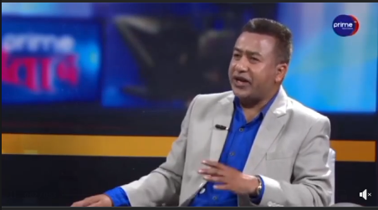

| **SN** | **LINKS** |
| --- | --- |
|  | *https://www.facebook.com/share/v/sGm7enBLiqreZAYC/?mibextid=oFDknk* |
|  | *https://www.facebook.com/share/v/PFHF3eH1V2JzoU33/?mibextid=oFDknk* |
|  | *https://www.facebook.com/share/v/XaKSRfFh6qu7jNTE/?mibextid=oFDknk* |
|  | *https://www.facebook.com/share/v/k6sMJjX7LmS9MwQ6/?mibextid=oFDknk* |
|  | *https://twitter.com/CartofNews1/status/1767422116255957038* |

**Seven political parties have announced their vote against Prime Minister Prachanda.**

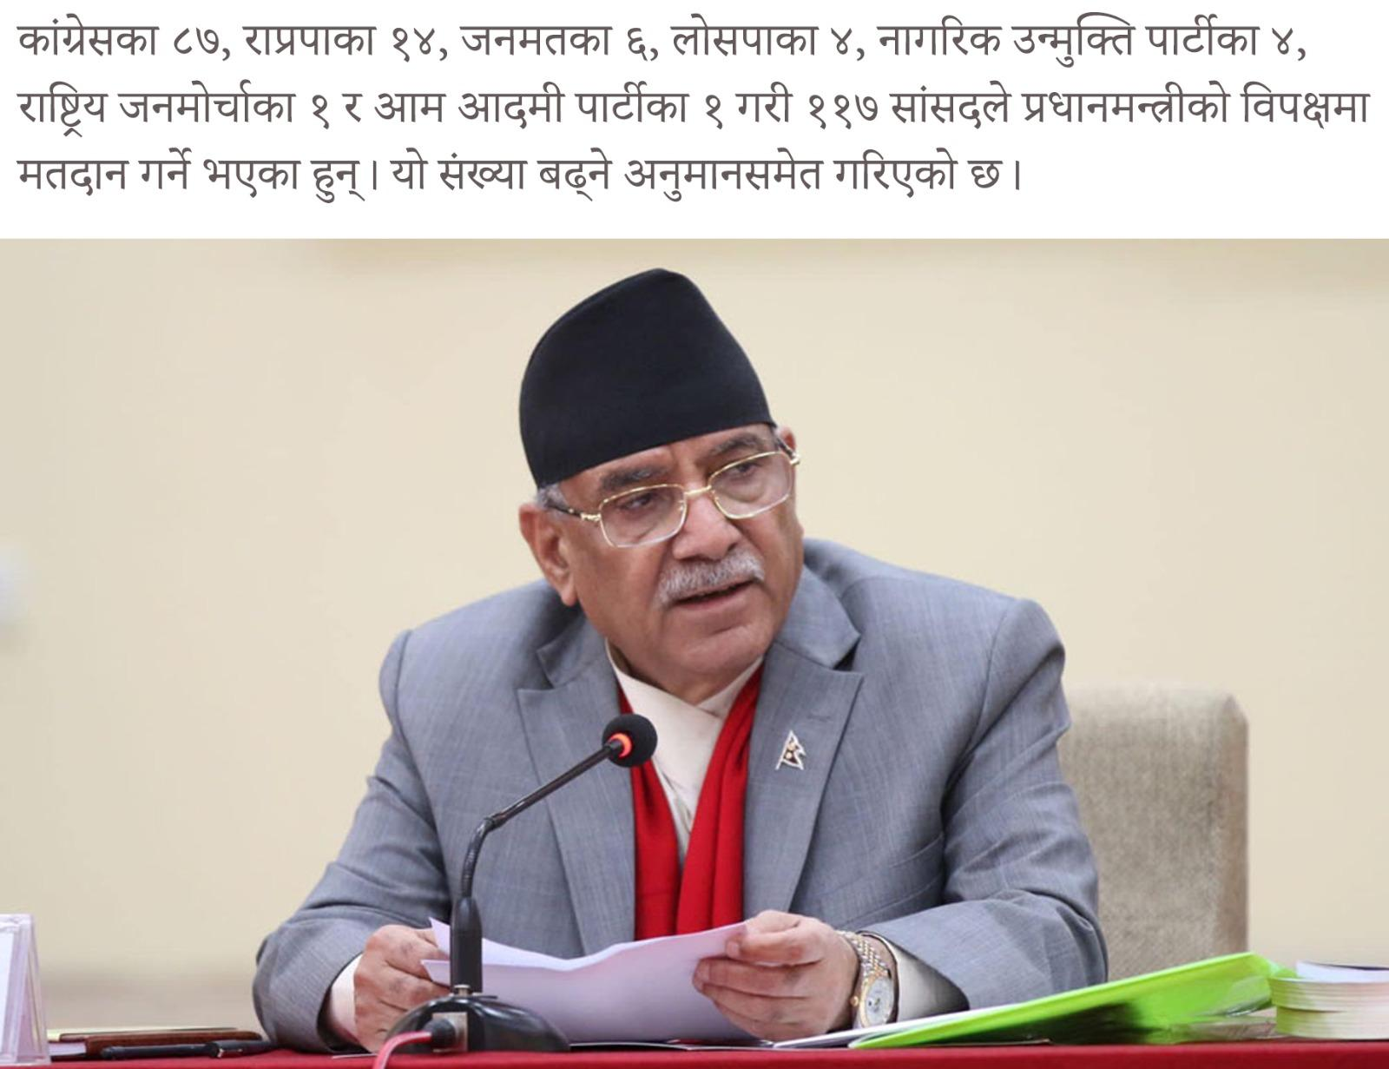

| **SN** | **LINKS** |
| --- | --- |
|  | *https://www.facebook.com/ratorachandrasurya0/posts/pfbid0ybxZfEwcrrJCFS84qWhGqRbFYhtvGT9oPhHDX7w8xDJhSWod8vwG5LWzzKr8XSfSl?__cft__[0]=AZWzcIjgVdJ9SHLbfnGkmxrSVV5Nd0_Zz93CBZwzrE3ujJsHU3LbouCyKa43k89VhPQiGi-NRgpw_ZnHbx7kQHeWHPtcJ4_TK-KZJeHjDURyT2RvASgsQW2rRmUrspe7wto&__tn__=%2CO%2CP-R* |
|  | *https://www.facebook.com/share/p/RJsCNCqNig6xwivd/?mibextid=oFDknk* |
|  | *https://www.facebook.com/share/p/SeJFyHku76CqJLSe/?mibextid=oFDknk* |
|  | *https://www.facebook.com/share/p/ZZjCcFdpnM4c1B59/?mibextid=oFDknk* |
|  | *https://twitter.com/CartofNews1/status/1767394980299931984?t=p5v0vciH9izeR123m-hrxg&s=19* |

**Prachanda's support is decreasing, a strong alliance is formed so as not to get a vote of confidence**

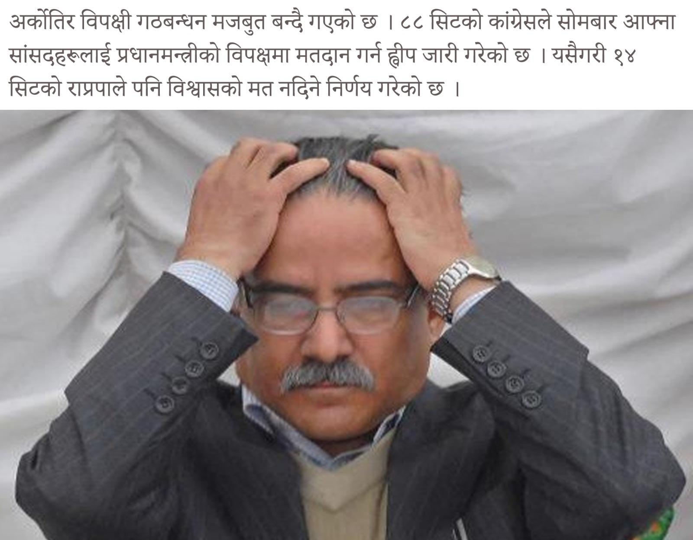

|  | *https://www.facebook.com/ratorachandrasurya0/posts/pfbid0ZsBPr2iahjXdmYcWzsb5yPEUwJmrRkitD56UVp3Gj17mom8QRyGZXNeHVfs9y3Pl?__cft__[0]=AZUPjHmYAjzP6GKPXE_dh2Ppcfch1k0s5pkBPwNMKnvCZ-x972ZiFG1v0mLIHidBl8ZtQc_vB121PDLm9RtBEWpAYFsdJRRhtm1hYxVkZrj8_0YdK_xOwf-XNtEZM_MwL6Y&__tn__=%2CO%2CP-R* |
| --- | --- |
|  | *https://twitter.com/CartofNews1/status/1767395417799659715?t=_zefpOrofUhM0-HGWMoBTw&s=19* |
|  | *https://www.facebook.com/share/p/uhHFXgKbuLZ1hzU3/?mibextid=oFDknk* |
|  | *https://www.facebook.com/share/p/QdWYHFTcx6oBrCWR/?mibextid=oFDknk* |
|  | *https://www.facebook.com/share/p/whuvhs6WWtc6yCRE/?mibextid=oFDknk* |

**118 MPs against Prachanda, the government will collapse anytime**

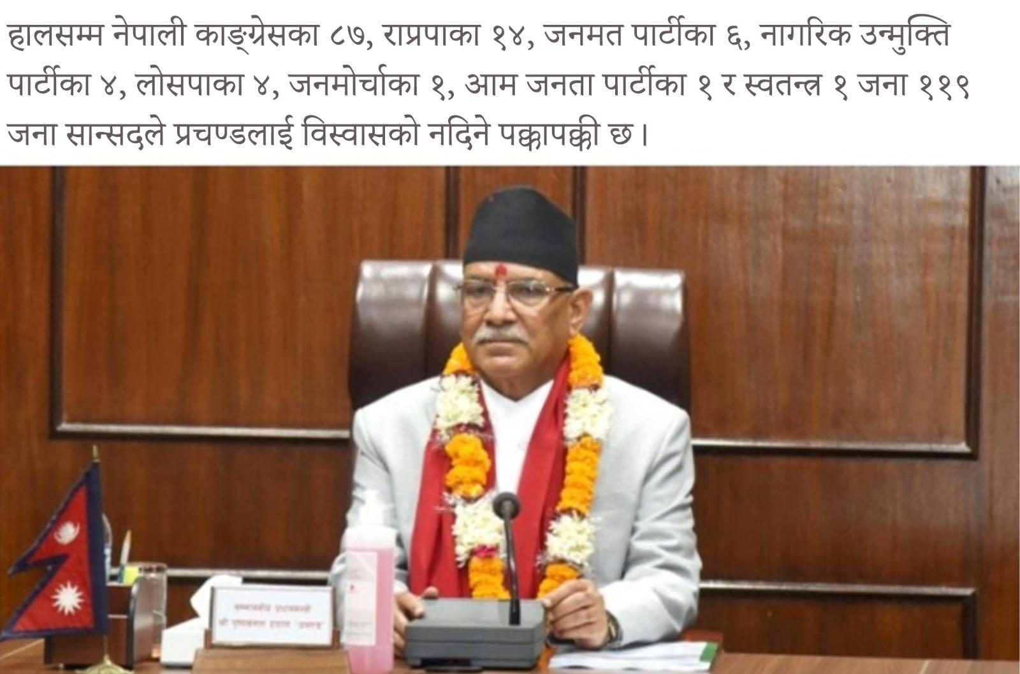

|  | *https://www.facebook.com/ratorachandrasurya0/posts/pfbid02HDHrDMaq8dgPZxWZuwAJkXMBHzRWMNaFv2bVFyiykd5a1N3aFxoWWmCYhRPRZ6xGl?__cft__[0]=AZV2Dc8hfiQbsdEXaUPvr_88YeG9fvdOFpiRnSYIgDud3MkfCjrgyNsmG9GyM5_L2BkwHp0Le5g6evvgz14AkWgLXyJTfli7Xo5gfzElpPiKIWMMNZuikwUW5eCmbSrXI2o&__tn__=%2CO%2CP-R* |
| --- | --- |
|  | *https://www.facebook.com/share/p/Vvp87FEvFNL86Ms9/?mibextid=oFDknk* |
|  | *https://www.facebook.com/share/p/JpB3pi4WcexnVE3s/?mibextid=oFDknk* |
|  | *https://www.facebook.com/share/p/wpxnkeYQCQ8LNjYh/?mibextid=oFDknk* |
|  | *https://twitter.com/CartofNews1/status/1767396170366951605?t=6KqDvDE04iX-Ant5LCEx6Q&s=19* |

**Question of Congress in Parliament: How will the demands of cooperative victims be fulfilled when the accused of cooperative fraud becomes the home minister?**

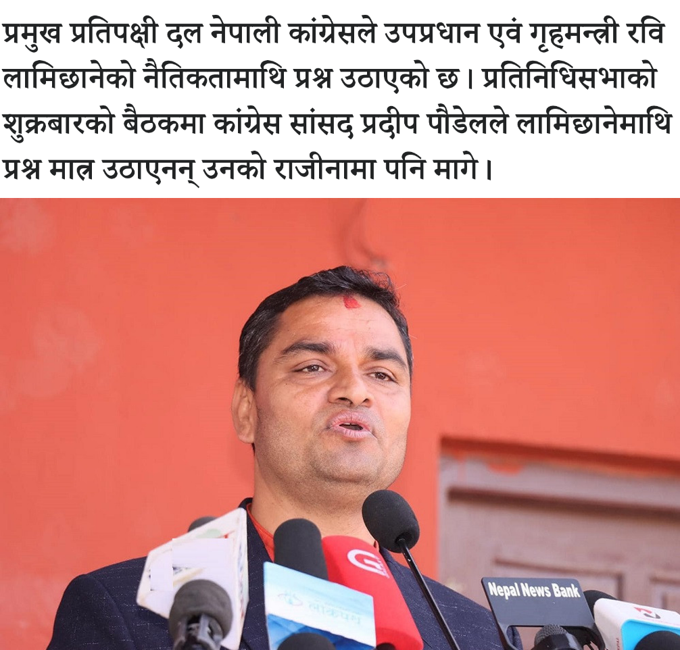

| **SN** | **LINKS** |
| --- | --- |
|  | [*https://www.facebook.com/share/p/rfDqTs2MptYU58wa/?mibextid=Nif5oz*](https://www.facebook.com/share/p/rfDqTs2MptYU58wa/?mibextid=Nif5oz) |
|  | [*https://www.facebook.com/groups/NepaliOnlineNewss/posts/2653732148143684/?__cft__[0]=AZXbc111TqgiUv4opNXpeqJGOOxXIXinn-5489vsADK2vTE4aejfTrWFlUs0vBLQta3yfe6W4UKQIqMkRFf3et9VBxgWC_wDWvo_yROmBc1eYigRYBwXVM0iRaUlDesYmA1gaWgfTi5_3mfVu6L8FkCy&__tn__=%2CO%2CP-R*](https://www.facebook.com/groups/NepaliOnlineNewss/posts/2653732148143684/?__cft__%5b0%5d=AZXbc111TqgiUv4opNXpeqJGOOxXIXinn-5489vsADK2vTE4aejfTrWFlUs0vBLQta3yfe6W4UKQIqMkRFf3et9VBxgWC_wDWvo_yROmBc1eYigRYBwXVM0iRaUlDesYmA1gaWgfTi5_3mfVu6L8FkCy&__tn__=%2CO%2CP-R) |
|  | [*https://www.facebook.com/groups/ssnepal/posts/7889882877774111/?__cft__[0]=AZVyxaWVFbT4bJFd2x9WDdpsSOLhbvEPKjWVCcw476wRIQM2cy4awjTPV9putcAhpkkNn_1fi7bW_vZ5vQKAPOByMDW677iBGenx6UzAWlPYrfshy354Y9ZeGpjEG4FnePBfMsJlu4AmSIKuNsHMvimr&__tn__=%2CO%2CP-R*](https://www.facebook.com/groups/ssnepal/posts/7889882877774111/?__cft__%5b0%5d=AZVyxaWVFbT4bJFd2x9WDdpsSOLhbvEPKjWVCcw476wRIQM2cy4awjTPV9putcAhpkkNn_1fi7bW_vZ5vQKAPOByMDW677iBGenx6UzAWlPYrfshy354Y9ZeGpjEG4FnePBfMsJlu4AmSIKuNsHMvimr&__tn__=%2CO%2CP-R) |
|  | [*https://www.facebook.com/groups/1074192292722252/posts/2984230601718402/?__cft__[0]=AZXU3E7RReOdwcmK3nZ5camE1vaNB5OuV-cgGn6czKMQ07vkzMai64EuOQvDkY11Pc99WXk4nSQqnsYF8nOHiMu_xi18HlJL3PSTZK65hNRho3Rb85LxDIYSvVEcPPhZF96nxw3dh0XASOBAsJyuKHHq&__tn__=%2CO%2CP-R*](https://www.facebook.com/groups/1074192292722252/posts/2984230601718402/?__cft__%5b0%5d=AZXU3E7RReOdwcmK3nZ5camE1vaNB5OuV-cgGn6czKMQ07vkzMai64EuOQvDkY11Pc99WXk4nSQqnsYF8nOHiMu_xi18HlJL3PSTZK65hNRho3Rb85LxDIYSvVEcPPhZF96nxw3dh0XASOBAsJyuKHHq&__tn__=%2CO%2CP-R) |
|  | [*https://x.com/CartofNews1/status/1768563459501728006?s=20*](https://x.com/CartofNews1/status/1768563459501728006?s=20) |

**Pokhara airport will not suffer the same fate as Hambantota port in Sri Lanka?**  
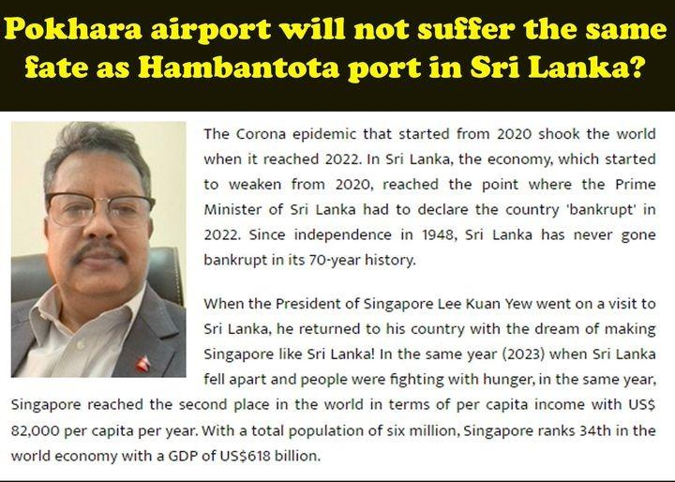

| **SN** | **LINKS** |
| --- | --- |
|  | *https://www.facebook.com/ratorachandrasurya0/posts/pfbid032NPvEmQACQ46aRnyxnQSdkr6YBNgmG7hX522y7CvrFoxvoFMKZLRNTyuiCuYgLjvl?__cft__[0]=AZVsh818ycW7BX2rt9sceUNyNfSsPwro1RXdgsD2yZROMb01o5cmbEFPbDK4Tzo-dlEtPvii5sM17f1lkn9kZPrpdl94U0ys7sdoTq1NTGSeqqP0bsmli0RnVOpAipwQ21A&__tn__=%2CO%2CP-R* |
|  | *https://www.facebook.com/nepolitics0/posts/pfbid02Shifh4jpwxAQrwD2A5mMJRipJC2QbZzaJNXY4KwB8fQyaNwY6gnw7PUgxyfZJxJml?__cft__[0]=AZXOawlQDa78Ld-5RJCgoH3NwCCwzBRslzznCfN-tUJTzrsw371nKClZqeel7khgEsU6adhILIgXqsJMSx9FBoK0CH_s0dr7tbwHlQ5YyJ3pjGbG31uZ-IIBuFyQ5hZQk94&__tn__=%2CO%2CP-R* |
|  | *https://www.facebook.com/groups/1074192292722252/posts/2992884954186300/?__cft__[0]=AZUywYQo-iUSQVzPcYn9LwmHqoj17u0j-uk0ZrAX0Ib3Ig3KgPyTnCQqnJ38fe2bd84-Z_lPDf1EfveOw6UgMMk5ZiBLEtieLQKEGGRKbt7rUIBxilod8S9967HuKVaScxa61u09DAH28mgrrOFGdMEe&__tn__=%2CO%2CP-R* |
|  | *https://www.facebook.com/groups/ssnepal/posts/7935692946526437/?__cft__[0]=AZVtiLyGqCzV4hWG8fGrma-eUsIXPL5v-rcEI2QJiLaWNBZPrTKxbImPZ7YkoboeScPZv3xqydfMxWzLnQn-gmm6jGhIAYUOc8lXJ_joUYzkYEbV642xv1Ni_D_ynQX6osyOKEyZIUrPqvtJ5b039Lw9&__tn__=%2CO%2CP-R* |
|  | *https://www.facebook.com/groups/NepaliOnlineNewss/posts/2661921103991455/?__cft__[0]=AZWpq2yQ2gcJSv9zy_F-jl7szDRr99Kj2NW3z21O-F4kS7Qg6J1YXAZmHl0MnIDPOSTEsMPj4uQ8f8rruZTLFjjQFjrHtkNlIt1GHO87Fxh_2s4bqb6ULfBl_hWdWwgMsnbvJrx4GaV6K31F1S49nYll&__tn__=%2CO%2CP-R* |
|  | *https://x.com/CartofNews1/status/1773011092207223194?s=20* |

**Why do politicians in Nepal lie?  
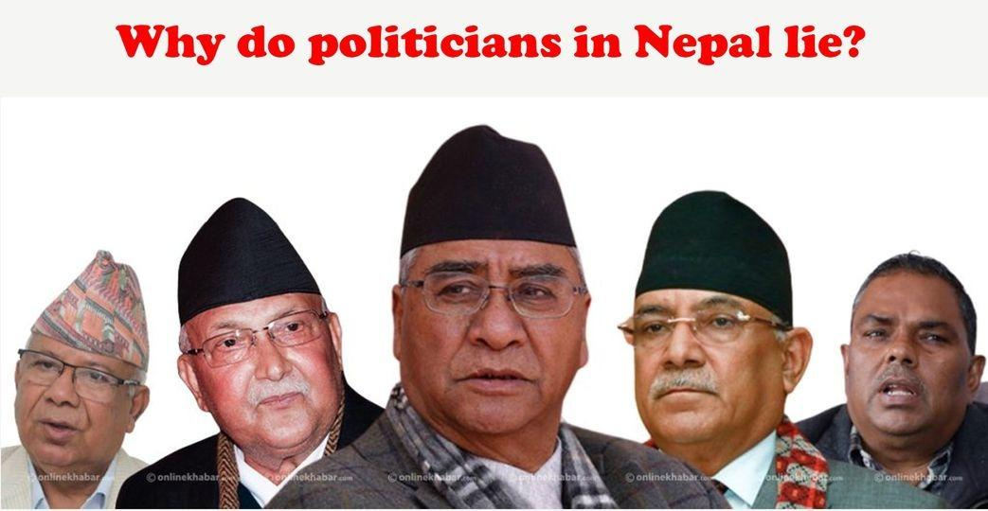**

| **SN** | **LINKS** |
| --- | --- |
|  | *https://www.facebook.com/ratorachandrasurya0/posts/pfbid0RYmsW3z9Hm9KkBTDx4jLzAax1gfPsQAe7rvP5rRb2mjy3SHdtDujdjAZCz5gZAVWl?__cft__[0]=AZVzaX7TqKQDtdWwCfZeRCHnZY4W1-oW5kFf4zMWiXKBYQMT-VOP_u7qnCOPy-PbyI8KJAAR5EBCkFMYHYgiEisyQmaLPeDAhMy__9JXna6FmhGXqqRGkXvvsgxb1VfU1S4&__tn__=%2CO%2CP-R* |
|  | *https://www.facebook.com/nepolitics0/posts/pfbid02tYGq9WHHev1oHLMY3fydpWJMUfw7VThPqBrmYmNb7CYogGQaqRshQmoegQ6J8DHl?__cft__[0]=AZWYY-GUBvwcKOG5-kktllxZcsofe2693MCFWFpdF_Me1bbAD3_7wyXMjHZPex_AHo9MBm6tJec6ALqoQjIlqFUBaZ-o1ZY8GaCJceT37htcodEZUtHKhDZsTUJWrgs08C4&__tn__=%2CO%2CP-R* |
|  | *https://www.facebook.com/groups/1074192292722252/posts/2992885114186284/?__cft__[0]=AZUkc5wIrgir0tdSqwOxVWQ6LNgZMfyaTk8LlxAlGKpuC4zxCZXsO_gldWsNJlVSdAqiNAHeThYWo2AbnBmxjbaQkoYYsqXWv8eLVur_GO66LqrkFqZgM2_QOuBcQPgtsac4JsVAEu2QRg9zylfecIwZ&__tn__=%2CO%2CP-R* |
|  | *https://www.facebook.com/groups/ssnepal/posts/7935694039859661/?__cft__[0]=AZUA_w6W3XbxgajeJHgUJPW5Ih8nYP6t7MuzoJ6bKhBk6--xrsNQkFFxDCZvHLM4QAWXyx5HLD7LNMQSqwlBm-OHZiIg2D0VF5V1VOpuZllFbLhBexOI-bqQ0uXMp7o9iG9a01fxvw5O1o1j1UU51mbp&__tn__=%2CO%2CP-R* |
|  | *https://www.facebook.com/groups/NepaliOnlineNewss/posts/2661921997324699/?__cft__[0]=AZUDxSJfhhlgbjQtvMC88jPR_cTxLVW5_3HYoub89_tmDq2eaa5H66YU1JUIWDPfv6dw6Sj5er-axD9adUuqmEZbJkhxEwrGZ6h9yjXvFLw8xQWdz0K72ML-GOTmhrfF1BUakWSNh0bUyJK1q2AkNyN3&__tn__=%2CO%2CP-R* |
|  | *https://twitter.com/CartofNews1/status/1773011249334223047* |

NC will come out clean from the current power tussle by being out of new coalition, and it may save its crucial vote bank (around 32-34%) to remain relevant in Nepali politics. It may of course now face harassment by Maoists and Communists to tarnish its image.

| **SN** | **LINKS** |
| --- | --- |
|  | *https://www.facebook.com/ratorachandrasurya0/posts/pfbid02Mcd6uVEc9ELNwzYEdarwpyxNX49yMVCun5HXz4CRvAEp1xRQurEaaUtCmVzFBEXyl?__cft__[0]=AZX3i010rMQRTaMI4gra0oH3d5HjD14ZTI41amOW5uPnKMvfXhPByS3zAGzYI0L1PWziqkMFXGgp9vqSBNMNRD1kkI7BEkQq2ib8ySEVZEMTaZN1w78s6TEqmoGVzdb2KU4NOuFC9yfnz65gRTz01ofTUovv7GMuaPt1GyXpMQTJxDhjAzEZhhrQzvv-OkGTcew&__tn__=%2CO%2CP-R* |
|  | *https://www.facebook.com/groups/1074192292722252/posts/2979850912156371/?__cft__[0]=AZXWfVqxbWL5oA6aTgS_w1dW4DGzm3nPZHlH_UgqJl2N8wH5J4QW0FZ7PAdmPtwFGZyQB2M3Z_khGAB7mHbJHHWcff7opxGqwPt4xzHBkjV4JiVrm_l5f2jGs5RY-4fQCkfxnDKuPmmIzOPyW0piLFIf&__tn__=%2CO%2CP-R* |
|  | *https://www.facebook.com/groups/NepaliOnlineNewss/posts/2649523475231218/?__cft__[0]=AZW7WBJAWx_ja_P5Z8Id9Nv3jMXLYwd7fV65RvksHuCv7yHHFAFjubfZu746PYvmodM8MQj_5lIzhkvgCuQTvJyy8fu2oLX5Zr7LqqEC1ybvSMHvzDpIeAv-Kl5RlDCmDoECluth3-pchb2CRFbhbRUW&__tn__=%2CO%2CP-R* |
|  | *https://www.facebook.com/groups/1508371462782588/posts/3915967782022932/?__cft__[0]=AZX9MChjeiOjsWq2y8550X6Gn_ikzQV_mrrQoiisJskoTw0o2T1VFYTyM8pijcq73lJChgCWjmOI1XCIy2d0gkQBKJfg7VN7tM3S8k8CkL8YxSVvVuR3_3-H_KofiC3jlTkxkwR44SOxxknui-wEWJGDwuH2Tz5i_XciPa19HbX2uQ&__tn__=%2CO%2CP-R* |
|  | *https://twitter.com/surya_rato/status/1766035711558303959?t=PziryLLrphGqx5CGVfQ-Iw&s=19* |

K.P. Oli and Prachanda intend to defame RSP and its President Rabi Lamichhane by dragging Rabi Lamichhane into dirty power politics. In 2022 elections, RSP had wrested seats from CPN (UML) and Maoists. Hence, both Oli and Prachanda are wary of the fact that if RSP contests the next election without being a part of the government, RSP would damage both further and emerge as the single largest Party. On past occasions, K.P.Oli has mentioned that new Parties like RSP have no future. Such statements of Oli show his fear of growing popularity of RSP. Hence, both leaders of old corrupt establishment are working in tandem by dragging RSP down in swamp of their corruption.

|  | *https://www.facebook.com/ratorachandrasurya0/posts/pfbid029cxMsjDLGWV1gJ6VRFAcZRzxmDKckV9k5otEhdKZWHoMKYDaCKSchQVtz2RoEk7ml?__cft__[0]=AZXoPJPj6wk1N3umtcDn_7iNY9qDGbp3D2qQpIBN68jKctAnQzaqc_tyLuaukwEyalAv9Q7dgfJihjP5PZS1dIyXzFPmKDnFKT52Zem0quK44aL3_sy67blbHLJICrE97urmFzbXR5QwzzjMkULyjdR4tvSuJJqOGN0ucRN77xO8BAYaoC35YDeJsgfePV4sZtw&__tn__=%2CO%2CP-R* |
| --- | --- |
|  | *https://www.facebook.com/groups/1074192292722252/posts/2979850805489715/?__cft__[0]=AZW6Z2skBudNnjZ5mDwPhGu_4Ogi8pKuRIDdPODRRo_rfz63gSktyMJR9xrpFABgO7OYYfdOXBRR309CUQ1okeir2sBIQle6Lxd0OtiGOs-VK0WFNbi_P1UBWWbCgW1JzcXMmHso268XW4cwVoSCaPJt&__tn__=%2CO%2CP-R* |
|  | *https://www.facebook.com/groups/NepaliOnlineNewss/posts/2649523315231234/?__cft__[0]=AZUBhx51J_j0Jzq0ADX4xRF4oun9AR1me4hD0zIPI_csAup1AJN1VPnaTBjZKab9cXNtQGvGg5vkup1AQupxiNJyt7rNaUhv-SYvUBJaceFd-RQphzkBUQmFHsPpHUTNCPvN1yMRGFwoHBULq1nku5En&__tn__=%2CO%2CP-R* |
|  | *https://www.facebook.com/groups/1508371462782588/posts/3915967592022951/?__cft__[0]=AZUSsjCJMhmMiM5t1jGI1mKdpRdRamZZLDQJUTBAjzmvRq8DEgwHL3I9DbxDH5fRaiwvreBE45ljPwjqqvA6Ukj37OdcZyAVDOA3F8tCRuzUyLOr4_UeJXhUglGFEhwD12L45JoWEE_CnqxUjcme70DeDCoeb_5Lvagf3Vriga5aVg&__tn__=%2CO%2CP-R* |
|  | *https://twitter.com/Sitalama88/status/1766142106010038655?t=2wm363dFDwv3fswCo81vCA&s=19* |

RSP leadership should also remember that Prachanda wants to launder his and his close comrades' wrong doings, corruption and violence against helpless civilians through Transitional Justice Bill. Once RSP supports it, it will also colour own hands in the blood of innocents.

|  | *https://www.facebook.com/ratorachandrasurya0/posts/pfbid02R8r2kUbACDeDZMpyYNxP1o49s71MYR6DhwRCrvQnRbDq456L99mc9mpJHmLZfAJEl?__cft__[0]=AZVl3AyLaMSbqPCMfo9VpIQ8soa1GwG_RdzGI-ctWYX2Dhs3BM5vpDptMcNeDFVGNZu6APRpF6pQHXSiUAF6oVsaAfCftVyUM8qaxREBmi325LHVJnzeM_qNxP49iqZlkDG0HxzpzdOl8W1fshhi8rP4_9IFxaKoY1xYQ9VSITPBlqQrB384osf1UdybdOumPms&__tn__=%2CO%2CP-R* |
| --- | --- |
|  | *https://www.facebook.com/groups/1074192292722252/posts/2979140008894128/?__cft__[0]=AZXMCQiMMZ4yFn50Qouh7VzKq-Oy1rpVhIi1OBWYP9hzczar0RL00RqHSP1C-ZJtT9qf8oDW20ruKXrNNcSBJda9jW_GeWHYUKOfqMeTZTLnJCAqxthokOkPT2c5NZ0EhGHxvJ5bPih7gL3xJfJDPqkz&__tn__=%2CO%2CP-R* |
|  | *https://www.facebook.com/groups/NepaliOnlineNewss/posts/2648816391968593/?__cft__[0]=AZUt6rgxTb-w7QNuCmSSOnuVe8oL1bI8uO__ZbP8h_jxRbXbQ9nAEZXrITm2qPV9kH7WnW60CpW9Ulk26ekV9lG5wjwbVTM72xuy8QMxAtNAGZX5I02q1gOgJg0DLpoFifi-_evMIvhYJplmBLK6m84e&__tn__=%2CO%2CP-R* |
|  | *https://www.facebook.com/groups/1508371462782588/posts/3915279102091800/?__cft__[0]=AZUMbg_wLQpmxOiTj7gFM7ua_hXlft4LJ1HXIIR19iO7p0vHRc7jYQUoLOclG_OarBmTST7Xil-TwKXLqyNQ5i02WYWjbpUFls9nWIqDTm3yyQ5VrZuD9F7Bg4AOHfFxjWKaoN1usAn-il_hRDvIo5b-eVbPT1U64tK-eWe8rs-HTA&__tn__=%2CO%2CP-R* |
|  | *https://twitter.com/surya_rato/status/1765723056230764929?t=vICbvpEBNfs9QWetYmnwHA&s=19* |

Joining by RSP of the new opportunist government will project RSP as compromised/power hungry Party and it would lose people's trust. This would invariably diminish support for RSP in the next elections.

|  | *https://www.facebook.com/ratorachandrasurya0/posts/pfbid0svFZESqckf251moKxZJoTmviDAozBH5j3LHtUYKUAg7s62r51qmfKDz4XKtqJepSl?__cft__[0]=AZVAwuk48Ho7gZFw61ef8PIB_zDS7mZpS2TKtrcNvNbO7jhahLRCkNPpyFtXw4qM9nic1_hCaPwpBy9DBIKJOYgfXILm74JWDnJ-zvxdnrWJZIq6J7cr5g6hJZR23uQpGbYP37KouyVxL4nooJfOnX-YMRT-aGJO7pBKLD5I_UqmNg7pEBT8wwAIqAc0D-eIPYk&__tn__=%2CO%2CP-R* |
| --- | --- |
|  | *https://www.facebook.com/groups/1074192292722252/posts/2979136952227767/?__cft__[0]=AZWWwuf2ihzeUxH3hnPQPfZlUc3DiNQ2bsnHvHyron7_pEH73ELpXd2F1Wy-k9KnLgrEdL9Xp1yK9LYJW8jbfxvT3-Ix2fiMNw8rprl1lGgadfD3dvIA_GawPDwyRDeWRn7v-wK646xNIC9Vt_SkaZbq&__tn__=%2CO%2CP-R* |
|  | *https://www.facebook.com/groups/NepaliOnlineNewss/posts/2648813681968864/?__cft__[0]=AZXfSwy9E50zA5OaJYI0DhwgkC7IAOjoy44Vv8m6-W386Q5lC5n5g4kuFChXS1OLQWLnYB0sXygCIU9r25ftkDydH2MpQkvxI42DLlDfAIIfjOuNSi2H5zZY8m4SMz_fBopSYPdwYskMy5zNBNYu1UBg&__tn__=%2CO%2CP-R* |
|  | *https://www.facebook.com/groups/1508371462782588/posts/3915279168758460/?__cft__[0]=AZWwtZ7wTWX-1sfPw3yqiHvYrXY0i8vVGYvGAevvdxwU84H2A1I7DnnI_Y8t7cIMdcXPvBie1b768vwTmm_I3KrWcYJ0funwljyVc_D2gIL7Pp1PPsy7T0cxKxI5qfMt1V-dKmAA4CfJwpGpT2M3ogKa2bVvFcCZvBivyc7lEv8O_g&__tn__=%2CO%2CP-R* |
|  | *https://twitter.com/Sitalama88/status/1766417490543071671?t=KKUnX6EFvDD6RUGY80lJwA&s=19* |

As the new emerging grass-roots level democratic force, RSP should focus on increasing its organizational base by giving a message to the common masses that it is ideology-driven and not power-hungry. It should also buttress its democratic credentials by supporting similar parties, instead of being entrapped by left-wing parties.

|  | *https://www.facebook.com/ratorachandrasurya0/posts/pfbid0318xk11xGrLH455gwx3bpvEUfPFaeGAhWxAUbN7VsN2RByhJ9EnUfFe9cH15E5SdJl?__cft__[0]=AZWKk1oWz_ZXKawfIeCEYuBjINxkjDEcE5TzV8w4kHbyR0bNvrGMVdeNAt2C1u-g-nLK-ZVJd1n7RdBBGocLS3BkR0f6CLzG1AUhlsrCQkuPAnzA3vzNEt3ys2wfMXhSoAxMZpiZKjNOeNzn1jij2cXtW6UnlVUIRiUWiuP2ES3gR6rwjVcU4w4eZ2ABVVtk8i8&__tn__=%2CO%2CP-R* |
| --- | --- |
|  | *https://www.facebook.com/share/p/ZGTkY8GA8d7xm7B9/?mibextid=oFDknk* |
|  | *https://www.facebook.com/share/p/SrNfJiYWKqQPfv69/?mibextid=oFDknk* |
|  | *https://www.facebook.com/share/p/SC7P3A6i6BFNpc7s/?mibextid=oFDknk* |
|  | *https://twitter.com/CartofNews1/status/1766429687906181311?t=pCjyLPT0U8KfYOBE6Ox-ag&s=19* |

"Amid allegations surrounding him and his RSP affiliation, Home Minister Ravi Lamichhane strategically shifts focus to governance reforms. Prioritizing redistribution of government land in 77 districts, he aims to steer away from the cooperative scam scandal. Stay updated. #RSP #GovernanceReform #LandRedistribution"

|  | *https://www.facebook.com/ratorachandrasurya0/posts/pfbid02BL7n2WsbPRWsNM6kt49o8qJMbWxq2qCxumRAuNTBVCmotD6JZRUpTMMXYDLB4Phul?__cft__[0]=AZXC2yEfVWUrol30VUpQ6GtlK_oKBhKruml3tiALohaBbNZPnLE-ZiZJIUIFQ9ZEDDc_JBEXNluyfwOj2fQRLRB_tQLmnbedzBowIDRb8k_VZDDKFPioL8gDSP4Bwk2nhm4&__tn__=%2CO%2CP-R* |
| --- | --- |
|  | *https://www.facebook.com/share/p/auLgHZra8zbc2ZxR/?mibextid=oFDknk* |
|  | *https://www.facebook.com/share/p/54Y9fBjtf8S4e3CX/?mibextid=oFDknk* |
|  | *https://www.facebook.com/share/p/JmCW3CkYMQL2vk69/?mibextid=oFDknk* |
|  | *https://twitter.com/surya_rato/status/1766430572841472077?t=5CjyFmTNCoJ-edgc6ssphQ&s=19* |

CPN (MC) and CPN (UML) have always criticised RPP holding it as a regressive force, while projecting themselves as progressive Parties. RPP should seek clarification from both Maoists and UML on the issue of support for Hindu religion.

| **SN** | **LINKS** |
| --- | --- |
|  | *https://www.facebook.com/ratorachandrasurya0/posts/pfbid02f8VhkhnBqMpsJmaNghRmoAVCWAUnbJxNSre2StjYpBtDugt6x1NisZiAL2hgMpkzl?__cft__[0]=AZXEg0ZjQ0Yh021zq-hoZWHPSQUm_Uq1dKTDLxeihDAA1OJyOSvW2V7Onf-WxTkQZ9tzfE_rNinEmqgHpqPeeMVayngZ_-t2fUvMnohHgG_cuo12FBSloYibBOcURch-mh5gPsFAo_STP2uHEyP5NbFGri49THrnR9BJyIbJmzshOChrPVwe8gAwIZkG5O4auFg&__tn__=%2CO%2CP-R* |
|  | *https://www.facebook.com/groups/1074192292722252/permalink/2979136518894477/* |
|  | *https://www.facebook.com/groups/NepaliOnlineNewss/posts/2648813408635558/?__cft__[0]=AZXMMQnYfEF-NMdhyzakl-j_WrTZGEgz2kamcCa83wK5Eac5TeXtDT_oxPnC8Vbid30ZV5OHizy0mMlB9dp81ZXupyvqOdWkTNF80LtcLqIBLGXhBsOU2VuvX1JA2SjkavlvDC-Bts22Vv4ppza93GBB&__tn__=%2CO%2CP-R* |
|  | *https://www.facebook.com/share/p/cFST88ZMpv8iCRYm/?mibextid=oFDknk* |
|  | *https://twitter.com/surya_rato/status/1766414296467361804?t=G1K-rCEvd6HZBESMBn6D1Q&s=19* |

Around 40% cadres/leaders of NC have favoured the agenda of Hindu Rashtra being supported by RPP. Thus, RPP is closer ideologically to NC, than to communists.

|  | *https://www.facebook.com/ratorachandrasurya0/posts/pfbid029z99GaMQh9DHaRU9PY29EZfC5w3yEzhkWLJBDHGuwYF19JUbbB4xsT3sJrMjFoV1l?__cft__[0]=AZV3l5OKHutpeJ7H1EEjoBLnoT-yDmP7W7MS5XBnm_t4Vlp6esy_nAxZr2zJMPkEaQBEDTmBTQ32x9s658ytkI14GTDe_ZIThreLxtItZjJ63B9YG6MM953-DEGdLYvsWXQnDk6mvaCEtrCS6UVQ8QKQe8DyEfEeZ0mXEjusBAM6L5ZXTXBATABwbejCGmKPQCs&__tn__=%2CO%2CP-R* |
| --- | --- |
|  | *https://www.facebook.com/groups/1074192292722252/posts/2979136852227777/?__cft__[0]=AZWcgI1NVQv7VOnOTDSHSh72gLBFOTKdrlMsYcte-J771tk1AVQ6JOT4jSu2pb1BaQPNoZSsHJEoNsimiq6VBm9ESmFZX-SEJxJ795E7xYtB_F3tL_tK0J4V7m1H2BfR4V8G5Pxw0Hxd1HE5XNP5JbIP&__tn__=%2CO%2CP-R* |
|  | *https://www.facebook.com/groups/NepaliOnlineNewss/posts/2648813511968881/?__cft__[0]=AZU421G2Ej5k2QJLCHRcKkscvo-pLoKidy55p4mRrAj6HZsacPxOSAsX2OI337ToefFFvA1jWbmguNeG5_RTpDb6rCWxbFdlRjMZL6NFIv1R1obWIJeS8I_L0mdM2Czy6oGrqua6-3cQxwMT5kts172-&__tn__=%2CO%2CP-R* |
|  | *https://www.facebook.com/groups/1508371462782588/posts/3915279065425137/?__cft__[0]=AZW2fgLTZEZXmLkXq73Row24TTk_xYvq-z2hdQqqXuK7buzvTSKvEHFuKDGa-UfZwemxpsipKs-H9RD6BYWvwmlp7kWv5ERtyZxzQv5lbr80QgGRXPFpmQP3J4NcY5aZTdjiDihyNstUsbmPIE3NS_sh_nPwhwLlIyftYV8YfclmAQ&__tn__=%2CO%2CP-R* |
|  | *https://twitter.com/CartofNews1/status/1765693061584068787?t=t7m7la7lZIpQTztDcerj2Q&s=19* |

If RPP moves ahead with its core agenda of Hindu Rashtra, it will certainly increase its seats in the next elections. However, if RPP reconciles with anti-Hindu Maoists/UML, it would be seen as power hungry Party, which exploits Hindu sentiments to gain power.

|  | *https://www.facebook.com/ratorachandrasurya0/posts/pfbid0vag7xFg3JgY9M63GGbn8ECs2RjvuHkKSg54g5jyxwvNi8oQp3GoUaapQr33d9gyLl?__cft__[0]=AZXPAuCpUDzw8DrRFr7T6fVYjlFwvffv2F5-u_iJ9gilyXIDf4kMnmKbBmIgCT1Sk48vijLdZmNPcJNu4t32zSwD2reeVeT1QoMmbWTMlq5VU0JK97PfKx3w7bwWKNuiYSOkODjNRJSPW66D4ZewD-3XZ8TEfx33fP-ALzHaKvmpf_WaTYrb6ZIB_72JquVo5V0&__tn__=%2CO%2CP-R* |
| --- | --- |
|  | *https://www.facebook.com/groups/1074192292722252/posts/2979850562156406/?__cft__[0]=AZVe9eN_-BprhB81J-6-eMZ8WEXepLPx69PMCjw-idQj0dCd3U4celRgJyT4KR4Aag-GOKwqT6997W5LiIZv1v4lDFlfWleZQ599glvLny2AWBpn0ejCU-RlfLaebWb9jgIOhG2EHcyq4iHw0kC6f3Tz&__tn__=%2CO%2CP-R* |
|  | *https://www.facebook.com/groups/NepaliOnlineNewss/posts/2649523051897927/?__cft__[0]=AZU6v8HNDjSVV6CYQI8MBvRjWLRqOxbpBzlmyRgnt8SS3D5ab5Iu-ifQ2Z41-_dG2bSjAU3pyBX7fLE4B-lob447uRnC_NTPNqQxep49bP3JyD6paTngmaPX8UwQ36pg08aj9HxK87BbtFJkjpeEOBne&__tn__=%2CO%2CP-R* |
|  | *https://www.facebook.com/groups/1508371462782588/posts/3915965715356472/?__cft__[0]=AZUCUyDiX2VFwR2JZtl7IGi0betIRo0OAH1KU9jS-rvg4h6pmyzKrCu0zvzPaK3gHz7WuuDp_cWvxOob8ZzlYVhLdNNLz12dLNMrJezKJXXuRHxpU8_cvO5TZhiXr1YfUGJtC8atPeG8iIy6XQsJmy7LRbr9-yhaFrxcrXF_XhXYAA&__tn__=%2CO%2CP-R* |
|  | *https://twitter.com/Sitalama88/status/1766141904679235723?t=0MYb0IiC2PhQYIYJnIhrhg&s=19* |

In civil war-era (1996-2006), Maoists cadres attacked Hindu Temples, and killed Pujaris & Sanskrit teachers. How can RPP go with such Party, which has always acted against Sanatan Hindu Sentiment.

|  | *https://www.facebook.com/ratorachandrasurya0/posts/pfbid0ZPQX72NqafD1L8xaMqLqmGGjthESSEJa4aWjxEY5wathk3pdCKFQgLmVUEK6dPCwl?__cft__[0]=AZUMTuXKCmncgco8M6nr12yjzEm_ms8FtHVTwmo80TVn9p_J6tnEJRyo9W4Q1BMzYdQv9MFeGlUQf8odk5u9_TXoHm0bfTvONImMMBEiXLfnfzym3VY37hvmpfNOfeP07DuQKVOUNuI3JCCWN6dxrGZ4szTDYs9LdvZCKBi3cd8hVOQQYzG8BszDVI_yx5dUwv8&__tn__=%2CO%2CP-R* |
| --- | --- |
|  | *https://www.facebook.com/groups/1074192292722252/posts/2979850685489727/?__cft__[0]=AZU7SMuQUPp-DRyv8tjHNAuobsVpTiNqO4YG6zCwB-Y-a7a4f4zSStsbOj99I5nGTuRua2W4zrtYbtRYNuzjofLZMpIw22bkDvnmlusOXrUTpQ-qEWMkgSSdct61VdFOGoARM6oroutzCI07n5LT9aW3&__tn__=%2CO%2CP-R* |
|  | *https://www.facebook.com/groups/NepaliOnlineNewss/posts/2649523181897914/?__cft__[0]=AZWTHWd58qHgRDoYSXoh1xdoCeLBNSr8yXisYgj80h9iRNeMzWK6YqIOO-u8Sp6Eu6OSbzr5ZrQ_ox5YHQhV_EUJcErxeinK3tPtQz6YcJem4-ndm7xlmGeIO9uIovbi-TFcJ5JfMTaIEuSU9bMoyChf&__tn__=%2CO%2CP-R* |
|  | *https://www.facebook.com/groups/1508371462782588/posts/3915965762023134/?__cft__[0]=AZXw5JgCLmqYyEFp-3_d_DBZj_GBdgrY_GUUkdjO0IAYIwcDN1ZzWLLmChh7ezD04SCZMXp126HJeuXhwfuqrAOTt1mGsxNC5U4_B794FpVRBUDye0jG1HfQ13_M1LIsCmZ8OrmZ6bE-9EULKeB7FNHWHSzuslcDNtDOV9-n2wp_EA&__tn__=%2CO%2CP-R* |
|  | *https://twitter.com/Sitalama88/status/1766141991941787665?t=FkhN30Ptdz70wzMH1lQZwQ&s=19* |

Many leaders of Maoists and CPN-UML are being controlled/financed by Christian Missionaries and they are working under the direction of such elements to damage Sanatan Hindu concept in Nepal.

|  | *https://www.facebook.com/ratorachandrasurya0/posts/pfbid0S6erqGAA2C16V4B2EU3WKVNtkN6h8GgV8kKmAXffyAbKt4YRF4XU4KHCarKHrGCzl?__cft__[0]=AZUcnuHmUhrtoaX2Wvg2D58O9qHqAQyfTV9_R_W1rEc97saejZCf-CwBClrfhOJDSCYsrLp9iLdCQgTfwoPjKE-hrg2lRrBsvOClnjfQNuXF-nIREDwqFA2uaX2mVzayr1Cs9eB7Y89q-KSNUYvN9EOwv-uilipAoO00D-kTYXMDT1mWbFhRthiglZaYwXEJb28&__tn__=%2CO%2CP-R* |
| --- | --- |
|  | *https://www.facebook.com/share/p/Qsd9RJBhaYoP3Nrw/?mibextid=oFDknk* |
|  | *https://www.facebook.com/share/p/LHSrtQJDwQrKnqCB/?mibextid=oFDknk* |
|  | *https://www.facebook.com/share/p/UeBtm1CeN4AAbW9f/?mibextid=oFDknk* |
|  | *https://twitter.com/GreenNepal3/status/1766427972138094710?t=qCUIzo3-8VMLvaQOlFivIA&s=19* |

Recently, Maoist Minister of Culture, Sudan Kirati appointed a non- Hindu entity as head of Pashupati Development Trust, which was opposed by RPP leaders.

|  | *https://www.facebook.com/ratorachandrasurya0/posts/pfbid0ywWHSaUsgScdn89HUJ2uUrXEeSxRi1UAugPBnZDGRVZyhCRvEfJtFazQBxxFecixl?__cft__[0]=AZUrxhTLvXVPgv4kXmfWPuLWuuN1nvIMkpVgxW7YkPdhbee2aWtxDeyobu4fUe0F8h3yzI898eisymTwlVbfD-OU4AZmH36Y2IYaEXJdQ1c9VRAy23AeHcYxU-2Zjs2-V7OXB2SNpA5Atxpkfp2kmuFXZ-BI9Zl9ppakRLtbu6ShbmZs85BsMGunRiy7dgdq4AE&__tn__=%2CO%2CP-R* |
| --- | --- |
|  | *https://www.facebook.com/share/p/9rbfX318F3dZrkkk/?mibextid=oFDknk* |
|  | *https://www.facebook.com/share/p/LtZAyhvzVP71PJHu/?mibextid=oFDknk* |
|  | *https://www.facebook.com/share/p/paDmvwGVVe76avGQ/?mibextid=oFDknk* |
|  | *https://twitter.com/seemaseema58/status/1766428857274692013?t=ykdHTjX7nGyGBHh15W-wtg&s=19* |

**Prime Minister, here is the proof that Ravi took the money (with report)**

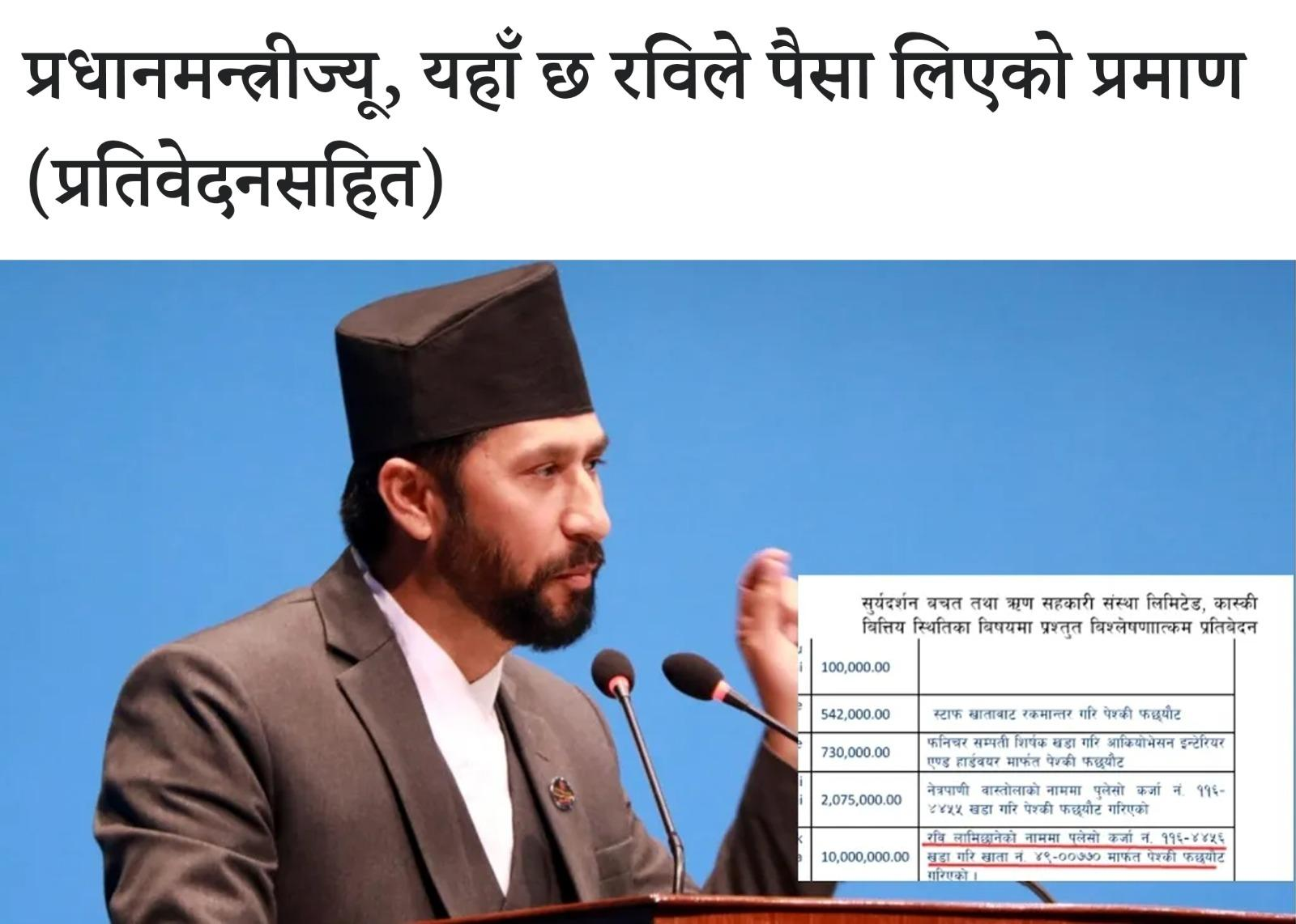

| **SN** | **LINKS** |
| --- | --- |
|  | [*https://www.facebook.com/share/p/vBUXZjCPJgRNawHP/?mibextid=oFDknk*](https://www.facebook.com/share/p/vBUXZjCPJgRNawHP/?mibextid=oFDknk) |
|  | *https://www.facebook.com/share/p/bVrCCr4LgMcHJLM7/?mibextid=oFDknk* |
|  | *https://www.facebook.com/share/p/sPuaQYC6hSMjNcCi/?mibextid=oFDknk* |
|  | *https://www.facebook.com/share/p/kChaq8pLXPoLGedt/?mibextid=oFDknk* |
|  | *https://twitter.com/CartofNews1/status/1770354234359271767?t=KsrIWl1MkgWRy6fPtRlL4Q&s=19* |
|  | *https://www.facebook.com/share/p/a4ZsmBGrMhAgjm2R/?mibextid=Nif5oz* |

**The Navy Union took out a rally in Lalitpur demanding the dismissal of Home Minister Ravi and Finance Minister Barsaman.**

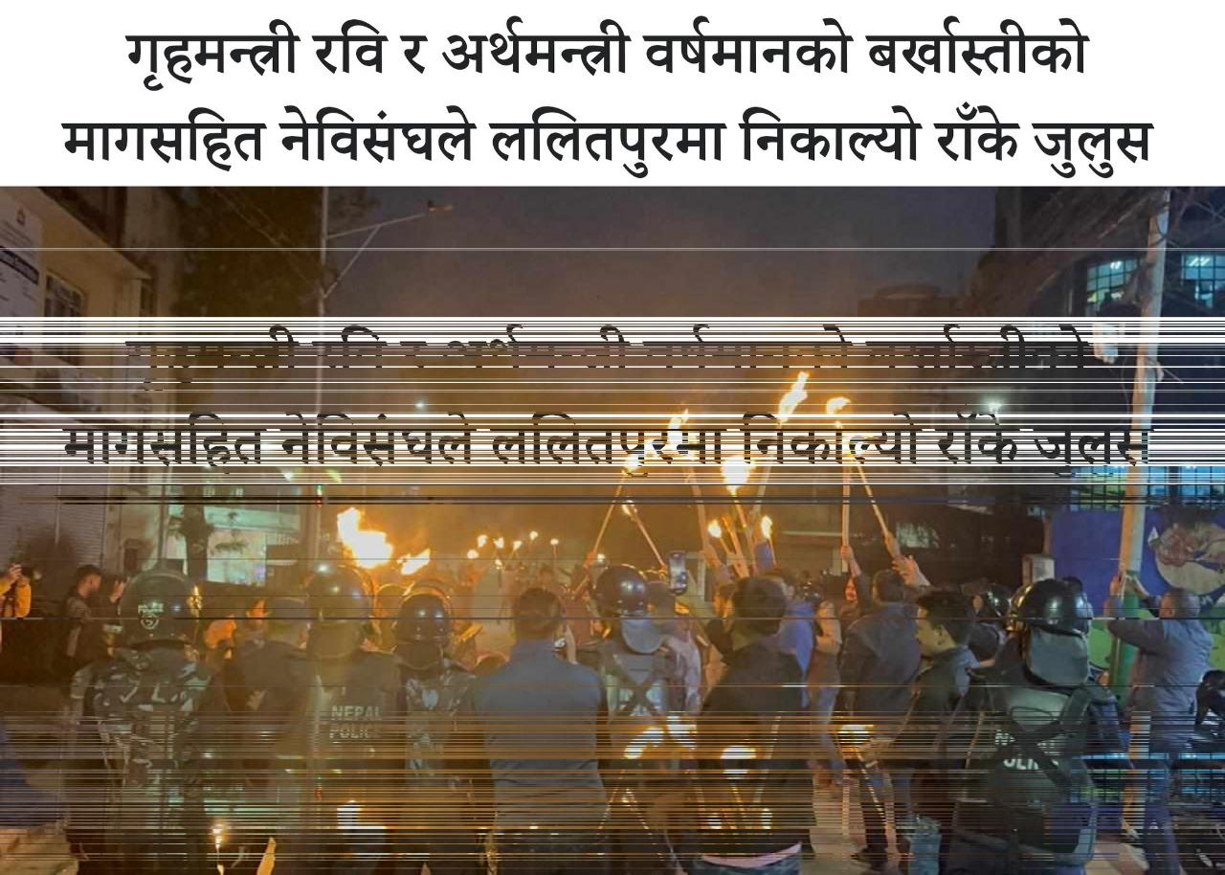

| **SN** | **LINKS** |
| --- | --- |
|  | *https://www.facebook.com/share/p/4n9yJtHkk2QWxJ9S/?mibextid=Nif5oz* |
|  | *https://www.facebook.com/share/p/h3ZBc8vMzz4r6pJh/?mibextid=Nif5oz* |
|  | *https://www.facebook.com/share/p/Xth5fdWTrAzx6wcf/?mibextid=oFDknk* |
|  | *https://www.facebook.com/share/p/AvjzPKyKLH72hPXf/?mibextid=oFDknk* |
|  | *https://www.facebook.com/share/p/13dgh2ifSirHA4xk/?mibextid=oFDknk* |
|  | *https://twitter.com/CartofNews1/status/1770388268380532941?t=8XJK-pS9hzGa6s-7fh4S0A&s=19* |

**Prachanda-Oli under the protection of Home Minister Ravi due to the fear of losing power. Oli, who is the 'Waiting Prime Minister', is in favor of not allowing the government to be formed under the leadership of the Nepali Congress.**

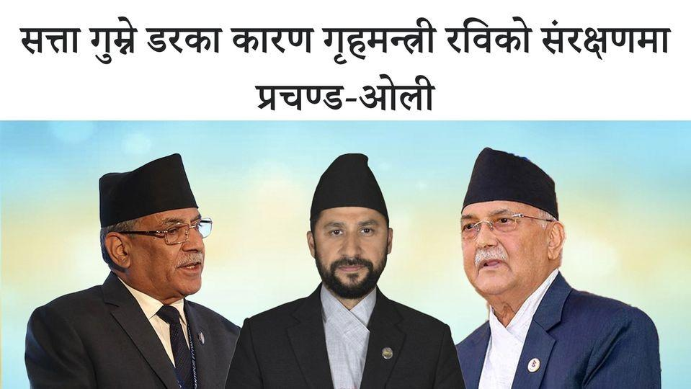

| **SN** | **LINKS** |
| --- | --- |
|  | [*https://www.facebook.com/share/p/zzWmh4UwenU5io55/?mibextid=oFDknk*](https://www.facebook.com/share/p/zzWmh4UwenU5io55/?mibextid=oFDknk) |
|  | [*https://www.facebook.com/share/p/thrqCZrJwg6E2hVk/?mibextid=oFDknk*](https://www.facebook.com/share/p/thrqCZrJwg6E2hVk/?mibextid=oFDknk) |
|  | [*https://www.facebook.com/share/p/e9vDCn5vVpeid8rJ/?mibextid=oFDknk*](https://www.facebook.com/share/p/e9vDCn5vVpeid8rJ/?mibextid=oFDknk) |
|  | [*https://www.facebook.com/share/p/S3b3nrLu7YpPSP1m/?mibextid=oFDknk*](https://www.facebook.com/share/p/S3b3nrLu7YpPSP1m/?mibextid=oFDknk) |
|  | [*https://twitter.com/Sitalama88/status/1770748020801274269?t=Wg0lfbzW3XVSbRm4P2GcMQ&s=19*](https://twitter.com/Sitalama88/status/1770748020801274269?t=Wg0lfbzW3XVSbRm4P2GcMQ&s=19) |
|  | [*https://www.facebook.com/share/p/cif3Yh4HZ1x6K1fH/?mibextid=Nif5oz*](https://www.facebook.com/share/p/cif3Yh4HZ1x6K1fH/?mibextid=Nif5oz) |

**Thakur Mohan was beaten up in the RPP office on charges of corruption. Former Additional Inspector General of Nepal Police (AIGP) Thakur Mohan Shrestha was beaten up in the Rashtriya Prajatantra Party (RPP) central office premises on Sunday afternoon.**

| **SN** | **LINKS** |
| --- | --- |
|  | *https://www.facebook.com/share/p/8Z1uNnM3BKRqs48D/?mibextid=oFDknk* |
|  | *https://www.facebook.com/share/p/en719dWXFUfNXtFu/?mibextid=oFDknk* |
|  | *https://www.facebook.com/share/p/B4yYbJY3ZAVrzNyC/?mibextid=oFDknk* |
|  | *https://www.facebook.com/share/p/au8NExDKVRCbHTQe/?mibextid=oFDknk* |
|  | *https://twitter.com/surya_rato/status/1767115956835537159?t=82IzhzivbAxDuPIu0SVHPw&s=19* |

**If RPP moves ahead with its core agenda of Hindu Rashtra, it will certainly increase its seats in the next elections. However, if RPP reconciles with anti-Hindu Maoists/UML, it would be seen as power hungry Party, which exploits Hindu sentiments to gain power.**

|  | *https://www.facebook.com/ratorachandrasurya0/posts/pfbid02c7YQojcY7791cWwfyij4yAiAXUtaHEq37azRfhr37XEnw3TMNi4L4YG11maAb9VQl?__cft__[0]=AZXzJ-soXpkd4ZXPTTAnYdo4B30a8rR2FWY3ShiBk_--BIxBTVWdctf1BHmDAbaJNcRendFYhCPMBh1_Luhz7kENGXkykWtOlBppWNQcFsrKnCJy3CgN1mrpzaj5REZM2C8&__tn__=%2CO%2CP-R* |
| --- | --- |
|  | *https://www.facebook.com/share/p/NTSX2yhJF91nyKRV/?mibextid=oFDknk* |
|  | *https://www.facebook.com/share/p/eUyCj6Bg7jE5anAS/?mibextid=oFDknk* |
|  | *https://www.facebook.com/share/p/xmtP6sEe8xUvHJvM/?mibextid=oFDknk* |
|  | *https://twitter.com/seemaseema58/status/1767153504551100854?t=bsiRvd-XHCLKCqVrRKyocw&s=19* |

**Despite giving a vote of confidence, expressed many criticisms of the Prime Minister. In which direction is the country going?**

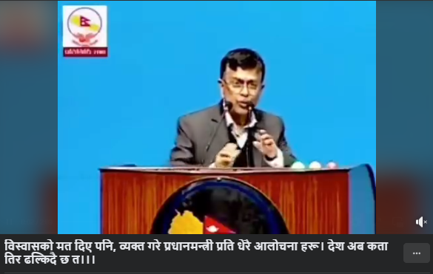

| **SN** | **LINKS** |
| --- | --- |
|  | [*https://www.facebook.com/share/v/Ma9hUGHQQbnPfxaR/?mibextid=oFDknk*](https://www.facebook.com/share/v/Ma9hUGHQQbnPfxaR/?mibextid=oFDknk) |
|  | [*https://twitter.com/CartofNews1/status/1768313247500058976?t=UZl1d5a8i3ResWvB17SXig&s=19*](https://twitter.com/CartofNews1/status/1768313247500058976?t=UZl1d5a8i3ResWvB17SXig&s=19) |
|  | [*https://www.facebook.com/share/v/XETLvYimRMNXLDnd/?mibextid=oFDknk*](https://www.facebook.com/share/v/XETLvYimRMNXLDnd/?mibextid=oFDknk) |
|  | [*https://www.facebook.com/share/v/KS8ThgepwUJa3vjE/?mibextid=oFDknk*](https://www.facebook.com/share/v/KS8ThgepwUJa3vjE/?mibextid=oFDknk) |
|  | [*https://www.facebook.com/share/v/zpqTHsgeiu6RbyXP/?mibextid=oFDknk*](https://www.facebook.com/share/v/zpqTHsgeiu6RbyXP/?mibextid=oFDknk) |

**People of Sarlahi**

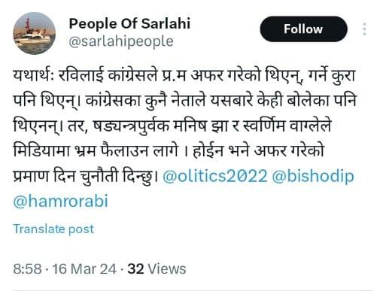

| **SN** | **LINKS** |
| --- | --- |
|  | [*https://www.facebook.com/share/p/uB5UgBND4v57JiNt/?mibextid=oFDknk*](https://www.facebook.com/share/p/uB5UgBND4v57JiNt/?mibextid=oFDknk) |
|  | [*https://x.com/CartofNews1/status/1768901795605254404?t=2iOZZb7vkjzqYmUsuFweZA&s=08*](https://x.com/CartofNews1/status/1768901795605254404?t=2iOZZb7vkjzqYmUsuFweZA&s=08) |
|  | [*https://www.facebook.com/share/p/v9Fz3Vx1i3AvDmC2/?mibextid=oFDknk*](https://www.facebook.com/share/p/v9Fz3Vx1i3AvDmC2/?mibextid=oFDknk) |
|  | [*https://www.facebook.com/share/p/e8GLkzqBoXpVAQbT/?mibextid=oFDknk*](https://www.facebook.com/share/p/e8GLkzqBoXpVAQbT/?mibextid=oFDknk) |
|  | [*https://www.facebook.com/share/p/pzvtR9CgnteWyUnV/?mibextid=oFDknk*](https://www.facebook.com/share/p/pzvtR9CgnteWyUnV/?mibextid=oFDknk) |
|  | [*https://www.facebook.com/share/p/caQnVngCG1p1dt1N/?mibextid=oFDknk*](https://www.facebook.com/share/p/caQnVngCG1p1dt1N/?mibextid=oFDknk) |

**People of Sarlahi**

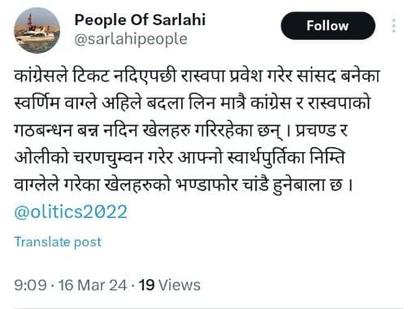

|  | [*https://www.facebook.com/share/p/5v5Sv2w6UdUM3RqS/?mibextid=oFDknk*](https://www.facebook.com/share/p/5v5Sv2w6UdUM3RqS/?mibextid=oFDknk) |
| --- | --- |
|  | [*https://www.facebook.com/share/p/oqNRmGnCF5R78ijA/?mibextid=oFDknk*](https://www.facebook.com/share/p/oqNRmGnCF5R78ijA/?mibextid=oFDknk) |
|  | [*https://www.facebook.com/share/p/ySabBKc9Y2ThsktA/?mibextid=oFDknk*](https://www.facebook.com/share/p/ySabBKc9Y2ThsktA/?mibextid=oFDknk) |
|  | [*https://www.facebook.com/share/p/p4PnzRydUUyiDW1m/?mibextid=oFDknk*](https://www.facebook.com/share/p/p4PnzRydUUyiDW1m/?mibextid=oFDknk) |
|  | [*https://www.facebook.com/share/p/NQgaQeitHqwHxuV6/?mibextid=oFDknk*](https://www.facebook.com/share/p/NQgaQeitHqwHxuV6/?mibextid=oFDknk) |
|  | [*https://twitter.com/CartofNews1/status/1768902608566280193?t=k7xCIEFuNv1-fXt-v41pPg&s=19*](https://twitter.com/CartofNews1/status/1768902608566280193?t=k7xCIEFuNv1-fXt-v41pPg&s=19) |

**Demand the resignation of those in the government involved in cooperative fraud and gold scandal. - Nepali Congress**

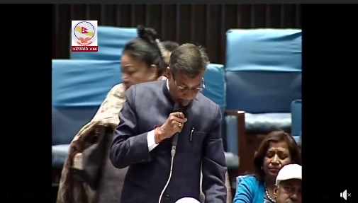

| **SN** | **LINKS** |
| --- | --- |
|  | [*https://fb.watch/qPTQcs_jrL/?mibextid=Nif5oz*](https://fb.watch/qPTQcs_jrL/?mibextid=Nif5oz) |
|  | [*https://www.facebook.com/share/v/3N3sHWspFefJjFrS/?mibextid=oFDknk*](https://www.facebook.com/share/v/3N3sHWspFefJjFrS/?mibextid=oFDknk) |
|  | [*https://www.facebook.com/share/v/5LRKFvZe7yD4fU9H/?mibextid=oFDknk*](https://www.facebook.com/share/v/5LRKFvZe7yD4fU9H/?mibextid=oFDknk) |
|  | [*https://www.facebook.com/share/v/6NRBv3m1jFd46yc2/?mibextid=oFDknk*](https://www.facebook.com/share/v/6NRBv3m1jFd46yc2/?mibextid=oFDknk) |
|  | [*https://x.com/surya_rato/status/1768589519811703143?s=20*](https://x.com/surya_rato/status/1768589519811703143?s=20) |

**MKN had been regularly humiliated by Oli on different occasions. Despite this fact, MKN joined the new coalition, by compromising his ideology; MKN and his Party members' political carrier may be finished by Prachanda and Oli by playing with MKN's greed to become Prime minister.**

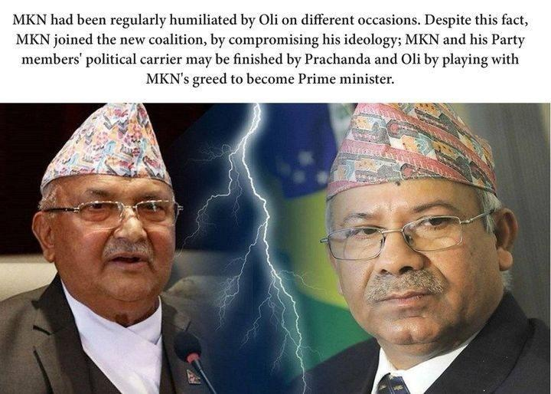

| **SN** | **LINKS** |
| --- | --- |
|  | *https://www.facebook.com/ratorachandrasurya0/posts/pfbid02NHHmwm1LNqoKhgxbx5L3Qug63iNBXMVZnkrebbk21e8Wa6aYmGTnC1SBKmF9WBLbl?__cft__[0]=AZW3UmiTkrWDOm7CnM_gVAB8t1X0ERJqyzXmf3soj2PYwbSfHACM3D6TE9Iwp9jk9JPDItC8aFEaI1Dr5b9KCwj7EWvc5_0lE9oqH6do9IJA2iJiP9qGN1BmDIAfvPUsyew&__tn__=%2CO%2CP-R* |
|  | *https://www.facebook.com/nepolitics0/posts/pfbid02qtdx1Ugh4XqnEU7NQ8zyC37afUMJzQjXM3mfi62mTJGuL2yncNXF6xegqtuvsFFWl?__cft__[0]=AZX5A0bBDZyP79sxT8D0PMOUQgdmf6j-YPCcyaMFZ3SPMKw7qaCD8vDnEBIpepYuLa1sFfDoglhwHkg43EmEIrAf7LFZhF07zzUuNOz7ncsCyNEQciXhEth7Q7JNF2QmUQA&__tn__=%2CO%2CP-R* |
|  | *https://www.facebook.com/groups/1074192292722252/posts/2987712678036861/?__cft__[0]=AZVNoR1fyw9Zcr34Eov286thagv9yhkVL1gtFJ5_GF-UintLiTydliHEFpDheKt8CdMh1j8HVdhILut_mQxPvAhWfkE9Cn7OtZvhCRJKfRW-HE_6e1xOvbSbaY4j5MVk7iQR4aop5XLuleizn5VIpbT-&__tn__=%2CO%2CP-R* |
|  | *https://www.facebook.com/groups/ssnepal/posts/7909118429183889/?__cft__[0]=AZV9AN2UXgDjzsmPeCbtONMwVTXJ_At6M1r4Em95-KFr-U9ujIo9Jfisu0BXCQh0AcQV9USEg8H_hdwwYdwgJf5Kd0FWWQVITIjOck4rruQi-RSkRqVWfEmmMXcXmQkxFIeb80dBkoeaFhpuvoyfWRVD&__tn__=%2CO%2CP-R* |
|  | *https://www.facebook.com/groups/NepaliOnlineNewss/posts/2657063921143840/?__cft__[0]=AZW56vSH2pIqCwzCtpqHm45iDHakoZ_6ckxbVbcZRvwHCnnjuk8qhXdsrkT51c09IudAolsT8VGyD6S2cBDbqPNfQBLhEz5l05LiHKhQHfUwz55PUpf45t0Q55Tqi8j-7bY4ShfYmmw4z_o6ip64G7H7&__tn__=%2CO%2CP-R* |
|  | *https://x.com/CartofNews1/status/1770457316774625424?s=20* |

**What about 17000?  
How about investigation?**

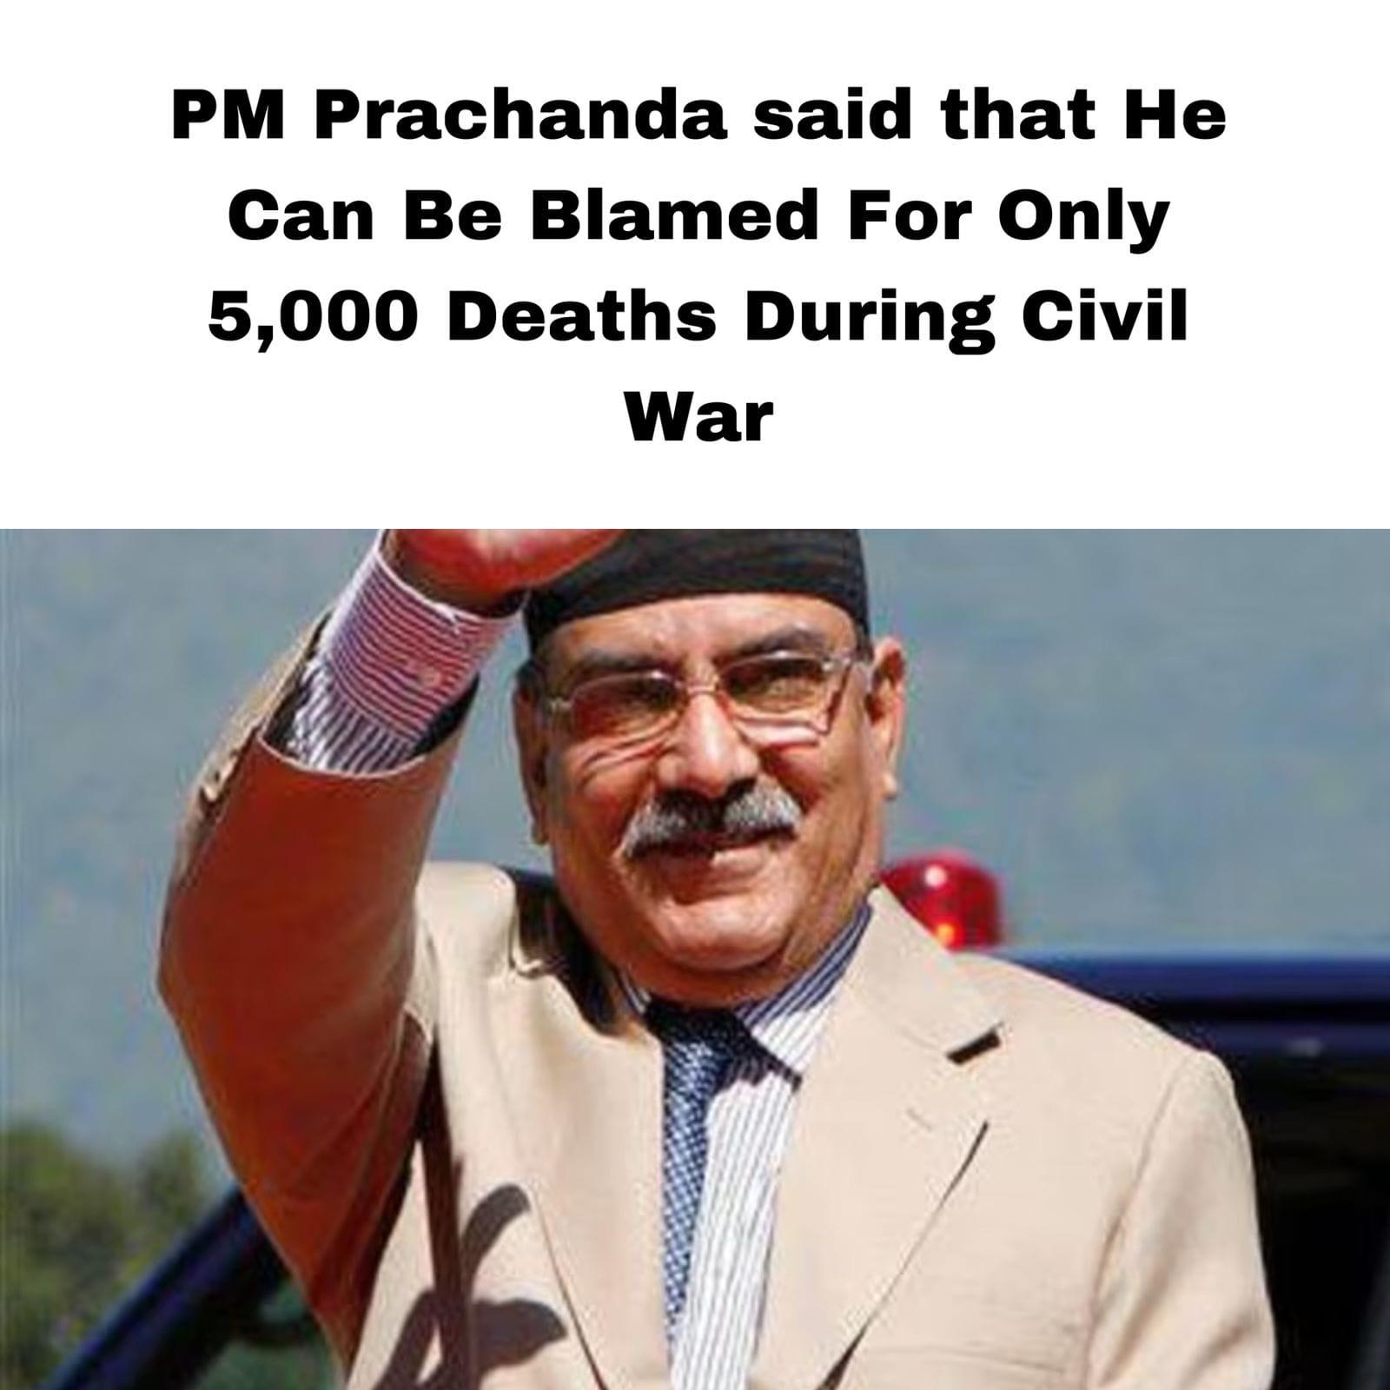

| **SN** | **LINKS** |
| --- | --- |
|  | [*https://www.facebook.com/share/p/cfcNR1Xo2SqzpBKV/?mibextid=A7sQZp*](https://www.facebook.com/share/p/cfcNR1Xo2SqzpBKV/?mibextid=A7sQZp) |
|  | [*https://www.facebook.com/share/p/hH3iobkZQLjQWcNQ/?mibextid=A7sQZp*](https://www.facebook.com/share/p/hH3iobkZQLjQWcNQ/?mibextid=A7sQZp) |
|  | [*https://www.facebook.com/share/p/zPfgnpTYKjxQt8vC/?mibextid=A7sQZp*](https://www.facebook.com/share/p/zPfgnpTYKjxQt8vC/?mibextid=A7sQZp) |
|  | [*https://www.facebook.com/share/p/ZcDbfBBaZa3HJ9B3/?mibextid=Nif5oz*](https://www.facebook.com/share/p/ZcDbfBBaZa3HJ9B3/?mibextid=Nif5oz) |
|  | [*https://www.facebook.com/share/p/sbysZYVmkrLP92cB/?mibextid=Nif5oz*](https://www.facebook.com/share/p/sbysZYVmkrLP92cB/?mibextid=Nif5oz) |
|  | [*https://twitter.com/CartofNews1/status/1771167069897121822?t=0ZyTWLQht-ePdEo-l2o7MQ&s=19*](https://twitter.com/CartofNews1/status/1771167069897121822?t=0ZyTWLQht-ePdEo-l2o7MQ&s=19) |

**Corrupt Finance Minister & Ex President**

**Nepal's investigative agencies have found that current finance minister Barshaman Pun and Ex- Vice President Nanda Bahadur Pun's have direct connections to a GOLD SMUGGLER Gurung who was advisor to Ex- Vice president.  
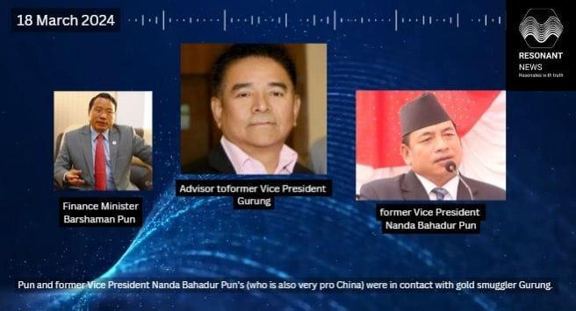**

| **SN** | **LINKS** |
| --- | --- |
|  | [*https://www.facebook.com/share/p/uGX4MQUYTfuZhaBt/?mibextid=A7sQZp*](https://www.facebook.com/share/p/uGX4MQUYTfuZhaBt/?mibextid=A7sQZp) |
|  | [*https://www.facebook.com/share/p/1dSXJ1KBVfkxa3We/?mibextid=A7sQZp*](https://www.facebook.com/share/p/1dSXJ1KBVfkxa3We/?mibextid=A7sQZp) |
|  | [*https://www.facebook.com/share/p/ERHkhufVkA4MGwGM/?mibextid=A7sQZp*](https://www.facebook.com/share/p/ERHkhufVkA4MGwGM/?mibextid=A7sQZp) |
|  | [*https://www.facebook.com/share/p/1xCuz5MzTshYL2Av/?mibextid=Nif5oz*](https://www.facebook.com/share/p/1xCuz5MzTshYL2Av/?mibextid=Nif5oz) |
|  | [*https://www.facebook.com/story.php?story_fbid=827337596106441&id=100064906233745&mibextid=Nif5oz*](https://www.facebook.com/story.php?story_fbid=827337596106441&id=100064906233745&mibextid=Nif5oz) |
|  | [*https://twitter.com/CartofNews1/status/1771167229146460478?t=nae4PVriel0yt6ibcty9bw&s=19*](https://twitter.com/CartofNews1/status/1771167229146460478?t=nae4PVriel0yt6ibcty9bw&s=19) |

**Ravi Lamichhane, Deputy Prime Minister and Minister of Home Affairs along with the CPN-Maoist Center paid tribute to the Maoists within a week of assuming power.**

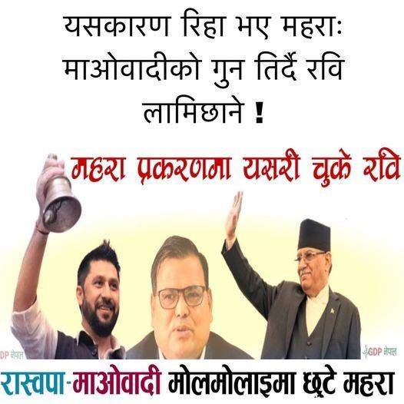

| **SN** | **LINKS** |
| --- | --- |
|  | [*https://www.facebook.com/share/p/Fp9zADBXc8zjxYe6/?mibextid=Nif5oz*](https://www.facebook.com/share/p/Fp9zADBXc8zjxYe6/?mibextid=Nif5oz) |
|  | [*https://www.facebook.com/story.php?story_fbid=435833132313471&id=100076603636578&mibextid=Nif5oz*](https://www.facebook.com/story.php?story_fbid=435833132313471&id=100076603636578&mibextid=Nif5oz) |
|  | *https://www.facebook.com/groups/1074192292722252/permalink/2989039914570804/?mibextid=A7sQZp* |
|  | *https://twitter.com/CartofNews1/status/1771170463890239670?t=0JYL4SYWMNosT9BjkYr6nw&s=19* |
|  | [*https://www.facebook.com/groups/NepaliOnlineNewss/permalink/2658369634346602/?mibextid=A7sQZp*](https://www.facebook.com/groups/NepaliOnlineNewss/permalink/2658369634346602/?mibextid=A7sQZp) |
|  | [*https://www.facebook.com/groups/ssnepal/permalink/7916621878433544/?mibextid=A7sQZp*](https://www.facebook.com/groups/ssnepal/permalink/7916621878433544/?mibextid=A7sQZp) |

**What did Gagan say in Parliament against Ravi, getting angry? | Gagan Thapa**

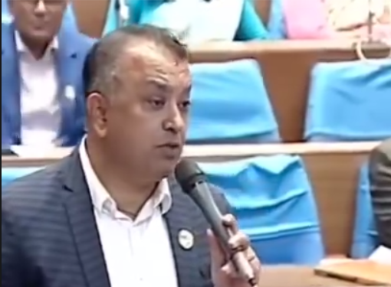

| **SN** | **LINKS** |
| --- | --- |
|  | [*https://www.facebook.com/share/v/XjYuUCbEhsKzhNGF/?mibextid=oFDknk*](https://www.facebook.com/share/v/XjYuUCbEhsKzhNGF/?mibextid=oFDknk) |
|  | [*https://twitter.com/surya_rato/status/1770017456977072225?t=fK23r7HwI95cauo5riqVQA&s=19*](https://twitter.com/surya_rato/status/1770017456977072225?t=fK23r7HwI95cauo5riqVQA&s=19) |
|  | [*https://www.facebook.com/share/v/FLum4Vzy2JoUc5Jg/?mibextid=oFDknk*](https://www.facebook.com/share/v/FLum4Vzy2JoUc5Jg/?mibextid=oFDknk) |
|  | [*https://www.facebook.com/share/v/siV8smWroycG1HkZ/?mibextid=oFDknk*](https://www.facebook.com/share/v/siV8smWroycG1HkZ/?mibextid=oFDknk) |
|  | *https://www.facebook.com/nepolitics0/videos/417297360788894/?extid=CL-UNK-UNK-UNK-AN_GK0T-GK1C&mibextid=Nif5oz* |
|  | [*https://www.facebook.com/share/v/M2mmB3eeJG2GP7Uz/?mibextid=oFDknk*](https://www.facebook.com/share/v/M2mmB3eeJG2GP7Uz/?mibextid=oFDknk) |

**Jeevan Chalauney, who is absconding in the gold smuggling case, has claimed that the DSP of CIB asked for 60 lakhs during the investigation of gold smuggling and AIG Shyam Gyawali refused to give him 20 crores.**

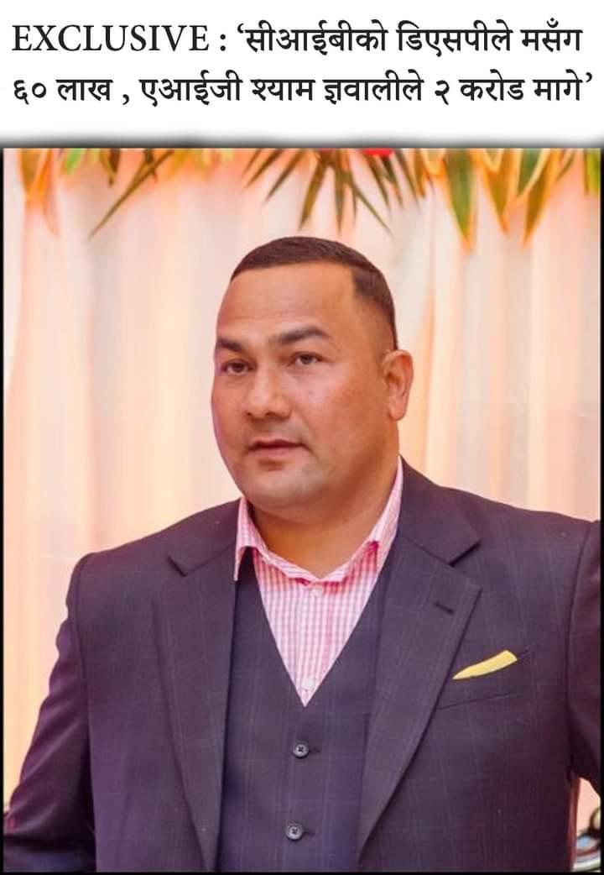

| **SN** | **LINKS** |
| --- | --- |
|  | [*https://www.facebook.com/share/p/5SjtmfucCyLG4CiA/?mibextid=oFDknk*](https://www.facebook.com/share/p/5SjtmfucCyLG4CiA/?mibextid=oFDknk) |
|  | [*https://www.facebook.com/share/p/6DzJzzgJXQ5vpdPf/?mibextid=oFDknk*](https://www.facebook.com/share/p/6DzJzzgJXQ5vpdPf/?mibextid=oFDknk) |
|  | [*https://www.facebook.com/share/p/pYsjNhtNGT5aC5UJ/?mibextid=oFDknk*](https://www.facebook.com/share/p/pYsjNhtNGT5aC5UJ/?mibextid=oFDknk) |
|  | [*https://www.facebook.com/share/p/mpg4P6iAJQY32xLS/?mibextid=oFDknk*](https://www.facebook.com/share/p/mpg4P6iAJQY32xLS/?mibextid=oFDknk) |
|  | [*https://twitter.com/surya_rato/status/1768901321116316090?t=y8JKpdBFwdr7hru8zqxrbg&s=19*](https://twitter.com/surya_rato/status/1768901321116316090?t=y8JKpdBFwdr7hru8zqxrbg&s=19) |
|  | [*https://www.facebook.com/share/p/Y6E4bKbM7se6gFS2/?mibextid=oFDknk*](https://www.facebook.com/share/p/Y6E4bKbM7se6gFS2/?mibextid=oFDknk) |

**Central member of CPN Maoist Center Ram Kumar Sharma has announced that he has left the party. Sharma, who is also a member of the Constituent Assembly, announced his resignation from the party on Thursday through social media.**

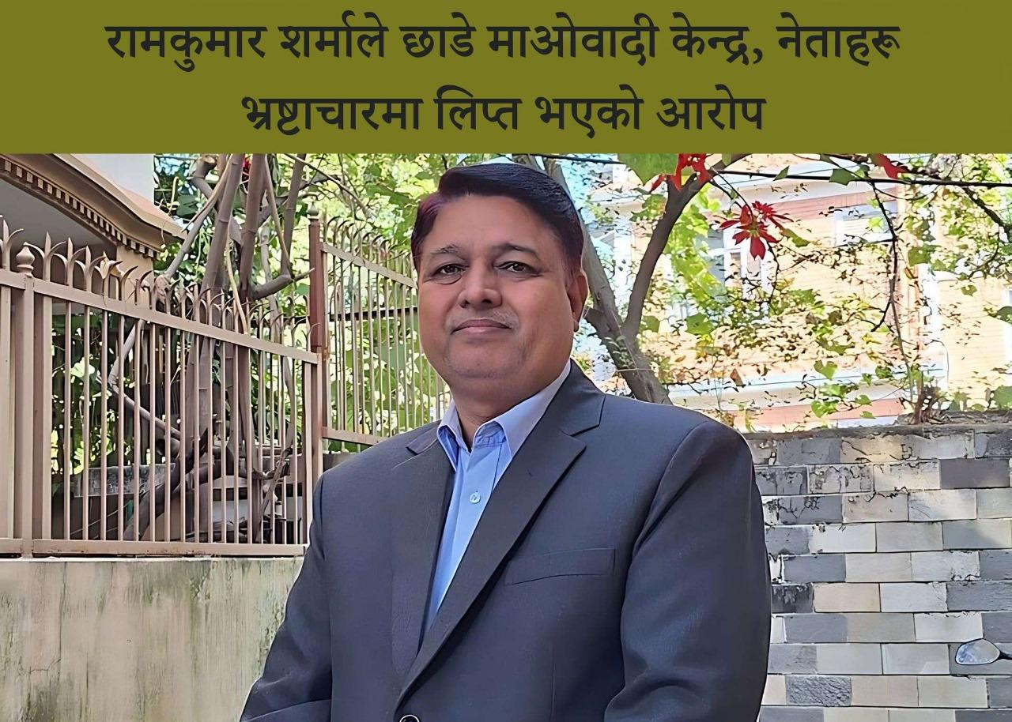

| **SN** | **LINKS** |
| --- | --- |
|  | [*https://www.facebook.com/share/p/1eQKQz1Txwofy3DE/?mibextid=oFDknk*](https://www.facebook.com/share/p/1eQKQz1Txwofy3DE/?mibextid=oFDknk) |
|  | [*https://www.facebook.com/share/p/Z9jd2UqNvAMTcEQf/?mibextid=Nif5oz*](https://www.facebook.com/share/p/Z9jd2UqNvAMTcEQf/?mibextid=Nif5oz) |
|  | [*https://www.facebook.com/share/p/qDbqVSMyDDPvfPvc/?mibextid=xfxF2i*](https://www.facebook.com/share/p/qDbqVSMyDDPvfPvc/?mibextid=xfxF2i) |
|  | [*https://www.facebook.com/share/p/RQPynJ5hqATmgWJe/?mibextid=xfxF2i*](https://www.facebook.com/share/p/RQPynJ5hqATmgWJe/?mibextid=xfxF2i) |
|  | [*https://www.facebook.com/share/p/7vhmbvQmgPWusjnd/?mibextid=xfxF2i*](https://www.facebook.com/share/p/7vhmbvQmgPWusjnd/?mibextid=xfxF2i) |
|  | [*https://twitter.com/Sitalama88/status/1770749607187783937?t=6zWbIwmYRB28QkVjjvcTxA&s=19*](https://twitter.com/Sitalama88/status/1770749607187783937?t=6zWbIwmYRB28QkVjjvcTxA&s=19) |

**The alliance between Prachanda and Oli isn't just a collaboration within the left-wing ideology, but rather a consolidation of leftist forces, according to Deepak Singh.**

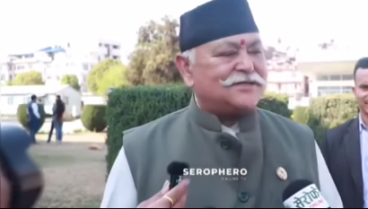

| **SN** | **LINKS** |
| --- | --- |
|  | [*https://fb.watch/qV5Imt8nl2/?mibextid=Nif5oz*](https://fb.watch/qV5Imt8nl2/?mibextid=Nif5oz) |
|  | [*https://www.facebook.com/share/v/dn5Pz9VKMDm2Py1w/?mibextid=oFDknk*](https://www.facebook.com/share/v/dn5Pz9VKMDm2Py1w/?mibextid=oFDknk) |
|  | [*https://www.facebook.com/share/v/UrQtvGRCTZfj8x4d/?mibextid=oFDknk*](https://www.facebook.com/share/v/UrQtvGRCTZfj8x4d/?mibextid=oFDknk) |
|  | [*https://www.facebook.com/share/v/vHegpcPnidxSzwtQ/?mibextid=oFDknk*](https://www.facebook.com/share/v/vHegpcPnidxSzwtQ/?mibextid=oFDknk) |
|  | *https://www.facebook.com/nepolitics0/videos/364428373234913/?extid=CL-UNK-UNK-UNK-AN_GK0T-GK1C&mibextid=Nif5oz* |
|  | [*https://twitter.com/surya_rato/status/1770017438417207534?t=DIHGllZqGV0ixfGkmikklg&s=19*](https://twitter.com/surya_rato/status/1770017438417207534?t=DIHGllZqGV0ixfGkmikklg&s=19) |

**When will the corruption file of UML leader Bhanubhakta Dhakal attached to Omni be opened?**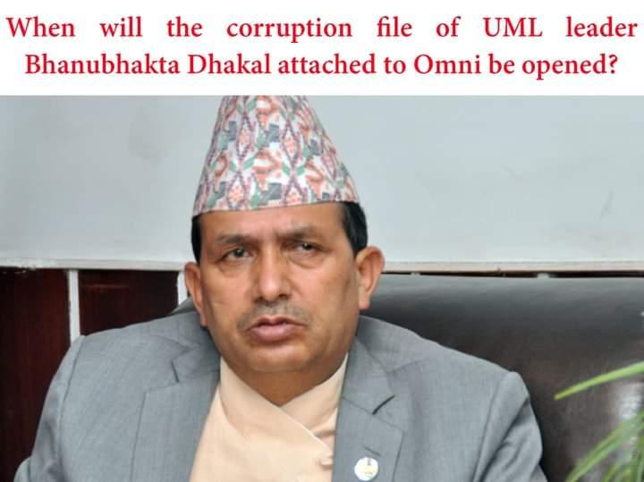

| **SN** | **LINKS** |
| --- | --- |
|  | *https://www.facebook.com/ratorachandrasurya0/posts/pfbid07VfeJQJpQE7XdNoKkNCyRxN4qpkaDxRRM22Rdn6r85a6skAsQpQkcGoZGsQxPbpLl?__cft__[0]=AZWNamr7wFYn3SKWa602OAXcoD2ghbrxdl9SWIVR7nJjSScs5T25r6pjeyUmLgQl5X4RWTLVE2nSVx4ZumrWr7CAQQ119IdJRxzhyynNcKj1eMmjcIJk374wuAkkWcFVtQXPq0-splQTaw2ccSDyb-xUksM82t7a5hSRGH6VAdMinpPDqCg4tK8qTFiELccb0iw&__tn__=%2CO%2CP-R* |
|  | *https://www.facebook.com/nepolitics0/posts/pfbid02yUDDrBq2px2ioES3jEYr51kZdB562kvFpoqeW1yk5FSU5m2ahqHa6ufWSMi5aDgSl?__cft__[0]=AZXoz-NTVvLXqkdvp6bwqOVx47vadwH3kao7JQkBkv0PsOGWRjZ4JZRNyC3PJr0AhDD4Ez8KKz-n8hvv9te1E41vdbwKhrZexBbz0U6kcV7tf8YKCBmY5itciuCwlYuzjJGhvSZnPK0HAxVC5DIy7aLR4G-DKudSmPlMe0x7H-KQ-fDMiG8OYA5ZvHIJ27o7M8U&__tn__=%2CO%2CP-R* |
|  | *https://www.facebook.com/groups/NepaliOnlineNewss/permalink/2660464997470399/* |
|  | *https://www.facebook.com/groups/1074192292722252/permalink/2991302391011223/* |
|  | *https://www.facebook.com/groups/ssnepal/permalink/7927561934006205/* |
|  | *https://x.com/CartofNews1/status/1772254078627971567?s=20* |

**Where has the investigation on Gokul Baskota reached in the 70 crore scandal?  
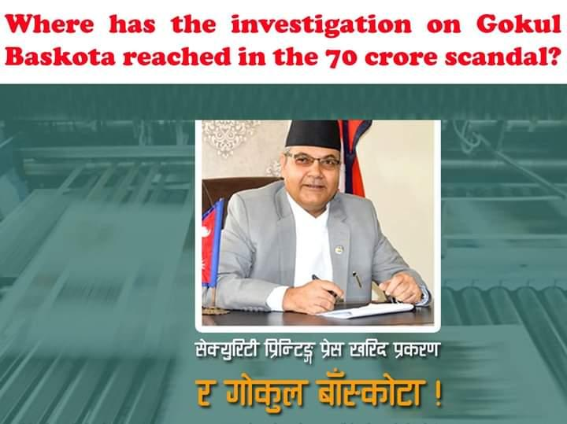**

| **SN** | **LINKS** |
| --- | --- |
|  | *https://www.facebook.com/ratorachandrasurya0/posts/pfbid02oMRe3FdxhTBsDRrurPBLeVPpLDjnk9GbDEeb6Leq4io3PGedvE3krRkUYRRt1YZyl?__cft__[0]=AZXLUmqY0TvQHnsUol8H2YCn1ekPTiQ2wwUzfxJg6SILvAFMj1AoUXwLUZrSNZxUtYwKf7CuX-AoNqHA1nHasynab8HmhroDEPTkxCeBTAAXy4S7PBIiRQ_VQ3vQ0TWuG3JsU-sMsGwCyrocoYy5DfvVDbBdt5j_8s6041pTMHQtSSr7gC_16WacN5TXqoRCoZM&__tn__=%2CO%2CP-R* |
|  | *https://www.facebook.com/nepolitics0/posts/pfbid07YceCe3ddWkAkD5ELyZQPDCFS17xcxiCbTrXSq3NJbTLJGE81LNd44XNXBK9YcFel?__cft__[0]=AZX_o2dg2tXCr98qtkhRUDulCOiEtP-slu4gs-Ra0O4uBhqlnYEcY9xAOW7gi57sjUhXT9xEjOHNq4f7vpKUf8yQ64rngBo8Wydbpu7c8AnSKgkcomPTebCPwX447AuZIyMhoF_Sf2B9Pb5qZmdGV9IUiIMMHBTS8sKgRaIKzc1hSZLv7kbSg5gMV_W7qI6ZyBE&__tn__=%2CO%2CP-R* |
|  | *https://www.facebook.com/groups/ssnepal/permalink/7927580354004363/* |
|  | *https://www.facebook.com/groups/1074192292722252/permalink/2991306941010768/* |
|  | *https://www.facebook.com/groups/NepaliOnlineNewss/permalink/2660467790803453/* |
|  | *https://x.com/CartofNews1/status/1772254121304715481?s=20* |

**The vote of confidence, the caste that should give to the people as the responsibility of electing the Prime Minister.**

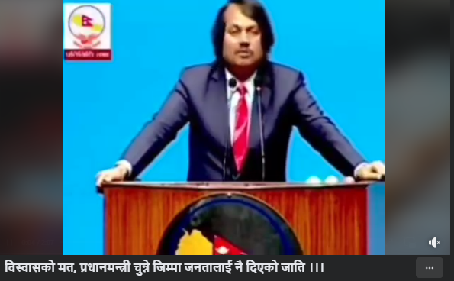

| **SN** | **LINKS** |
| --- | --- |
|  | [*https://www.facebook.com/share/v/VicavH6YqYVjRFDS/?mibextid=oFDknk*](https://www.facebook.com/share/v/VicavH6YqYVjRFDS/?mibextid=oFDknk) |
|  | [*https://www.facebook.com/share/v/8CKzDVsxfkhYKAyJ/?mibextid=oFDknk*](https://www.facebook.com/share/v/8CKzDVsxfkhYKAyJ/?mibextid=oFDknk) |
|  | [*https://www.facebook.com/share/v/biLNFbsBjqeP7G5s/?mibextid=oFDknk*](https://www.facebook.com/share/v/biLNFbsBjqeP7G5s/?mibextid=oFDknk) |
|  | [*https://www.facebook.com/share/v/y4FSAj8G749JPWQN/?mibextid=oFDknk*](https://www.facebook.com/share/v/y4FSAj8G749JPWQN/?mibextid=oFDknk) |
|  | [*https://twitter.com/surya_rato/status/1768310949138817235?t=OauLRlQJFfGQESeR3jmB_w&s=19*](https://twitter.com/surya_rato/status/1768310949138817235?t=OauLRlQJFfGQESeR3jmB_w&s=19) |

**CK Raut is the main hope for Madhes as Upendra Yadav has consistently played with Madhesi spirit**

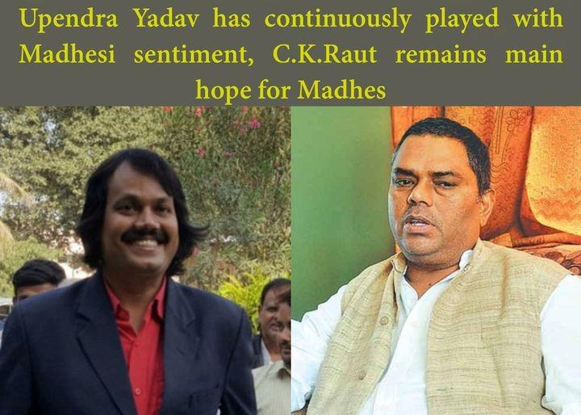

| **SN** | **LINKS** |
| --- | --- |
|  | [*https://m.facebook.com/story.php?story_fbid=pfbid0ynmwn8LWqnRfPaJ2ayLeV7HVt7tW69kMvxYsWwXiomup9Gz539UX8PXHNh8Wig5Pl&id=100064906233745&mibextid=JRoKGi*](https://m.facebook.com/story.php?story_fbid=pfbid0ynmwn8LWqnRfPaJ2ayLeV7HVt7tW69kMvxYsWwXiomup9Gz539UX8PXHNh8Wig5Pl&id=100064906233745&mibextid=JRoKGi) |
|  | [*https://www.facebook.com/share/p/ikniuqbC16mVRs1Q/?mibextid=oFDknk*](https://www.facebook.com/share/p/ikniuqbC16mVRs1Q/?mibextid=oFDknk) |
|  | [*https://www.facebook.com/share/p/8dceq6fpkNRCyAbK/?mibextid=xfxF2i*](https://www.facebook.com/share/p/8dceq6fpkNRCyAbK/?mibextid=xfxF2i) |
|  | [*https://www.facebook.com/share/p/kdYpXoFeaWgAJJGz/?mibextid=xfxF2i*](https://www.facebook.com/share/p/kdYpXoFeaWgAJJGz/?mibextid=xfxF2i) |
|  | [*https://twitter.com/surya_rato/status/1770750108553932987?t=6blzHtOqNWW1A76mZRA7rg&s=19*](https://twitter.com/surya_rato/status/1770750108553932987?t=6blzHtOqNWW1A76mZRA7rg&s=19) |
|  | [*https://www.facebook.com/share/p/nVKvLPNHbsFnnbxR/?mibextid=Nif5oz*](https://www.facebook.com/share/p/nVKvLPNHbsFnnbxR/?mibextid=Nif5oz) |

**If those who stood in the opposition stood on the same side, those who were cheated shouted the slogan 'We are one', then what would be the situation? - Question to the Prime Minister.**

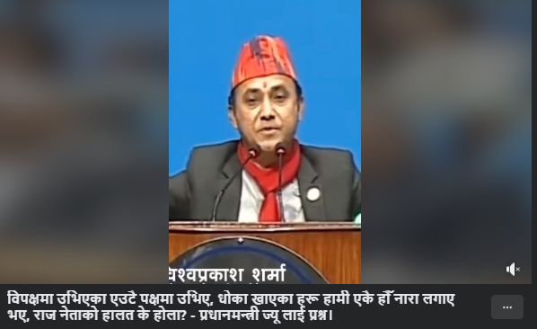

| **SN** | **LINKS** |
| --- | --- |
|  | [*https://www.facebook.com/share/v/9tJBQkV7BDtJjPU4/?mibextid=oFDknk*](https://www.facebook.com/share/v/9tJBQkV7BDtJjPU4/?mibextid=oFDknk) |
|  | [*https://twitter.com/CartofNews1/status/1768311983454200044?t=Wro4zwTthRnuyvtMebHIXg&s=19*](https://twitter.com/CartofNews1/status/1768311983454200044?t=Wro4zwTthRnuyvtMebHIXg&s=19) |
|  | [*https://www.facebook.com/share/v/tC96Vioo9UWKxokN/?mibextid=oFDknk*](https://www.facebook.com/share/v/tC96Vioo9UWKxokN/?mibextid=oFDknk) |
|  | [*https://www.facebook.com/share/v/3hqwLimbzXn3X9xv/?mibextid=oFDknk*](https://www.facebook.com/share/v/3hqwLimbzXn3X9xv/?mibextid=oFDknk) |
|  | [*https://www.facebook.com/share/v/wAred7VirnEguv34/?mibextid=oFDknk*](https://www.facebook.com/share/v/wAred7VirnEguv34/?mibextid=oFDknk) |

**The land of Nepal Trust which was sold at very less cost by Ishwor Pokharel, will there be action on Ishwor?**  
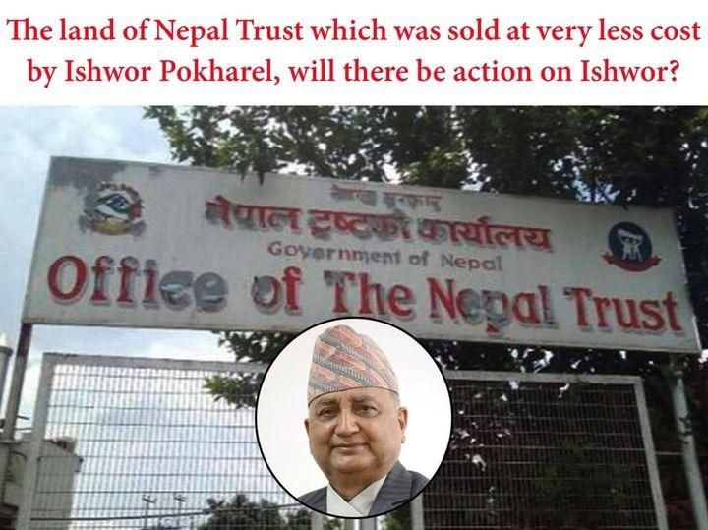

| **SN** | **LINKS** |
| --- | --- |
|  | *https://www.facebook.com/ratorachandrasurya0/posts/pfbid027s57J8yameARGns4efXEFxW74RUiACgRjD8yaKZiLYucZ5iKM3Q3ga3JaFUHBh4sl?__cft__[0]=AZVP9oMCJIQTZ146j7f7WgAW-sp5XBXQfopX_rUO67xaWvkvaIWu2iMBkjsSAUUlFBfvu5YaQqCDtD1055AVLcQntFUYPPaQxKI__FwPFcMLdvNXo7StGJZokJmV_-lLwSsuTc9K4EOhFMJDlnmPl_Lt-jmY8rDCldmSxWid4bZk69J_PdWawyLZy8mHhjN35iw&__tn__=%2CO%2CP-R* |
|  | *https://www.facebook.com/nepolitics0/posts/pfbid0CaRdvdydunHZZbingqFvfYRvqBiMZrKqEgpyd7mce1VEpkuW9tLtehGxY4v97g97l?__cft__[0]=AZXCNObHZmpFUaYl9xhsG3S-gsz85UFqhcnXO6tRKBslXWcIbmkqGTS1tOPNmFdl8JcukBVGxyXnB3WTF3FK-JtdlQRDCz_mDAZN5VDi7TmpKTMYhRR-q61UeIqTGjryazM&__tn__=%2CO%2CP-R* |
|  | *https://twitter.com/CartofNews1/status/1772638148977127447* |
|  | *https://www.facebook.com/groups/NepaliOnlineNewss/permalink/2661227374060828/* |
|  | *https://www.facebook.com/groups/1074192292722252/permalink/2992118010929661/* |
|  | *https://www.facebook.com/groups/ssnepal/permalink/7931818080247257/* |

**Fake Bhutanese refugee case: Why was there no investigation on KP Oli’s PA Rajesh and former home minister Badal?  
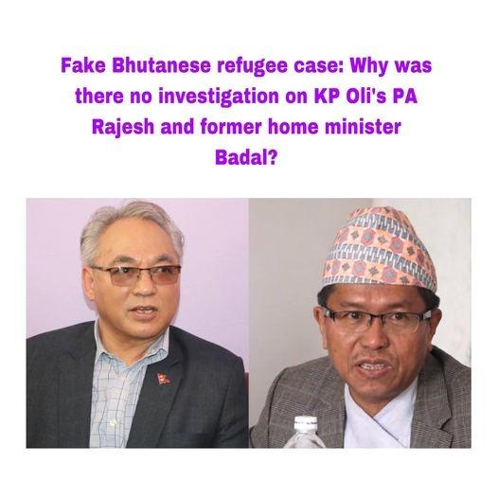**

| **SN** | **LINKS** |
| --- | --- |
|  | *https://www.facebook.com/ratorachandrasurya0/posts/pfbid0ELKS5j9N5hCDE9uB4e589bj3i7Racdn81mRbwu85u8gAYYPrWzHD5JUtvkuo7nyVl?__cft__[0]=AZVvj_rsBMGDINL1Q6u8_AMuLA6lZ6hY_zX1L6xP5iUmnOEhy62zbmRrU_AzBYVgSeU2nyVwqOsLvjkX1i8BlnkRH0mDvbHCf5pSUoTKIFopSB0rQPZt7vitr6lFw8kD9ZycTHHjyWnS8Z-9KaN-O0-4EL7NvJATu_Y0jB-vOz0xR6h5n-rbdgokbdXoqFpQi7Y&__tn__=%2CO%2CP-R* |
|  | *https://www.facebook.com/nepolitics0/posts/pfbid02cJgzZSFKo3qBi8t2352RkPLzvW7UtPvK5GCtzwL9RM9Qkz5WmMxeFEubASq7Jkq2l?__cft__[0]=AZXcNiJIPOO84CN4D6PO3xEX0uksvOEamDFuLos1gQDdmhMgsEoKjT_gWpwqAZ91wmTcq_Bjd_9SgxGbhboOQfMp9w6IeMdTcBYR0aJD7ajzXWBMA3BQoG1ckRsOG5ldn5I&__tn__=%2CO%2CP-R* |
|  | *https://twitter.com/CartofNews1/status/1772638219013685331* |
|  | *https://www.facebook.com/groups/NepaliOnlineNewss/permalink/2661227860727446/* |
|  | *https://www.facebook.com/groups/1074192292722252/permalink/2992118400929622/* |
|  | *https://www.facebook.com/groups/ssnepal/permalink/7931820256913706/* |

When will the investigation initiate towards Ishwor Pokhral for leasing the land of Nepal Trust to Yeti Group?  
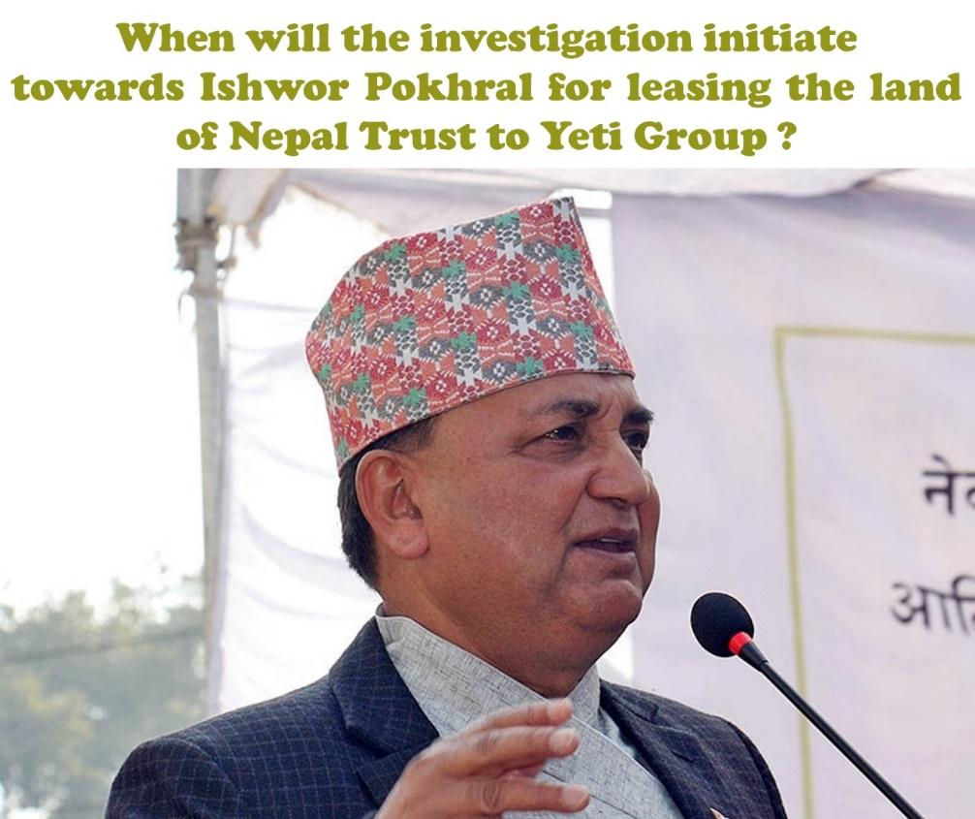

| **SN** | **LINKS** |
| --- | --- |
|  | *https://www.facebook.com/ratorachandrasurya0/posts/pfbid03Ap1zsgVwPGqKpouaBqknBp4rDkJ77JnnD4o98RsngqnTyF7EPCx6hZSL6RkXSKfl?__cft__[0]=AZXASpjAR5X1zhorlD-3FnJ9i39gcOkpdVMkYVvcN4bP6GY0zgAMVLsR5DmEomhULd9y35CWyfBtVGpTXX0N2-09jaqMM-q6N89PKn5Ge_bMkqU8B6OwT-gmBjjv_P9oW9psBIcDqlUuv4BW9g0Q4p-QcVyr2J-pqTdXqRfvkYBAgmqGH8366nB_wYtBnm2gqf0&__tn__=%2CO%2CP-R* |
|  | *https://www.facebook.com/nepolitics0/posts/pfbid02efXgLuejMtyqu554Yfc1RVRxiU5gPUgJRS8wDNFMpcrKBZ3ocKagRQ3YpMX5uoyol?__cft__[0]=AZXTzWuAals_p2MDFgMx2_UTPBCaJN9ifPd0fMbcUXy0xf0ity7UZ3A2jQJmuJjD1qSFuqh0EsWJYQJ-SfXwqKcywTatDvy8NC09EYioy_Ii9sU4h9BcLz5o_GrOJUp8F3dWkVJIOcEOd5-IbMsz6vhxkZ5bCr7Hoh_UaNm_hUighxdAki_e0EyPmU5qMWFfOSs&__tn__=%2CO%2CP-R* |
|  | *https://www.facebook.com/groups/NepaliOnlineNewss/permalink/2660416467475252/* |
|  | *https://www.facebook.com/groups/1074192292722252/permalink/2991240957684033/* |
|  | *https://www.facebook.com/groups/ssnepal/permalink/7927270034035395/* |
|  | *https://x.com/CartofNews1/status/1772253940979052840?s=20* |

**Will there be any action to Prachanda for taking responsibilies of killing of 5 thousand people during Civil War? Investigation is still pending  
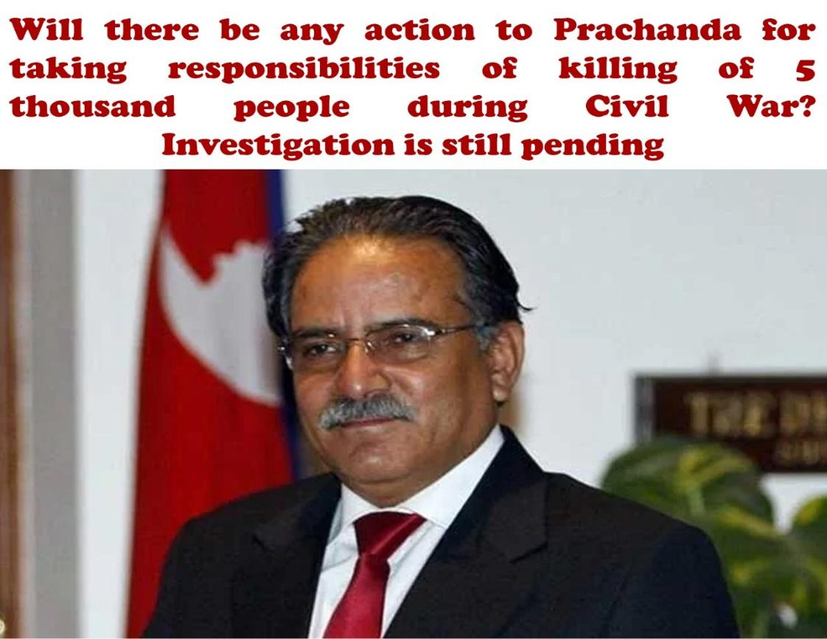**

| **SN** | **LINKS** |
| --- | --- |
|  | *https://www.facebook.com/ratorachandrasurya0/posts/pfbid02Yo829C9DdkqfHJ6VDezjntxEyoxJAQoYiU2nT7Uj8oti7BBCt1zxi1fvB2DRUNejl?__cft__[0]=AZUc4KL_d7lciBASEuJ7xNEdbAPlCN5N2l8SEU0BXN1twQaIRBKLlhT9pqYxBMdUuq9PerkxK_b1g9GrIHl0GmjkINwjhSrZXCPrD7EZCOgcbCjae_l986JIZgRyX-Jo3l7lgl5vt0R-NTOgbP6lYRr6j4qiou5nW726i2c_4fUjLZmQbymW_OZ0Sdeczf5Gp0Q&__tn__=%2CO%2CP-R* |
|  | *https://www.facebook.com/nepolitics0/posts/pfbid02efkM7KAHDVBjcmUwfCrDrebPnCk9iDdb2ugQ9txHzKNy27C2s5iPTyic3UMXwfLTl?__cft__[0]=AZWUzj4jZsbSWzc2A75onwFKRbFEbmFD5Xmp0sUoPEv_mqPw_nEj-7aDsB2w5hYSiWVQERE-5-o7Kb9KdJ2JfKWAGthJr_7l556gvXBf-2PdsjPgVUwTWvGJIWVVVgJdUudAKqIxdhqwkD2cA-88z4ZZ-Jed-pfGefcm5VornTFsn9dkOyIhmB9-1ym2tELOZ6U&__tn__=%2CO%2CP-R* |
|  | *https://www.facebook.com/groups/ssnepal/permalink/7927270884035310/* |
|  | *https://www.facebook.com/groups/1074192292722252/permalink/2991241281017334/* |
|  | *https://www.facebook.com/groups/NepaliOnlineNewss/permalink/2660416867475212/* |
|  | *https://x.com/CartofNews1/status/1772253989351948526?s=20* |

**Human Rights and Peace Society Nepal demands immediate regignation of Home Minister Rabi Lamichhane as there have been several reports of his involvement in the infamous cooperative fraud case.**

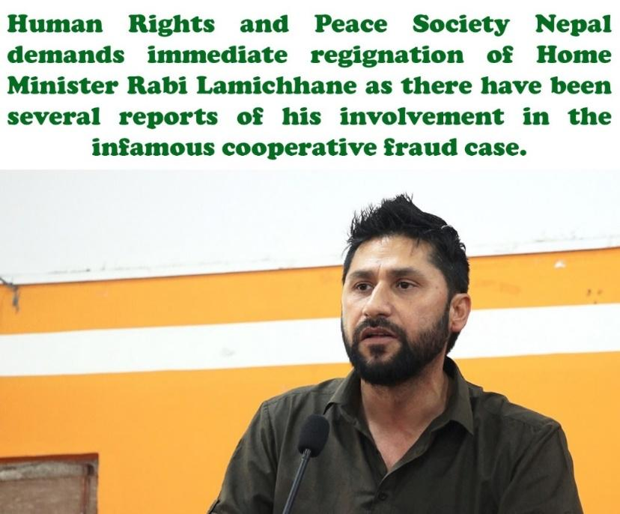

| **SN** | **LINKS** |
| --- | --- |
|  | *https://www.facebook.com/ratorachandrasurya0/posts/pfbid02Yt34NK75QdTx7m2mrSGXwQnGx5MCApGQoR6PZ82AsJ8xRqGenfnuwwkZpFrQ3tNul?__cft__[0]=AZUrFpWFpTi-pcUtsBF56Oprfyj8dmMofQcnxccZQ4x40RmtlnpQ4a4EbhzEMqWp2DrbEIG7pj41I8lXP_SRNAnYWsMYhBKu10QKG8QJmvX_5RIrw6nne5lzxHF1zrEQ87rgDGWVRiC_eXOFI06hAcM3wM8aEni3mdS2wMD3BQbBXUTrx_AC0AMFrBU9sFf_qHw&__tn__=%2CO%2CP-R* |
|  | *https://www.facebook.com/nepolitics0/posts/pfbid0fJzPYt4h4XGxGZ8QENKZnM3eUJGQbKmeXAQirHiG6PWe4sH9zYnUCkpReUmhoNdxl?__cft__[0]=AZVVCAxNyxRmqw6FVJq0xsP1iep7CddUOLWSU5WaZagYB37cWdru0rABXkglg7A2x-M_f6bpB6zI5B3FTfa3QaEKODO7H4euQ44LXFF5HqjojWyY6yof7IlIzWGcf_eDqk9imKKRczWzzb0GNV12dK-eSls2KHbdWaroKKWSjRR91OcnrxgN85BlnMFMgAVxQPU&__tn__=%2CO%2CP-R* |
|  | *https://www.facebook.com/groups/ssnepal/permalink/7927553337340398/* |
|  | *https://www.facebook.com/groups/1074192292722252/permalink/2991300064344789/* |
|  | *https://www.facebook.com/groups/NepaliOnlineNewss/permalink/2660464107470488/* |
|  | *https://x.com/CartofNews1/status/1772254034960818569?s=20* |